
H.C.B-R1337
VOLVO D13 ENGINE STAND ADAPTER

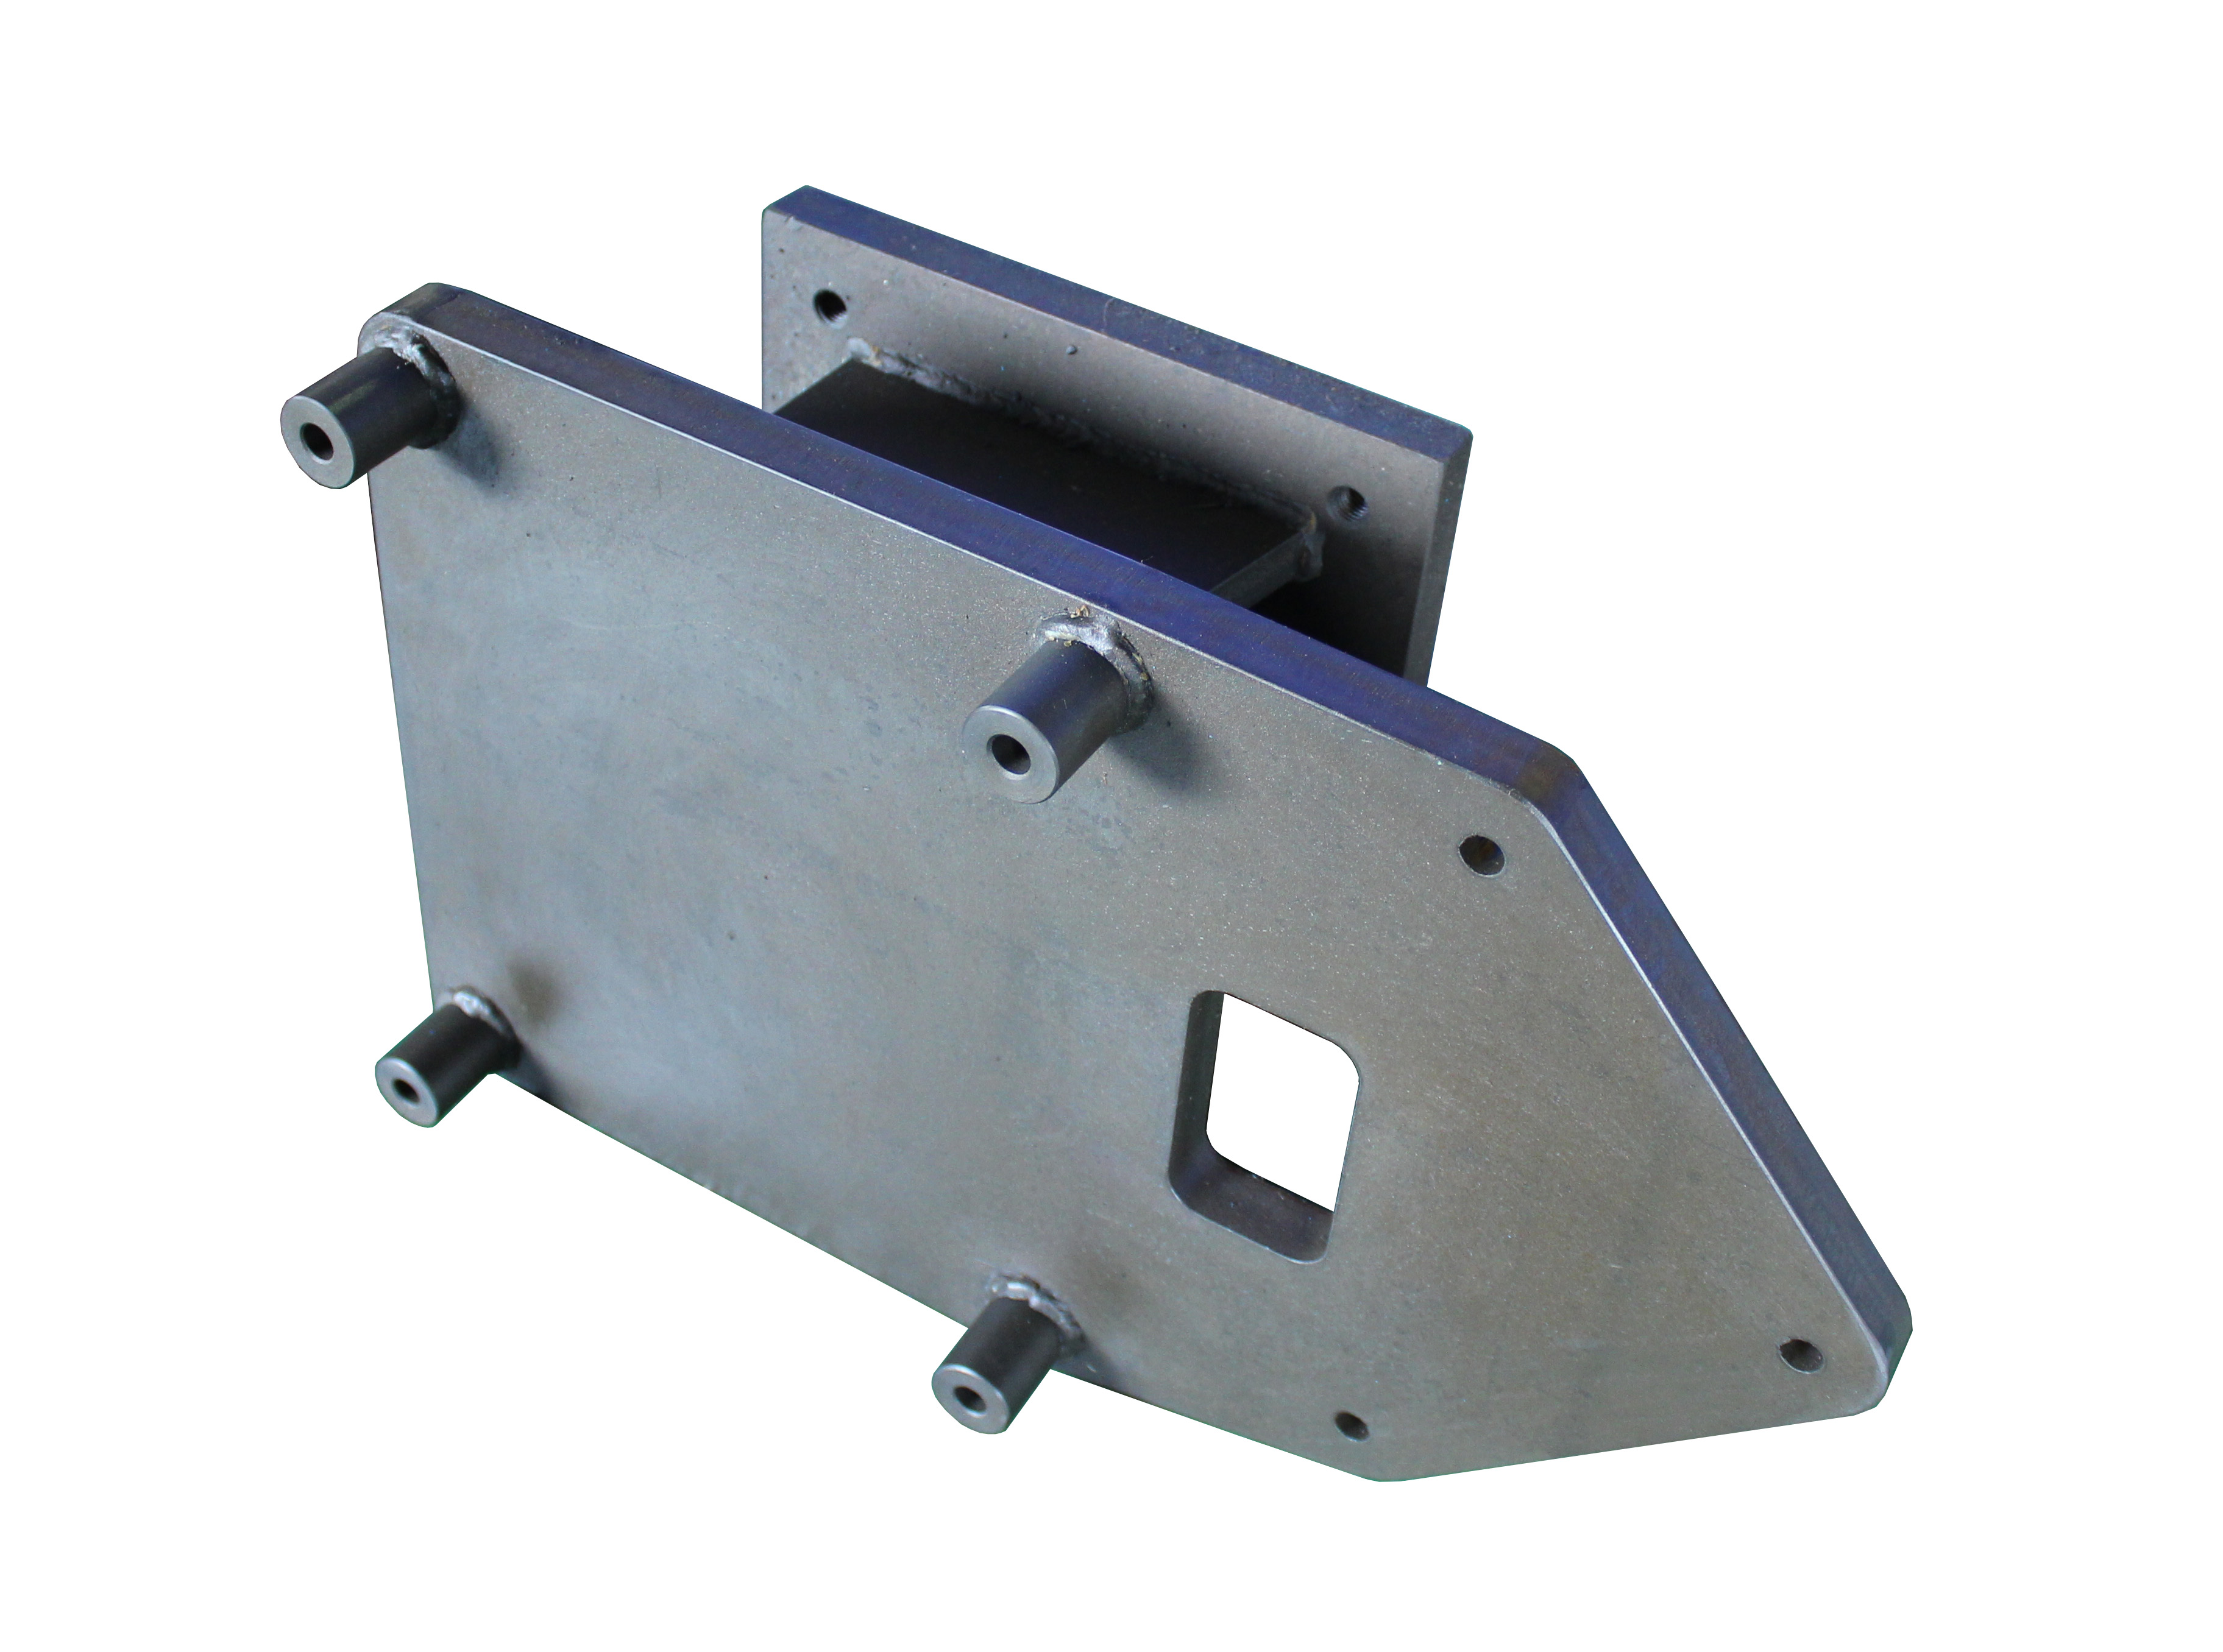

- This adapter must use with the H.C.B-A1337 engine stand.
- It’s use to lock the VOLVO D13 engine into engine stand and repair.
- Application: VOLVO D13

