
H.C.B-Q1337
DAF TRANSMISSION ADAPTER
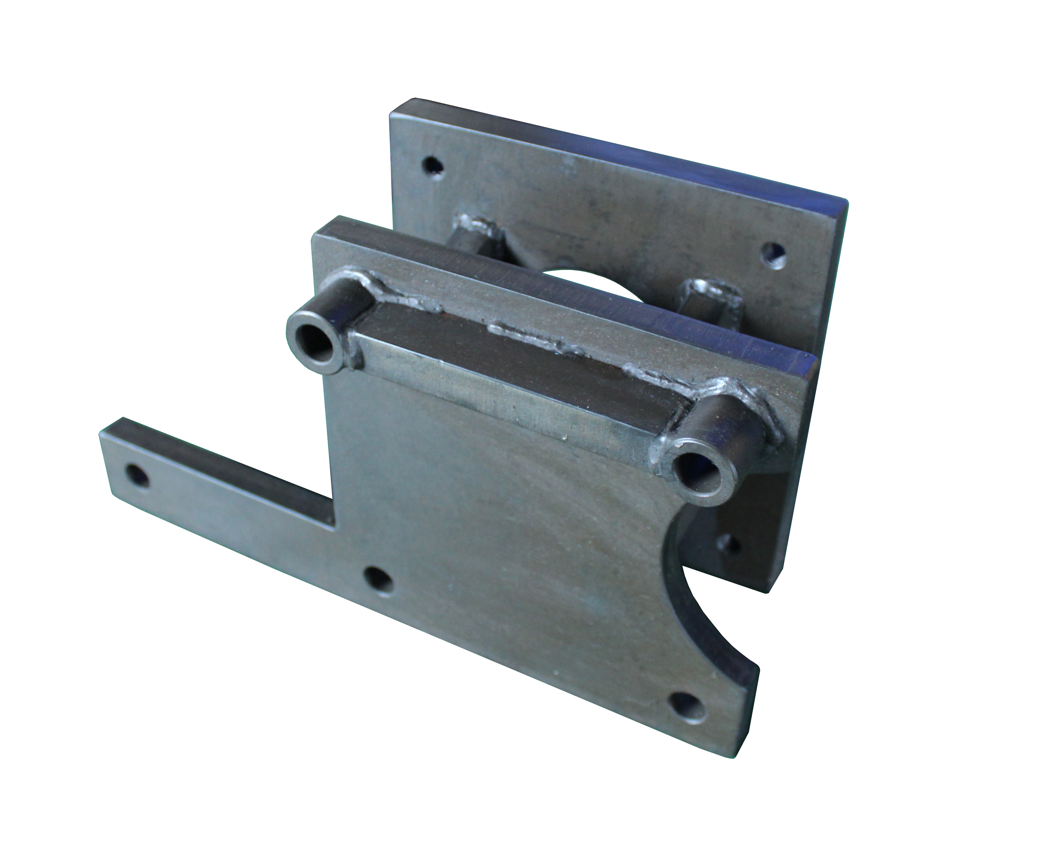

- Special design adapter to lock the transmission on engine stand
- This transmission adapter need to combine with H.C.B-A1337 engine stand
- Application: DAF MX-11
- OEM no. ref: 1903046

