
H.C.B-IV1051
IVECO CRANKSHAFT REAR GASKET INSTALLATION TOOL

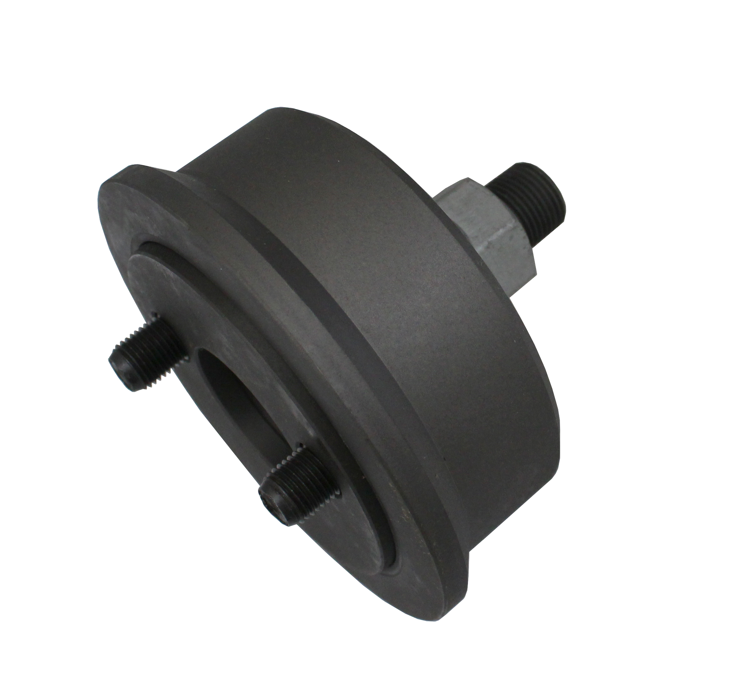
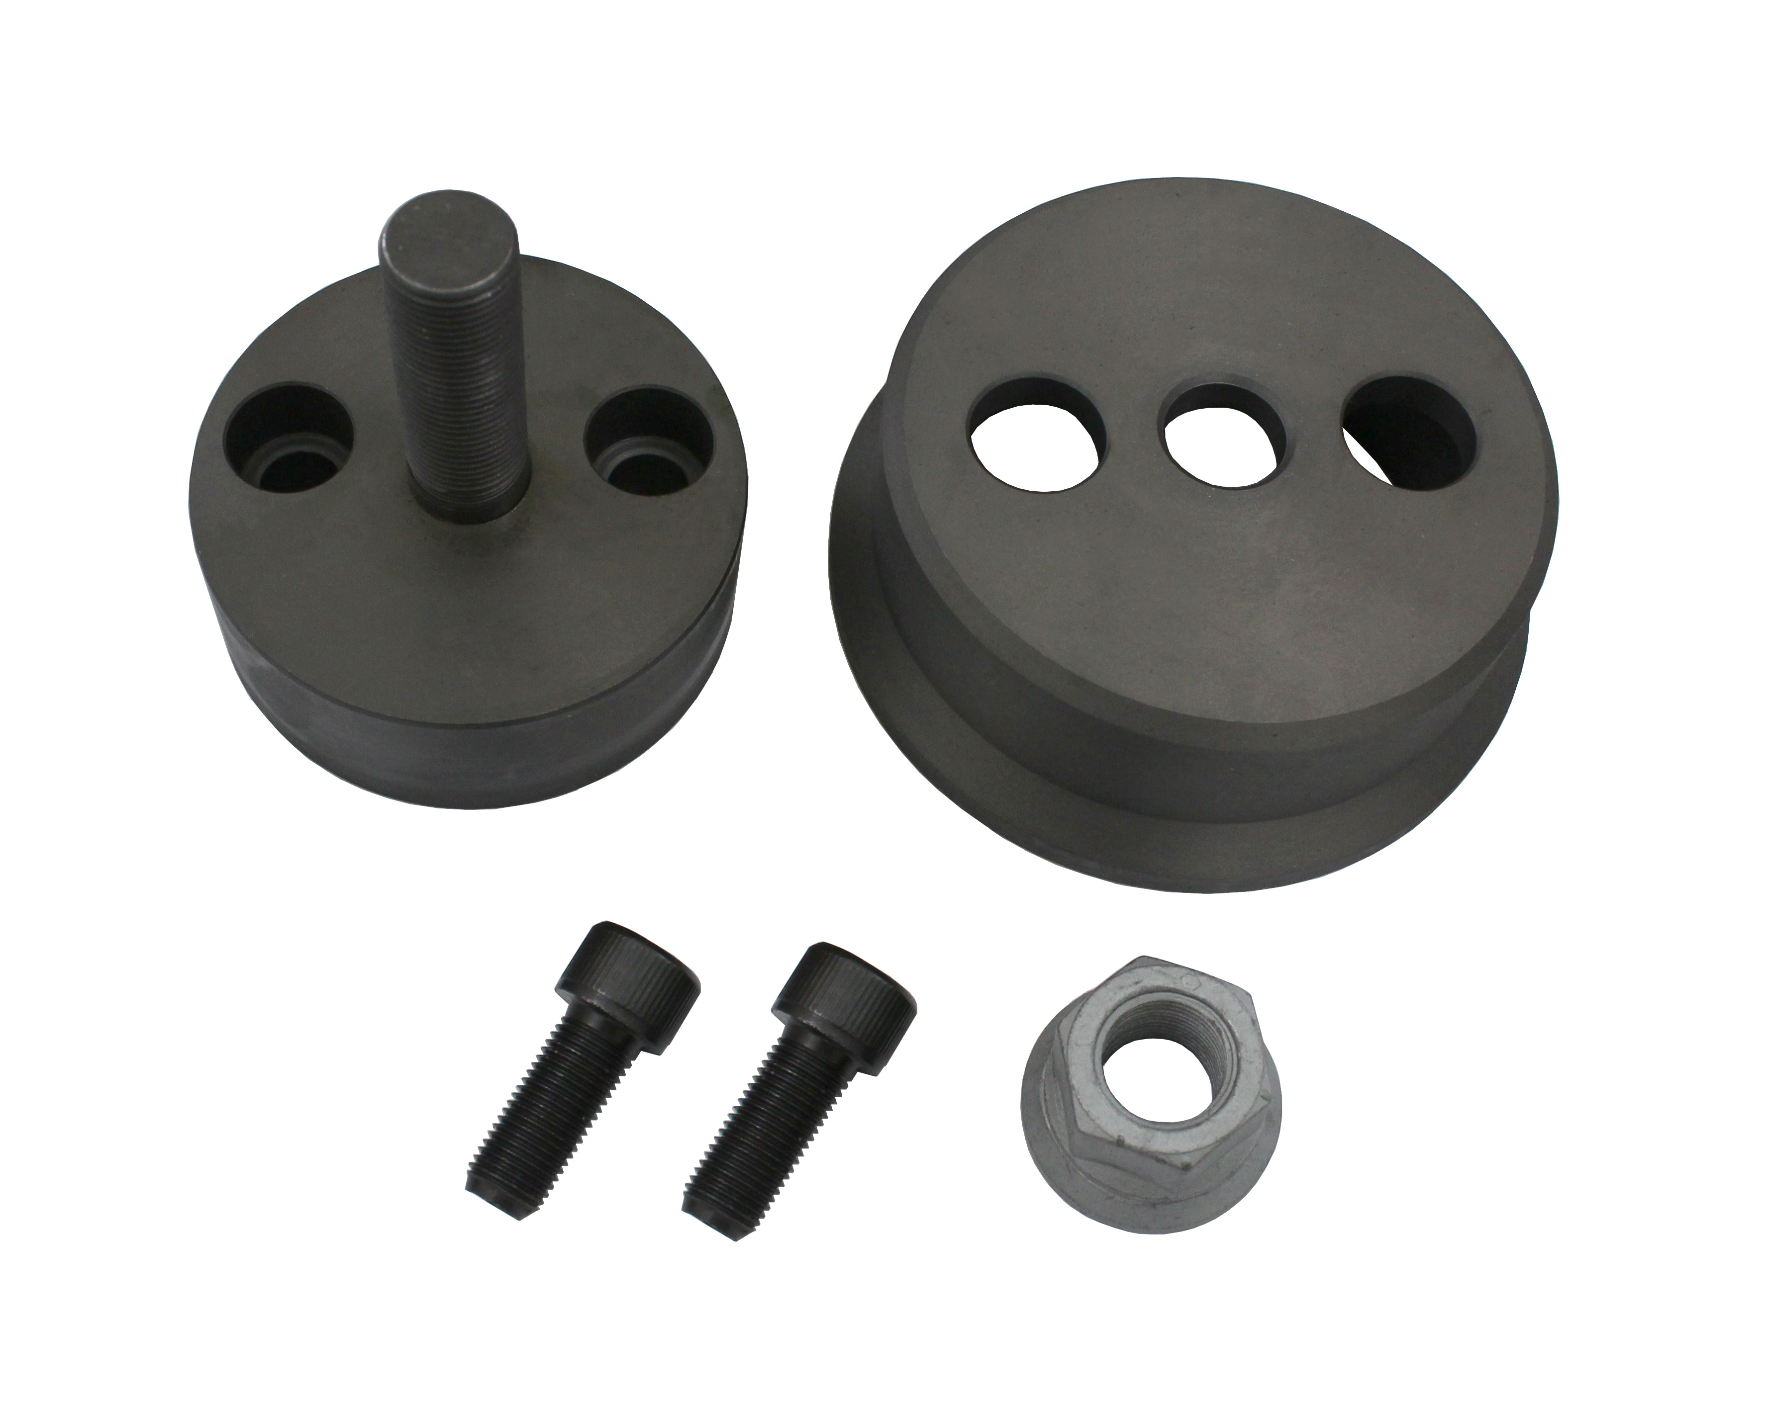

- Application: Engine FIA (2300), Models: Daily-Ducato
- Device for mounting crankshaft rear gasket
- OEM no. ref.: 99346255

