
H.C.B-IV1049
IVECO OUTPUT SHAFT REAR GASKET REMOVAL INSTALLATION TOOL

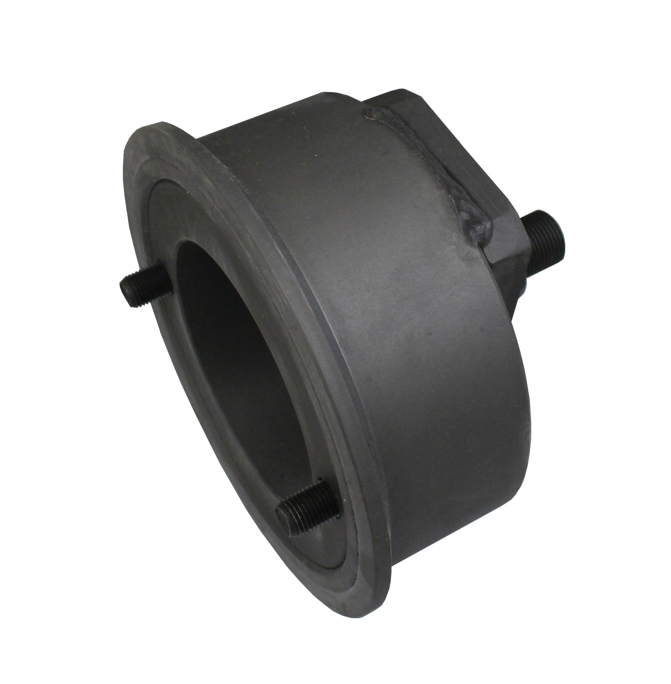
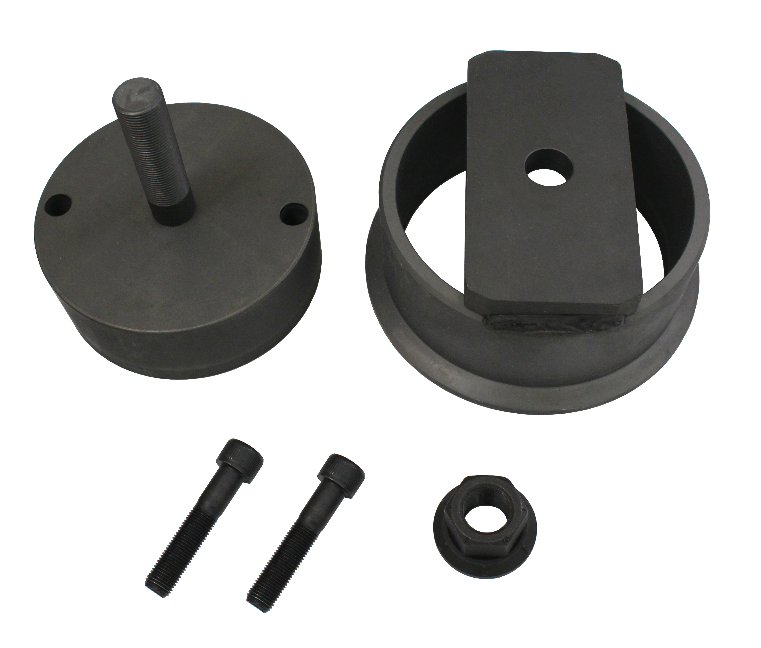

- Application: TN85A TN95A TN85DA TN95DA TN85SA T4000 T4000F T4000V T4000N T4F T4LP T4N T5000 TSA T6000 T6 T7000 T7 LM CVT F4CE F4DF F4DFE F4GE F4HE F4HF F4HFE
- Designed for fitting output shaft rear gasket
- OEM no. ref.: 99346253

