
H.C.B-IV1048
IVECO OUTPUT SHAFT FRONT GASKET REMOVAL INSTALLATION TOOL

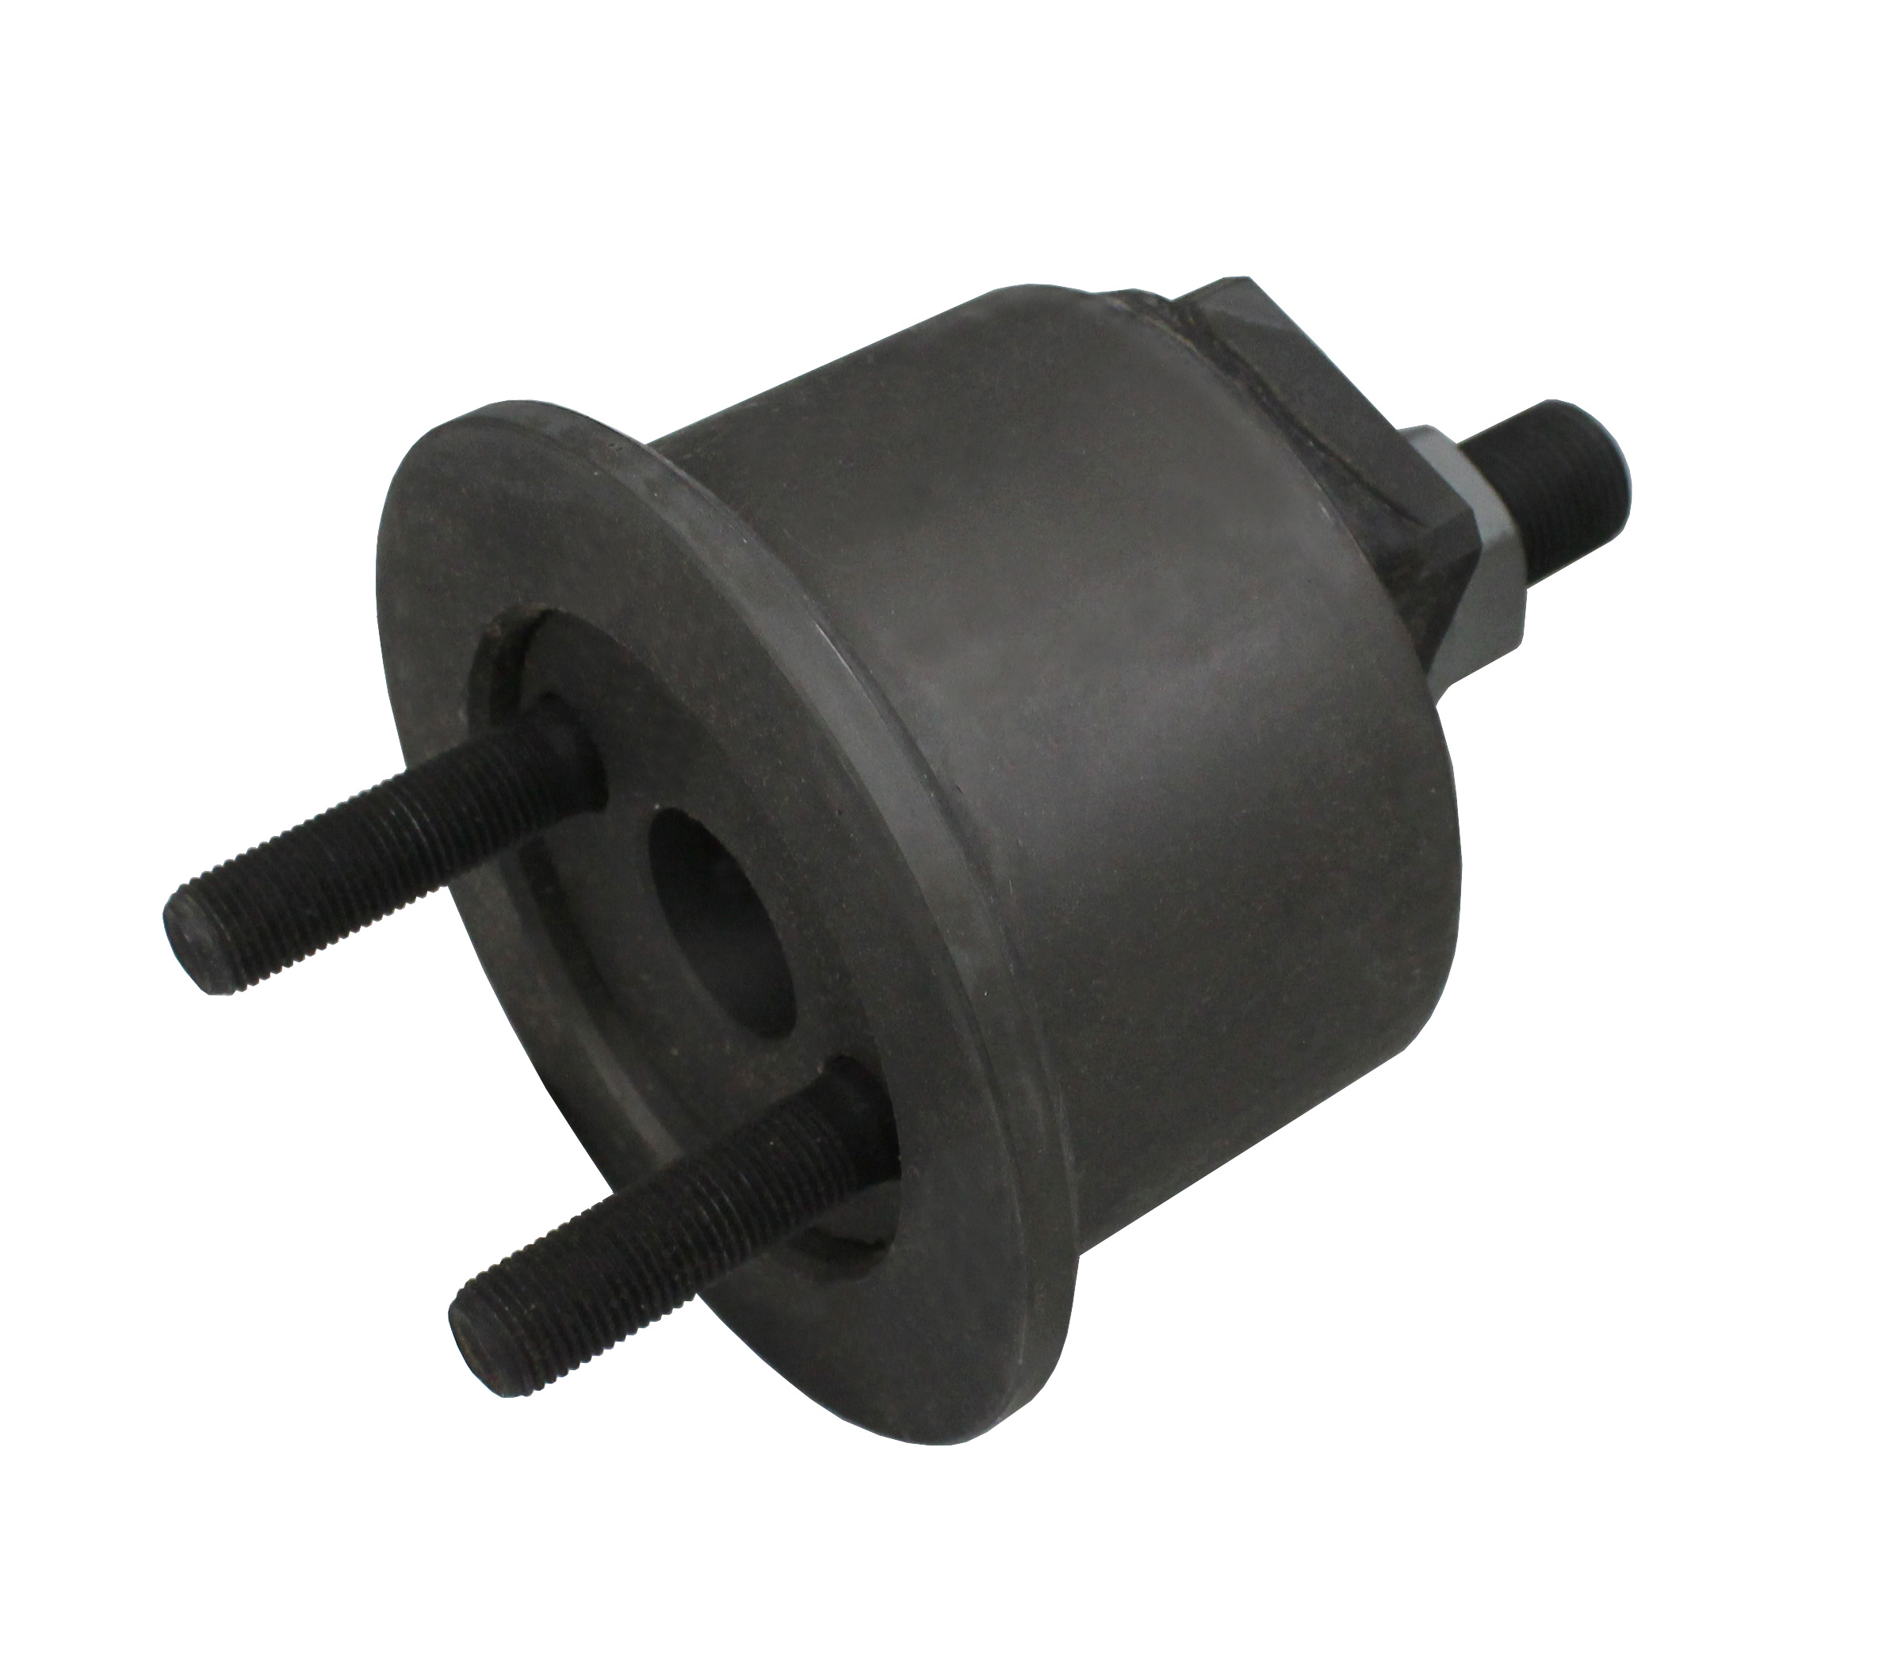
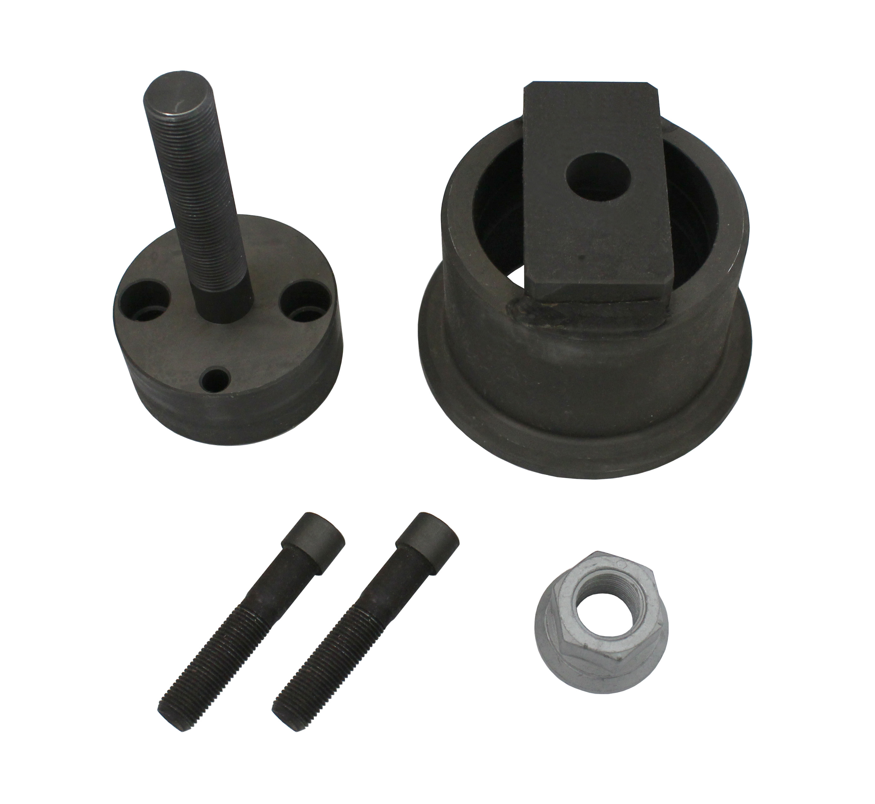

- Designed Tool for fitting output shaft front gasket
- Application: Engine F4A, Model: Euro Cargo
- OEM no. ref.: 99346252

