
H.C.B-IV1046
IVECO CRANKSHAFT REAR SEAL REMOVAL TOOL
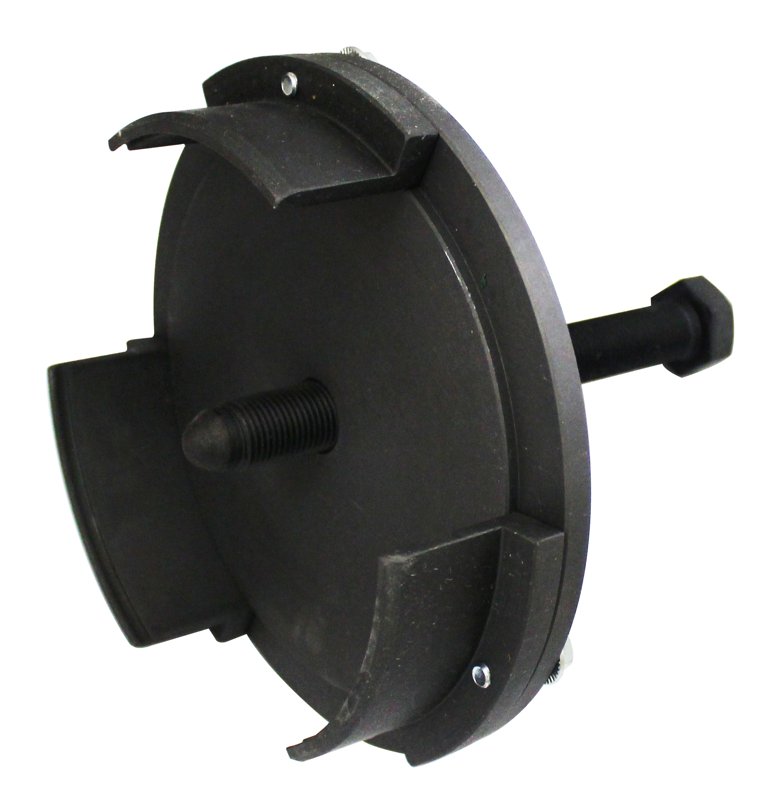

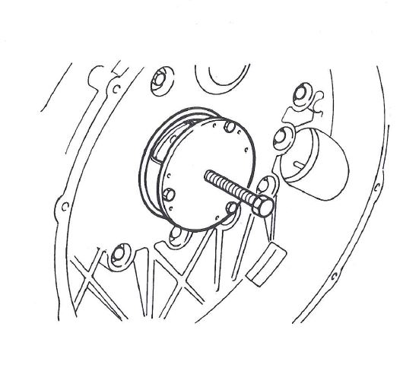

- This tool is designed for remove the rear seal on crankshaft.
- Applications: F3A, F3B,.(CURSOR 10, CURSOR 13)
- Model:EuroTech-EuroStar
- OEM no. ref .: 99340054

H.C.B-IV1046
IVECO CRANKSHAFT REAR SEAL REMOVAL TOOL

- This tool is designed for remove the rear seal on crankshaft.
- Applications: F3A, F3B,.(CURSOR 10, CURSOR 13)
- Model:EuroTech-EuroStar
- OEM no. ref .: 99340054

