
H.C.B-IV1045
IVECO CRANKSHAFT REAR SEAL INSTALLATION TOOL
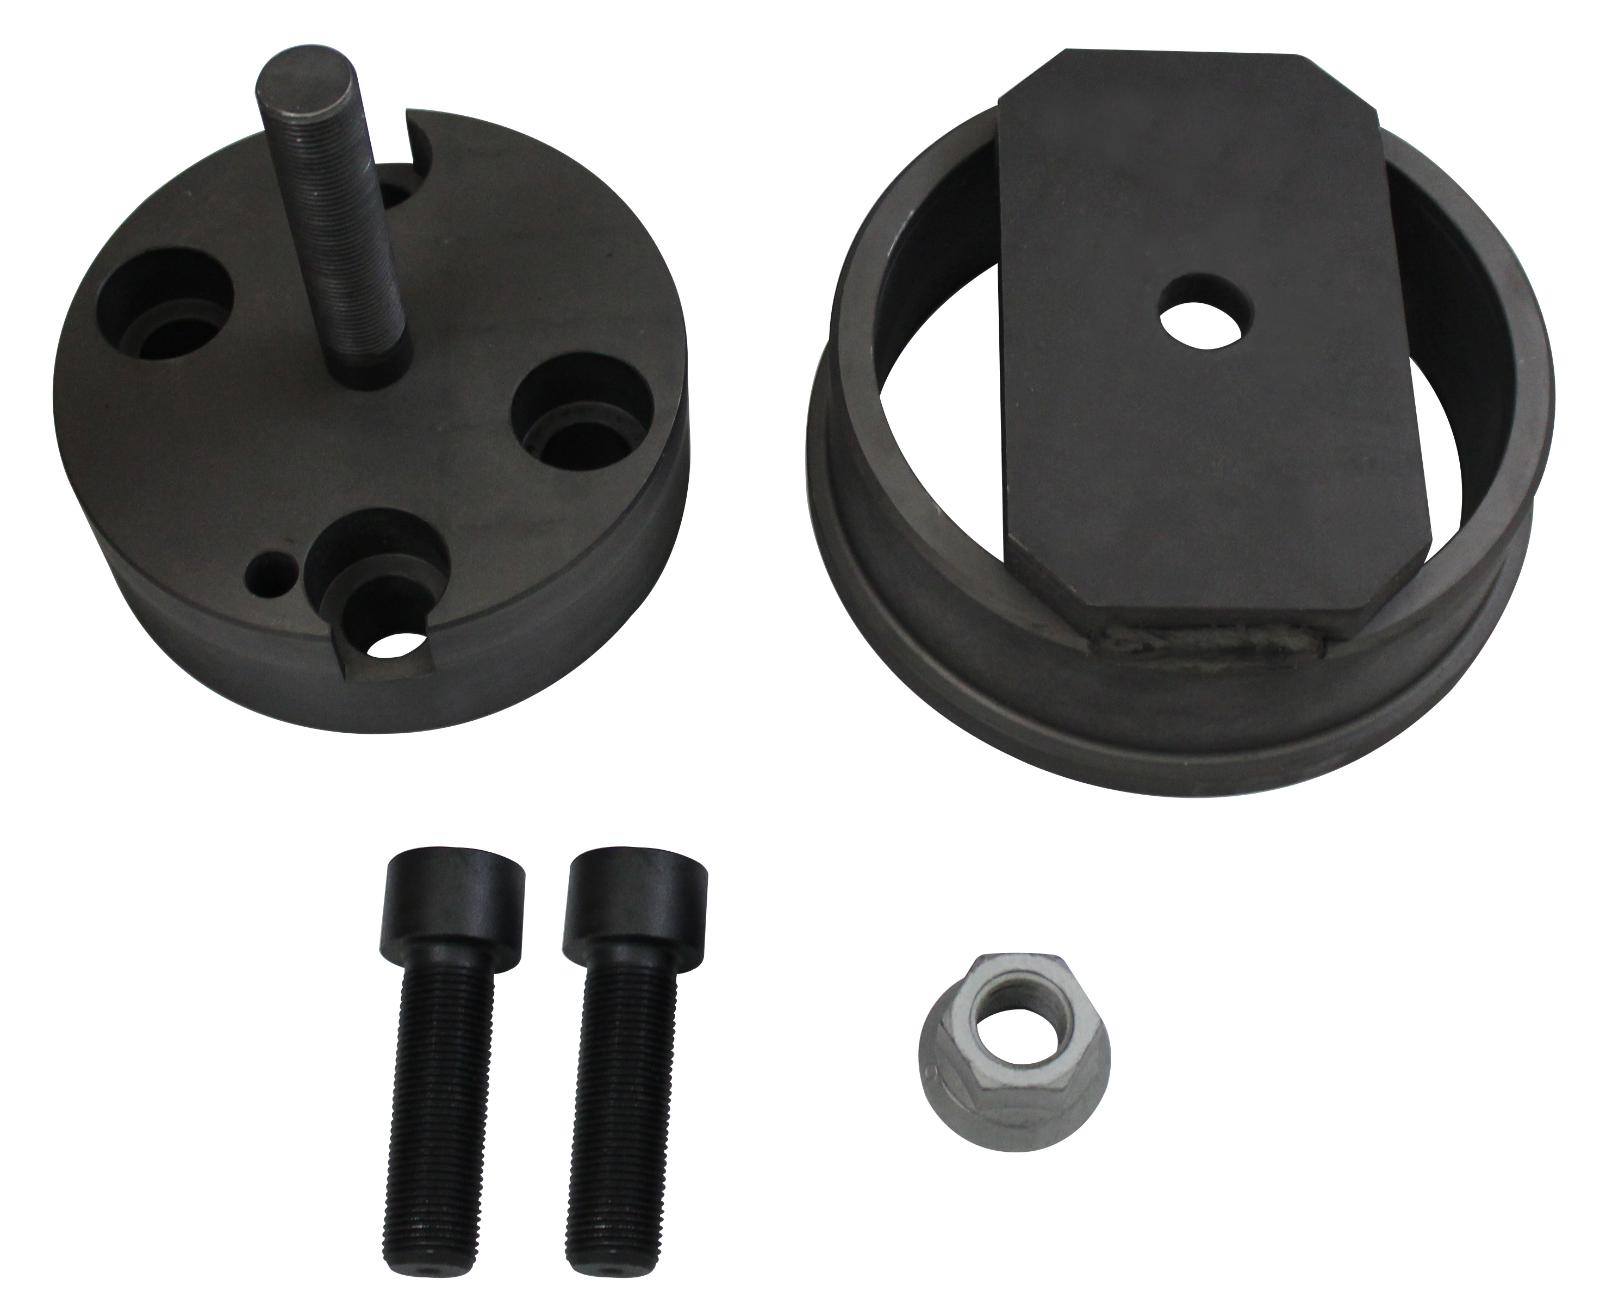

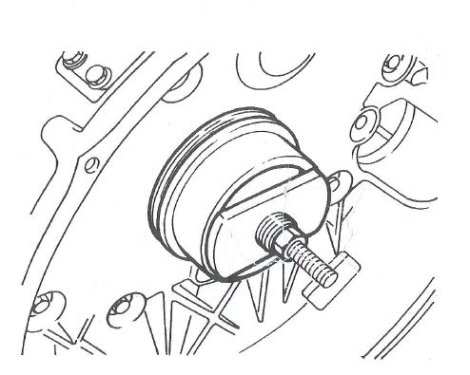

- This tool is designed for install the rear seal on crankshaft.
- Applications: F3A, F3B,F2C.(CURSOR 10, CURSOR 13)
- Model:Heavy ON/OFF Road, BUSH
- OEM no. ref .: 99346260
H.C.B-IV1045
IVECO CRANKSHAFT REAR SEAL INSTALLATION TOOL

- This tool is designed for install the rear seal on crankshaft.
- Applications: F3A, F3B,F2C.(CURSOR 10, CURSOR 13)
- Model:Heavy ON/OFF Road, BUSH
- OEM no. ref .: 99346260

