
H.C.B-IV1044
IVECO CRANKSHAFT FRONT SEAL
REMOVAL TOOL
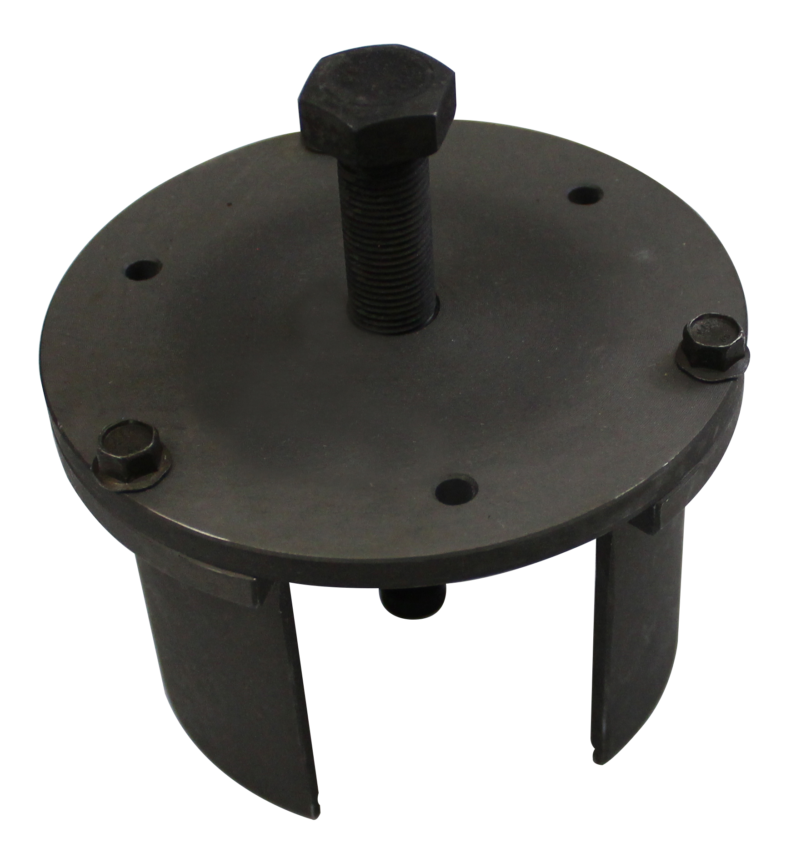

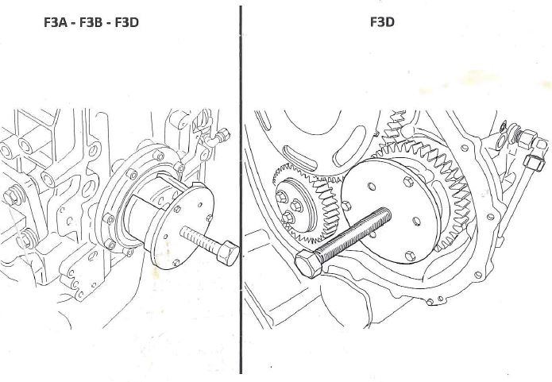

- This tool is designed for remove the front seal on crankshaft.& high pressure pump gear
- Applications: F3A, F3B,F3D.(CURSOR 10, CURSOR 13)
- Model: Eurotech , Eurostar
- OEM no. ref .: 99340053
H.C.B-IV1044
IVECO CRANKSHAFT FRONT SEAL
REMOVAL TOOL

- This tool is designed for remove the front seal on crankshaft.& high pressure pump gear
- Applications: F3A, F3B,F3D.(CURSOR 10, CURSOR 13)
- Model: Eurotech , Eurostar
- OEM no. ref .: 99340053

