
H.C.B-IV1041
IVECO VALVE GUIDE SLEEKER 8mm

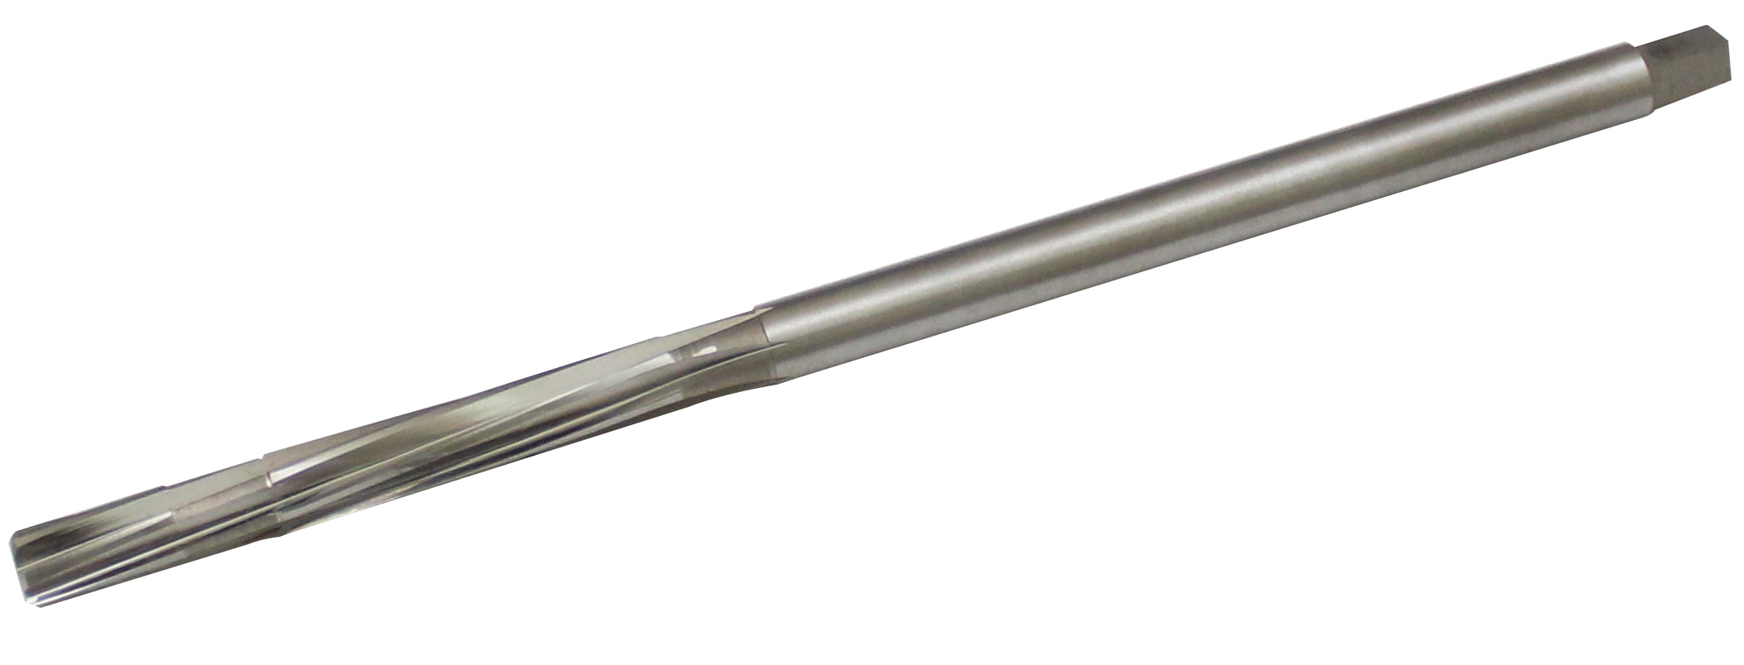

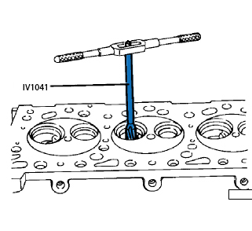

- It’s use for rebore the holes
- OEM no. ref .: 99390330

