
H.C.B-IV1041-B
IVECO VALVE GUIDE SLEEKER 9mm

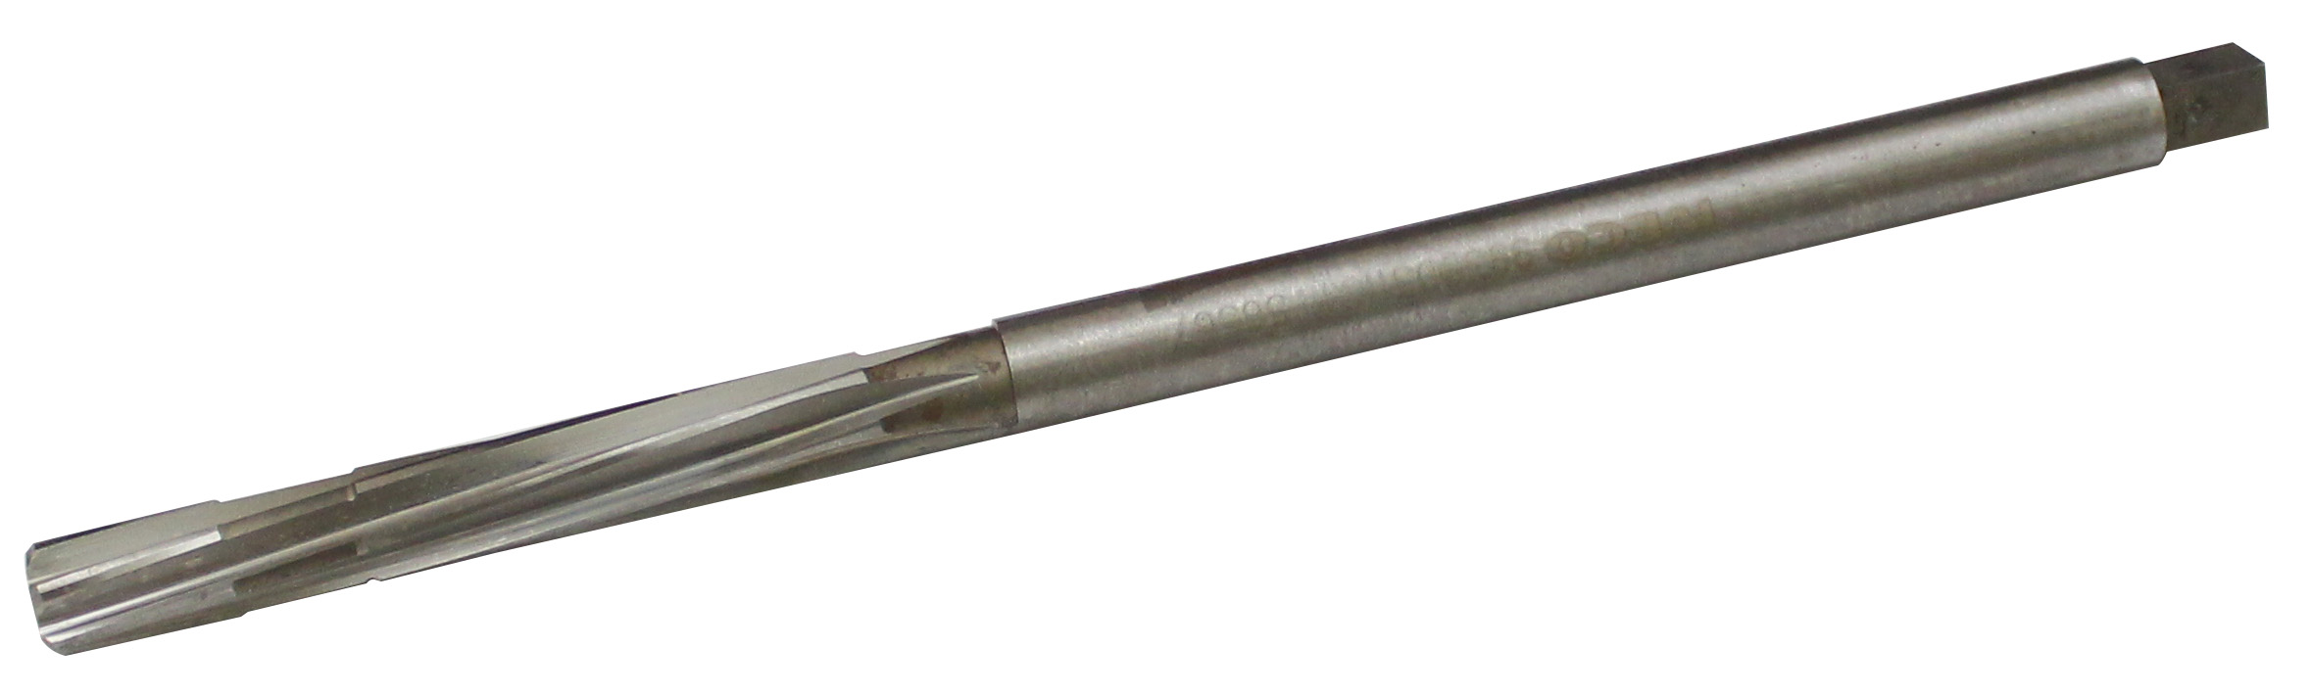

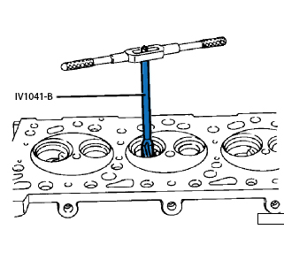

- It’s use for rebore the holes
- OEM no. ref .: 99390310

