

H.C.B-IV1039
IVECO INJECTOR HOLDER CUTTER

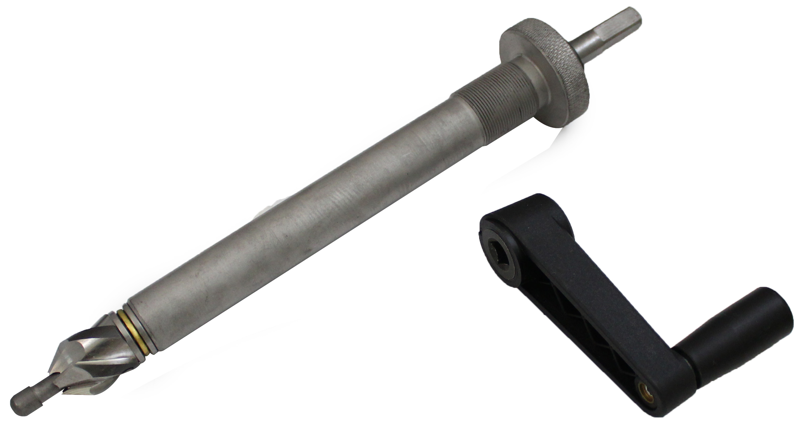

- Cutter for regrinding injector seat.
- IVECO OEM no. ref.: 999394041

H.C.B-IV1039
IVECO INJECTOR HOLDER CUTTER

- Cutter for regrinding injector seat.
- IVECO OEM no. ref.: 999394041

