
H.C.B-IV1038
IVECO GUIDE SLEEVE

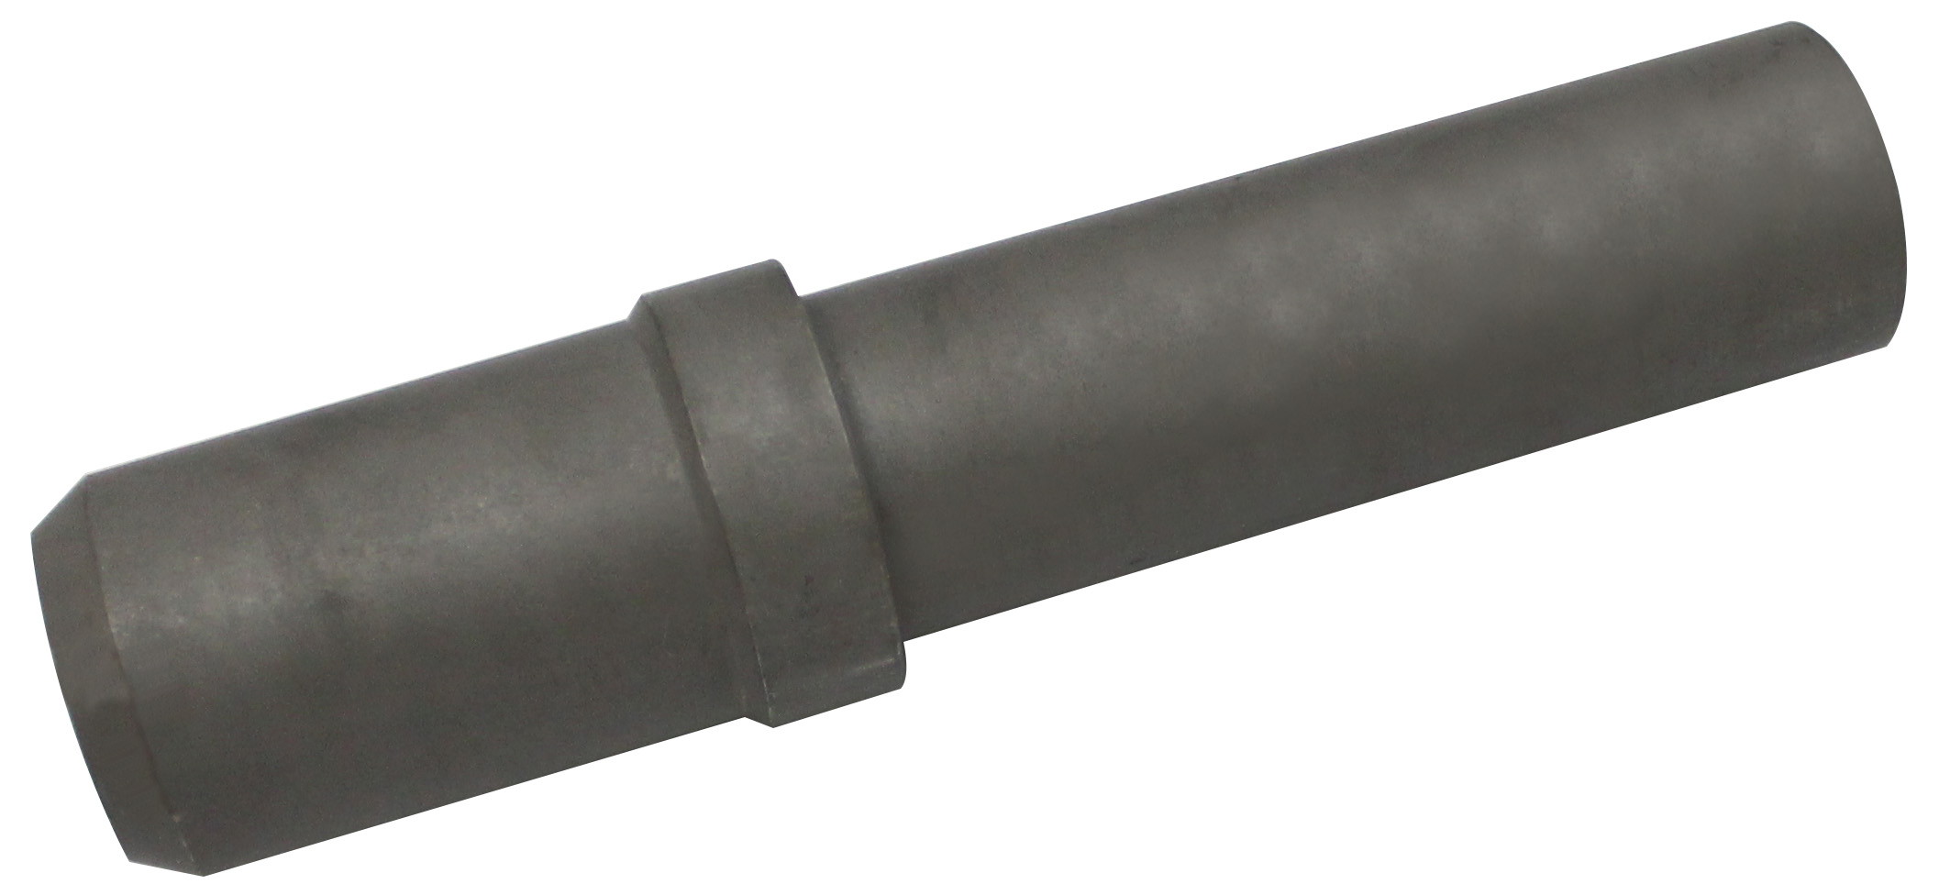

- to used with IV1039-B)
- IVECO OEM no. ref.: 99394014


H.C.B- IV1038
IVECO GUIDE SLEEVE

- to used with IV1039-B)
- IVECO OEM no. ref.: 99394014

