
H.C.B-IV1038-B
IVECO GUIDE BUSH
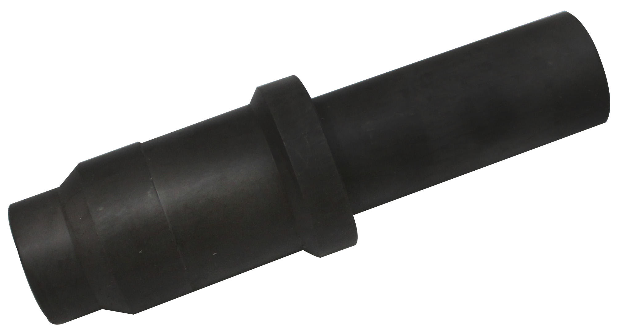

- to used with IV1039 or IV1039-B
- OEM no. ref .: 99394015

