
H.C.B-IV1036
IVECO INJECTOR SLEEVE REMOVAL TOOL
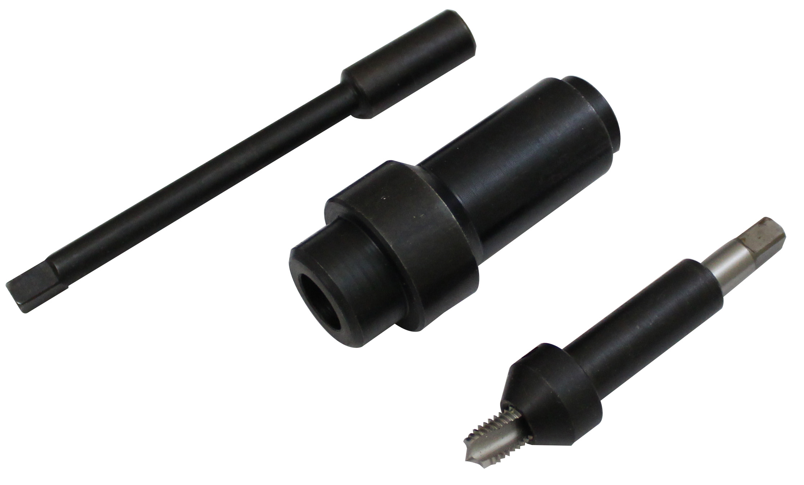

- This tools is used for threading injector holding cases to be extracted.(to used with IV1036-B)
- IVECO OEM no. ref.: 99390804

