
H.C.B-IV1036-B
IVECO INJECTOR SLEEVE GUIDE BUSH TOOL
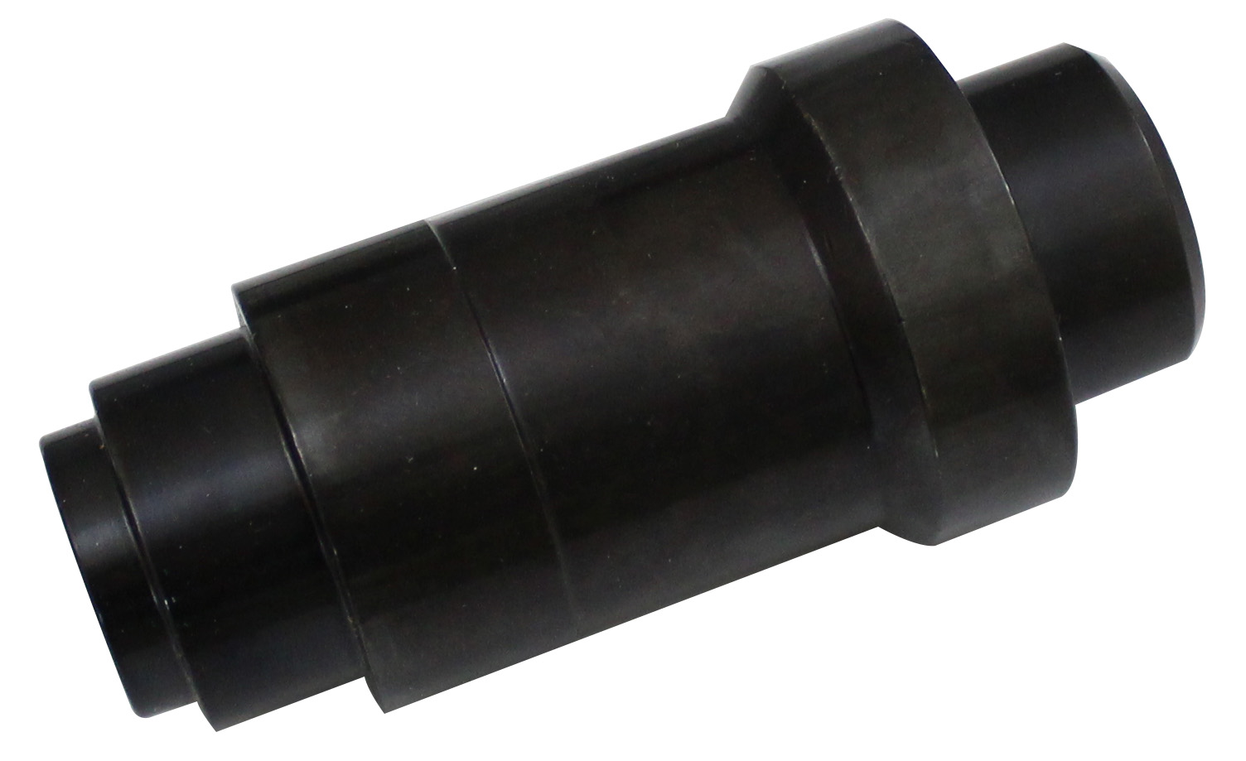

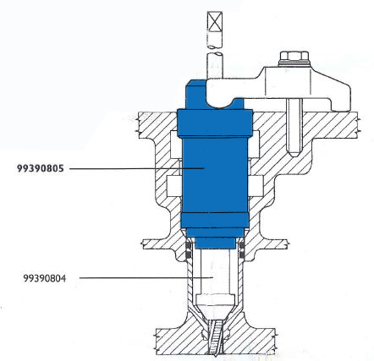

- This tools is used for threading injector holding cases to be extracted.(to used with IV1036)
- Application: ENGINE F3A-F3B (EuroTech-Euro Star)
- IVECO OEM no. ref.: 99390805

