
IV1035-B
IVECO INJECTOR SLEEVE REMOVER
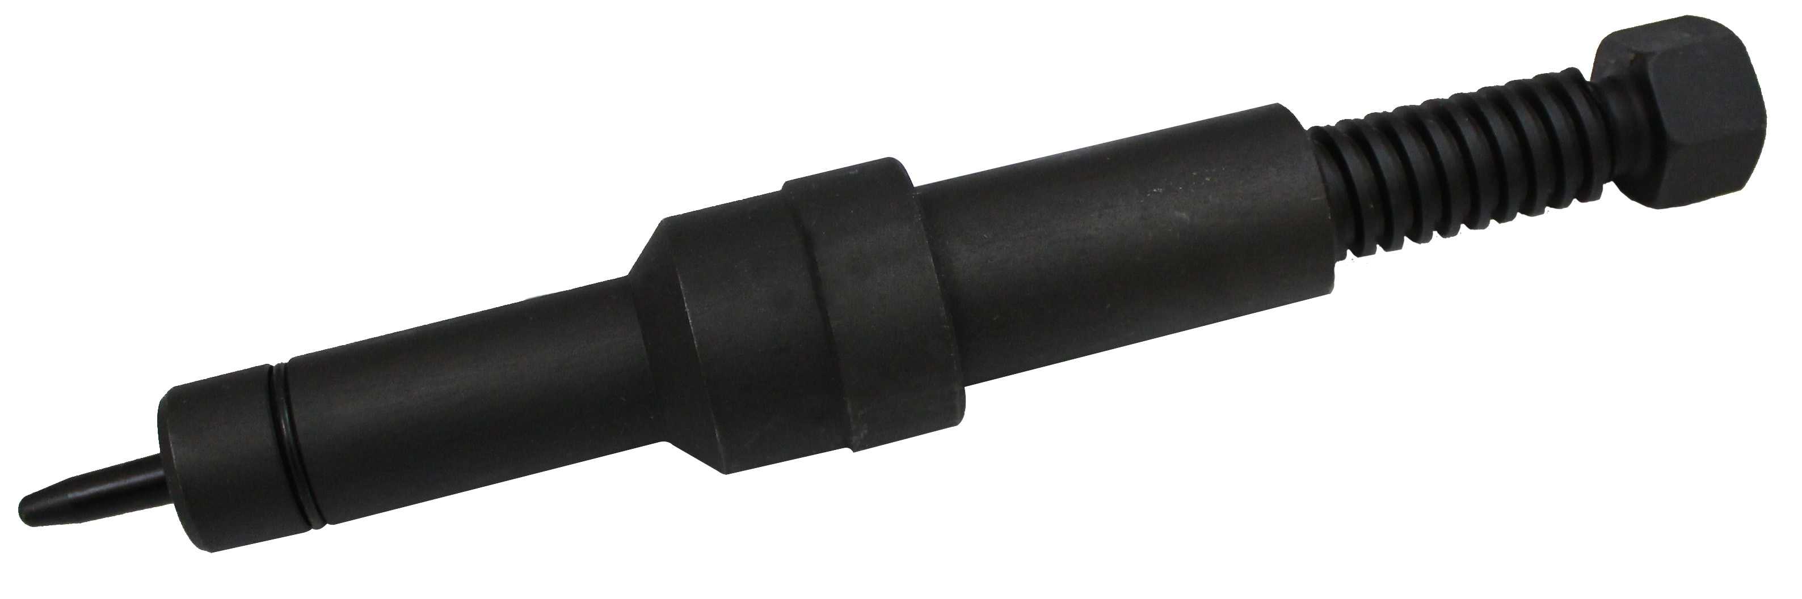

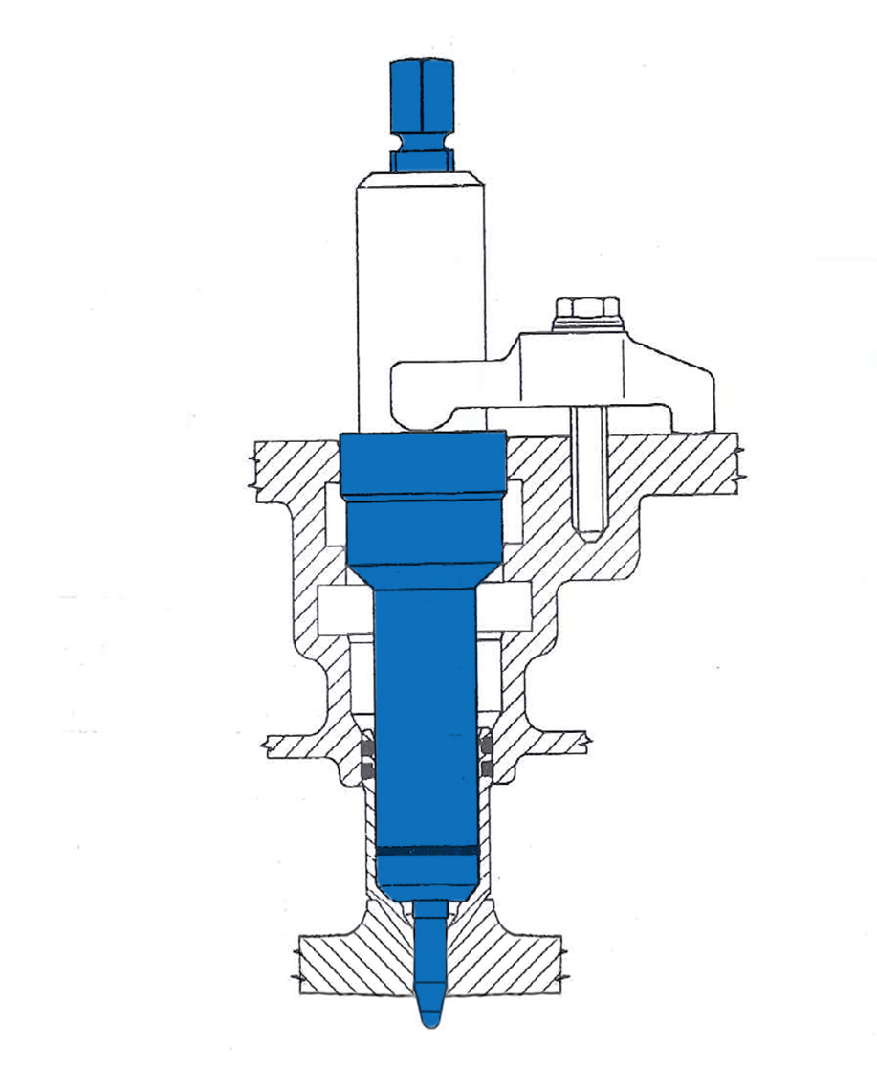

- This tools is used for injector sleeve upsetting tool
- Applications: Engine F2B (Euro Tech MH)
- OEM no. ref .: 99365054

