
H.C.B-IV1034
IVECO INJECTOR SLEEVE REMOVER
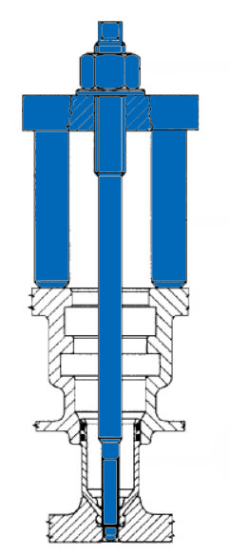

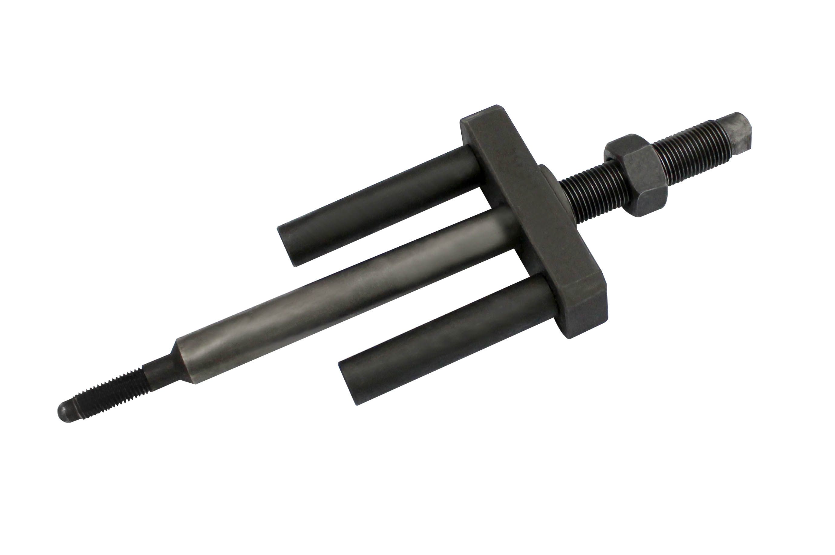

- This tool is designed for removing removing the injector
- OEM no. ref .: 99342149
- Applications: F2B (Stralis)

