
H.C.B- IV1034-B
IVECO INJECTOR EXTRACTOR

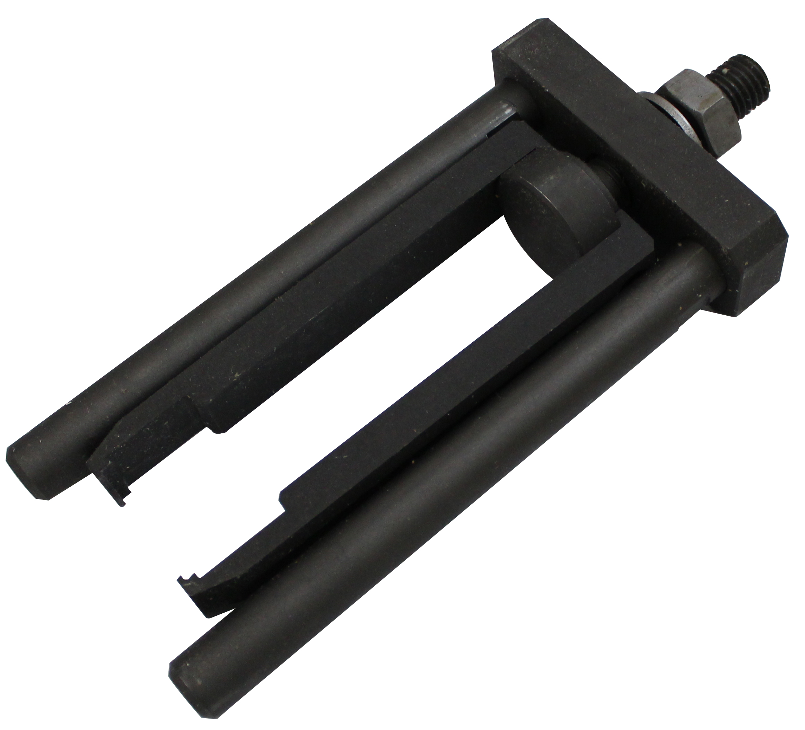

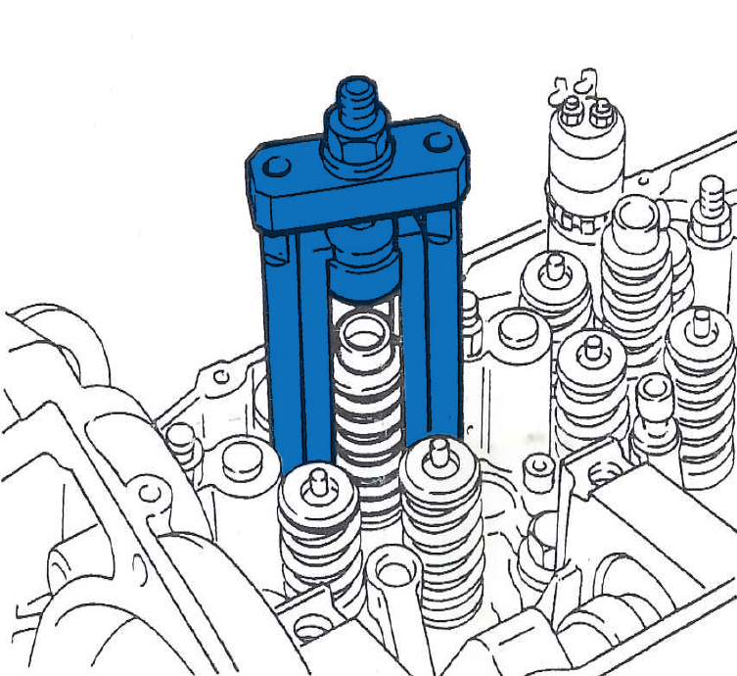

- Tool to remove injectors
- Applications: Engine F2B (Euro Tech MH)
- OEM no. ref .: 99342148

H.C.B- IV1034-B
INJECTOR EXTRACTOR

- Tool to remove injectors
- Applications: Engine F2B (Euro Tech MH)
- OEM no. ref .: 99342148

