
H.C.B-IV1029
IVECO WHEEL HUB BEARING NUT SOCKET
(6 POINTS, 91.5 mm)
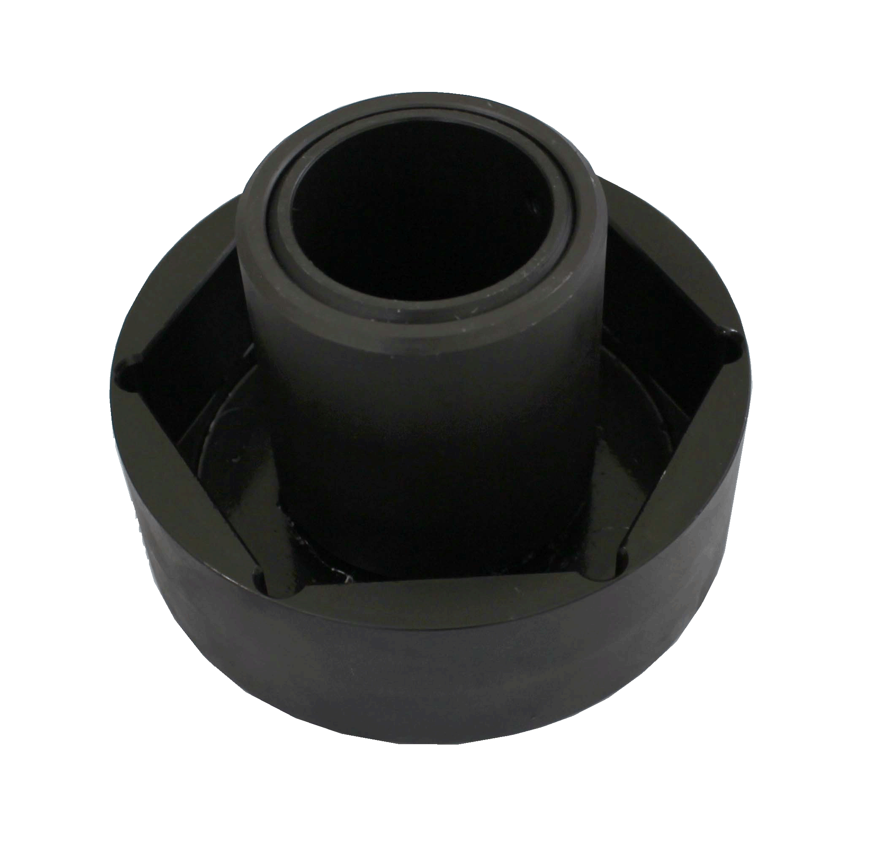
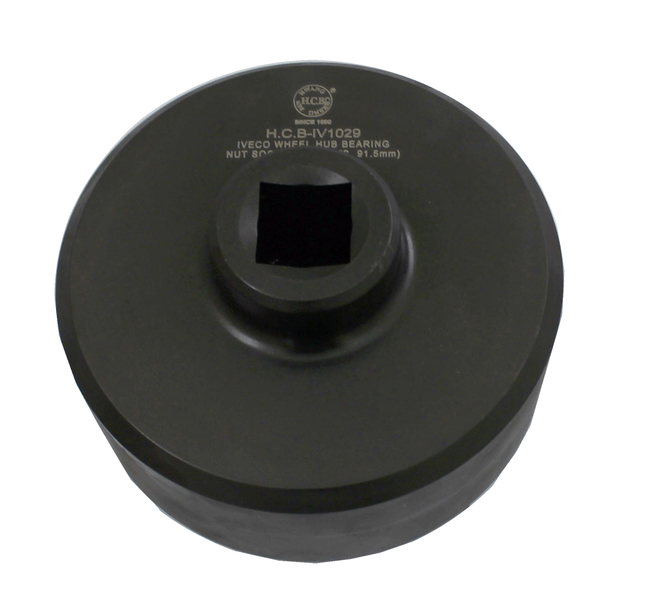

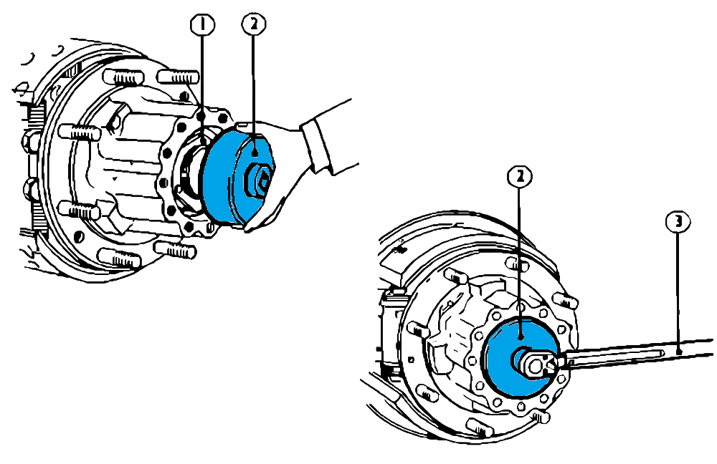

- Socket (91.5mm) for adjusting wheel hub bearings nut.
- Application: Rear axle- R0537 (4517)-R0753 (F125E)-R0653 (F120E)-4536HR
- Models: 59.12-80.13A/ AH-80.16A-90.13A/ AH-95.14 EuroCargo/ Cargo (60E10-60E12-60E14-65E10-65E12-65E14-75E12-75E14-75E15-100E15-100E18-100E21)
- IVECO OEM no.ref.: 99357080

