
H.C.B-G3036
HIGH PRESSURE MANOMETER (15,000 PSI)

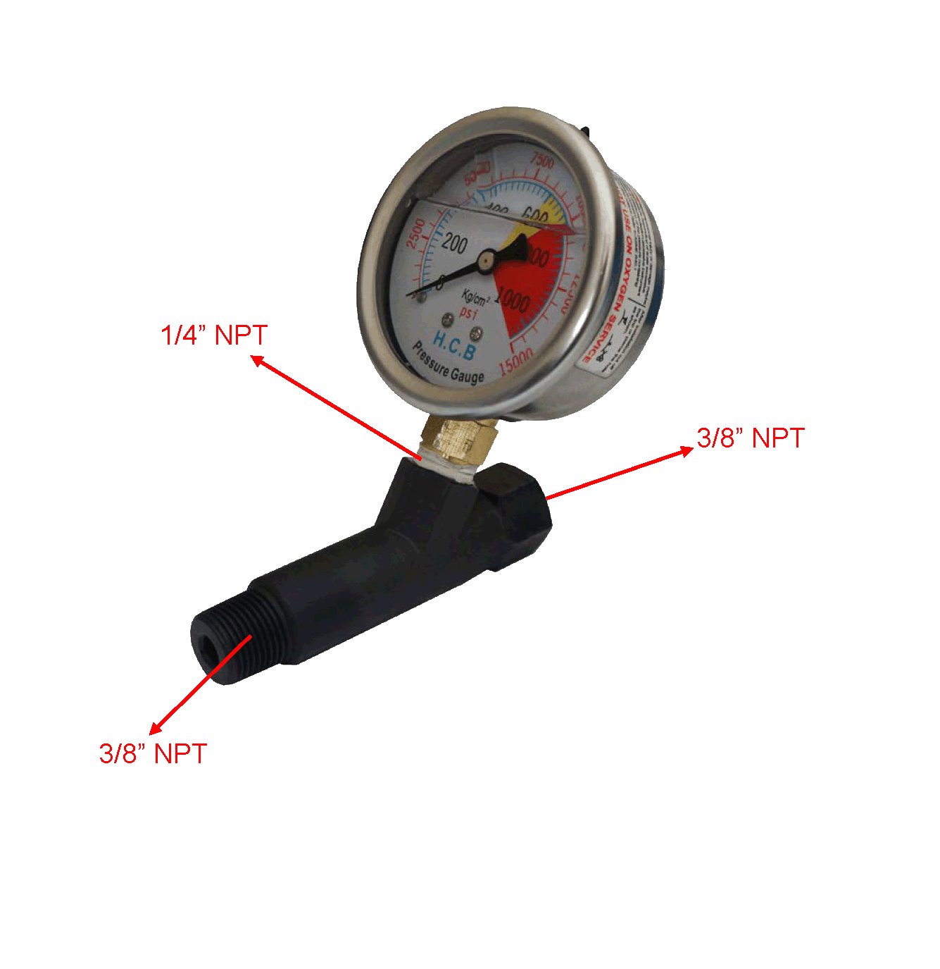

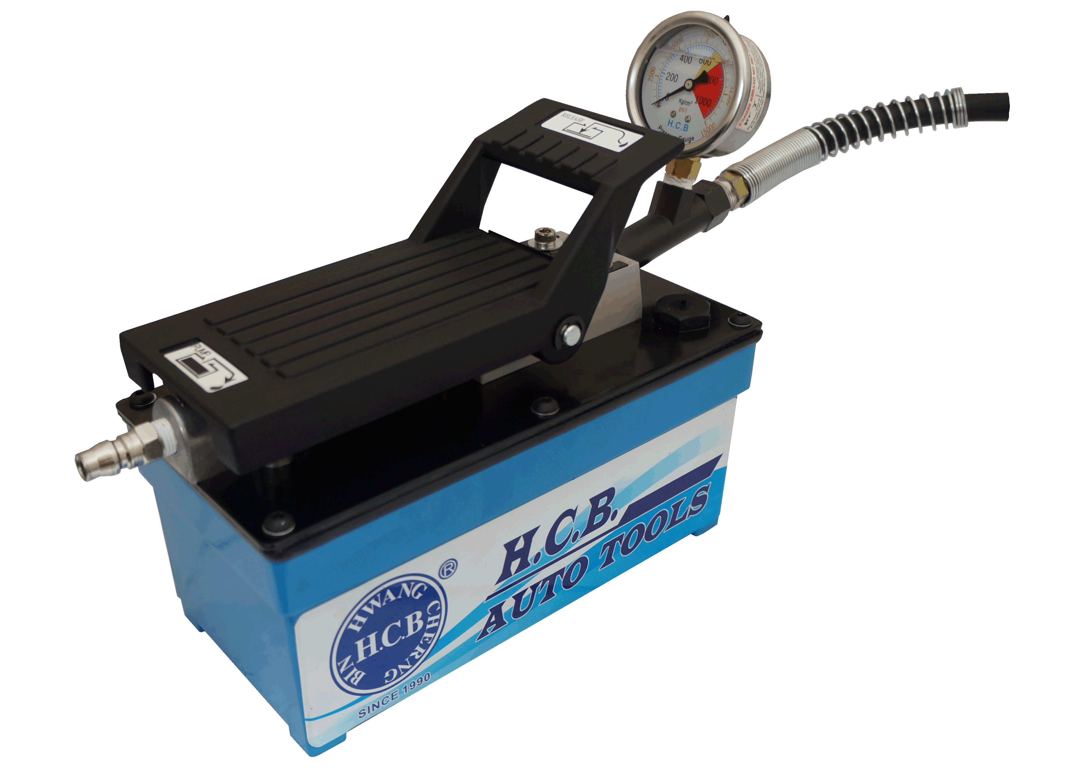

H.C.B-A3036 is equipped with H.C.B-G3036

  - Manometer for H.C.B air pump 3036 series.
  - For monitoring hydraulic pressure.
  - Maximum detection pressure is 15,000 psi.

H.C.B-G3036
HIGH PRESSURE MANOMETER (15,000 PSI)

H.C.B-A3036 is equipped with H.C.B-G3036

  - Manometer for H.C.B air pump 3036 series.
  - For monitoring hydraulic pressure.
  - Maximum detection pressure is 15,000 psi.

