
H.C.B-G1090
SCANIA DIFFERENTIAL REAR AXLE NUT SOCKET
(Dr. 3/4")
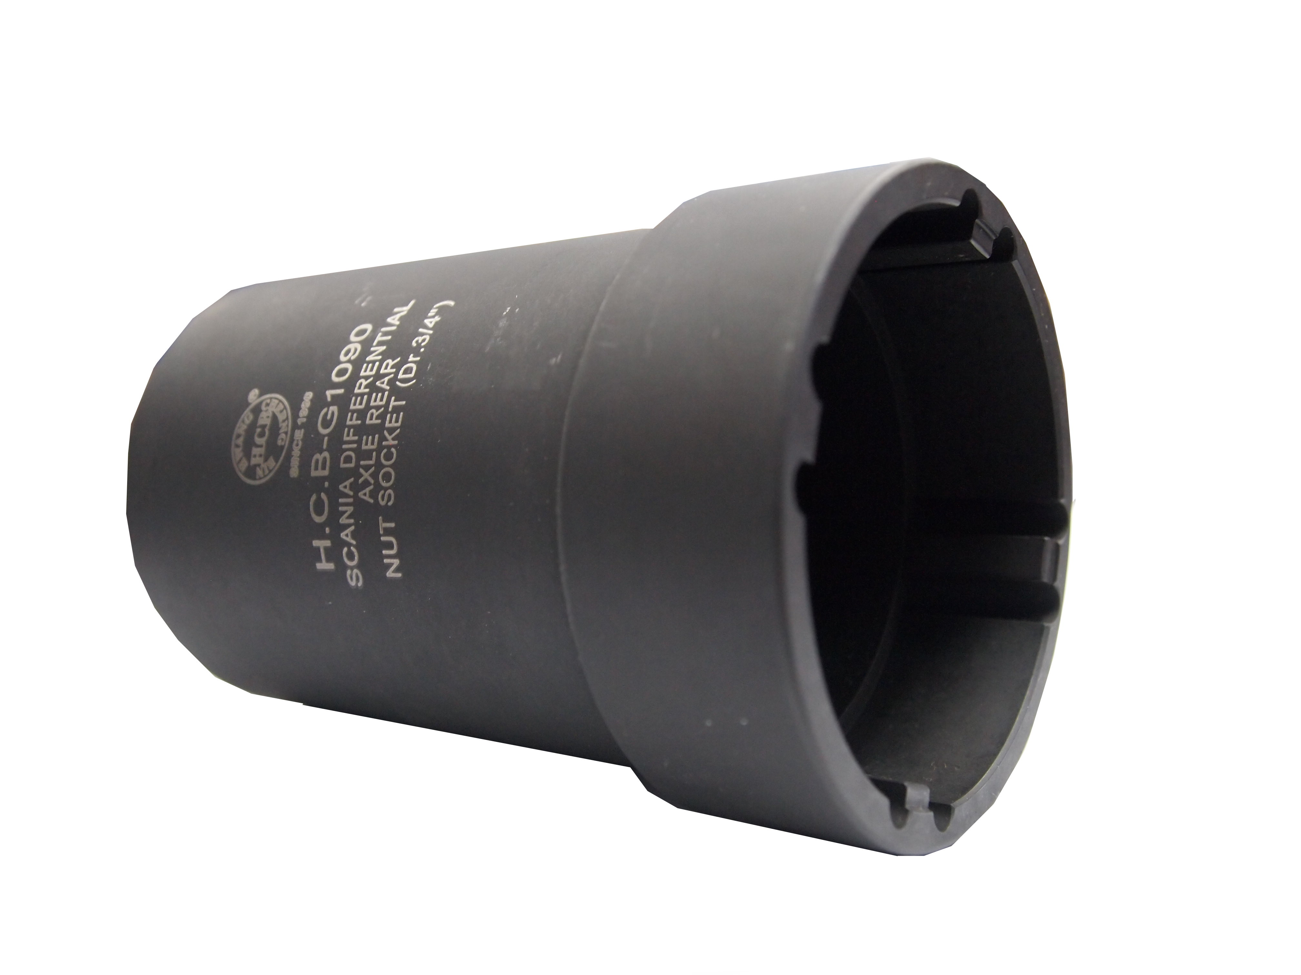

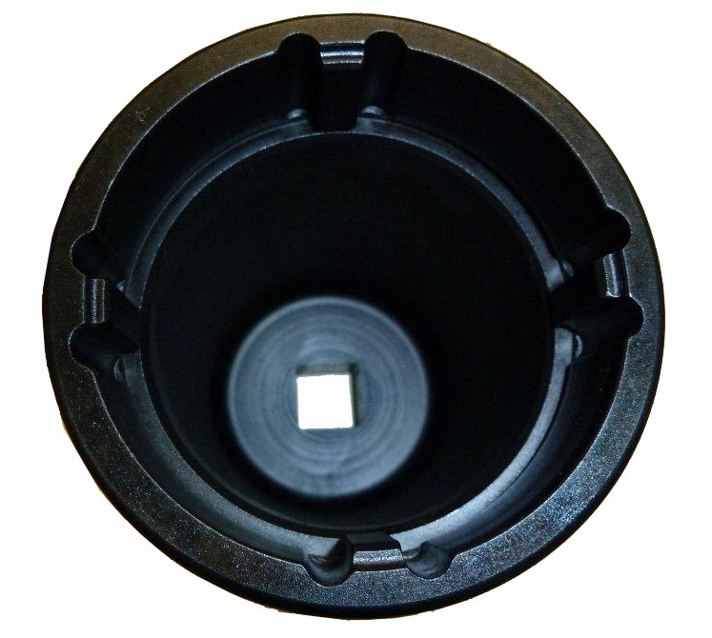
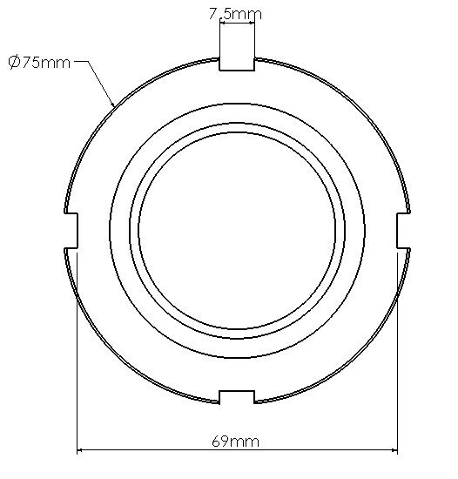

Genuine no. of tool: 98480
NUT SIZE
- For removing/installing differential rear pinion nut.
- Genuine stock : 1338267
- Applicable: SCANIA (3- series) differential gear rear nut. EX: RB660, RB662, RBP735/835…

