
H.C.B-E1766
CUMMINS B & C SERIES REAR CRANKSHAFT SEAL/WEAR SLEEVE INSTALLER - (*3824078) 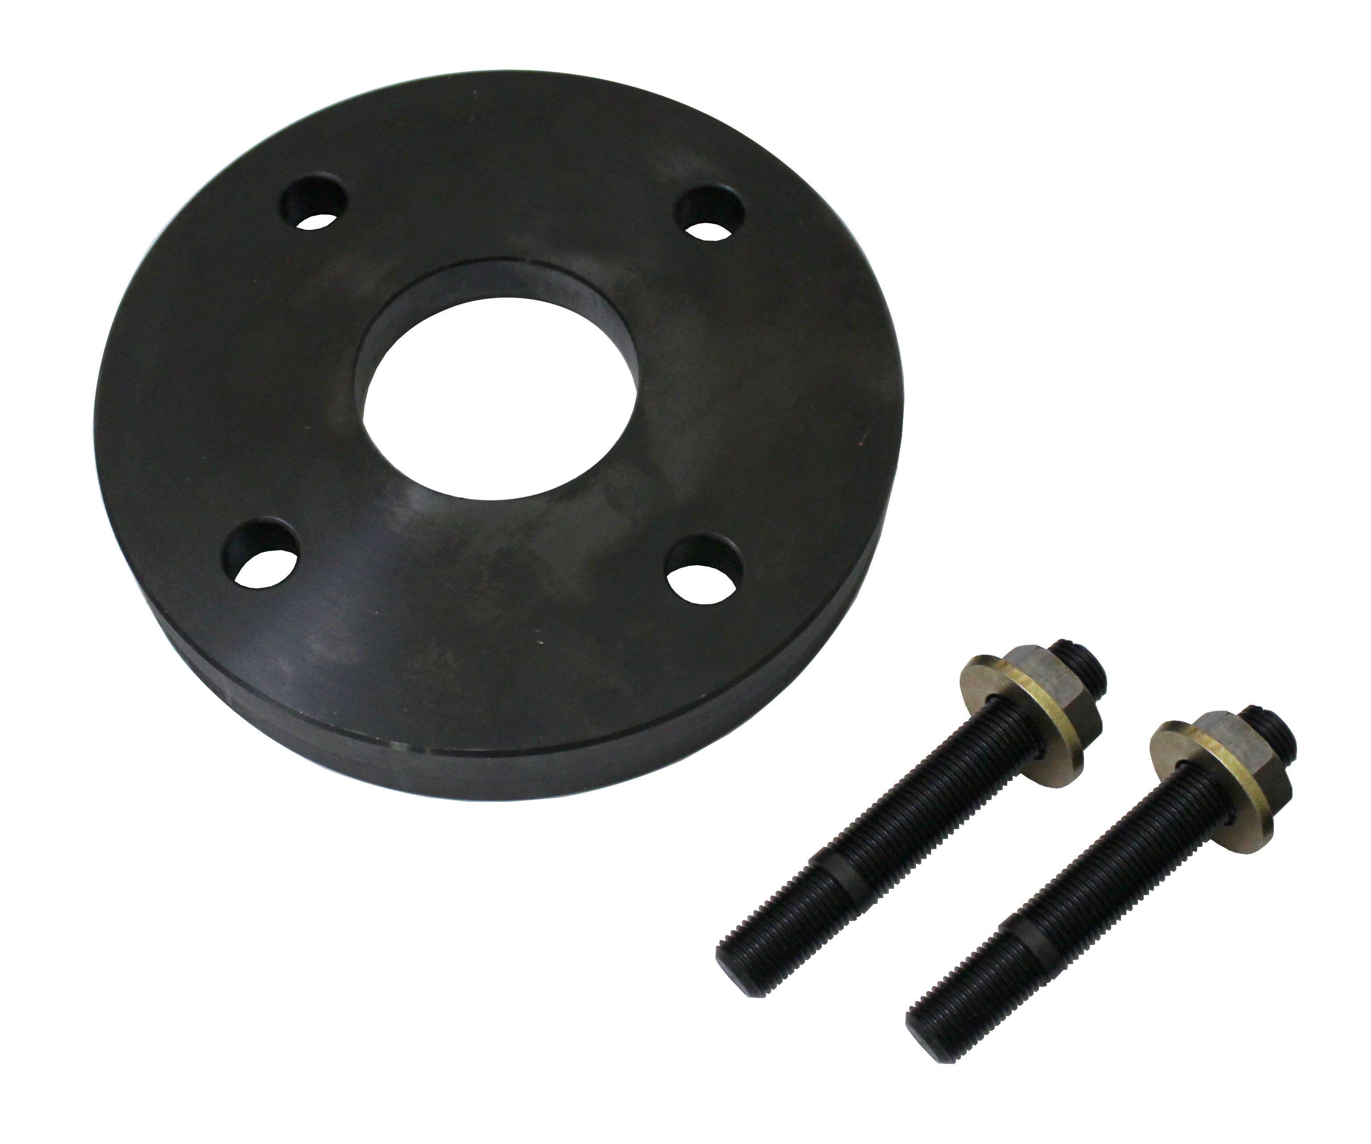

- Applications : Cummins B & C series, ISC, ISL, and the 8.3 L..

