
H.C.B-E1337
CUMINS (EURO 4) / DAF (LF 65) 17 TONS ENGINE FIXING BASE

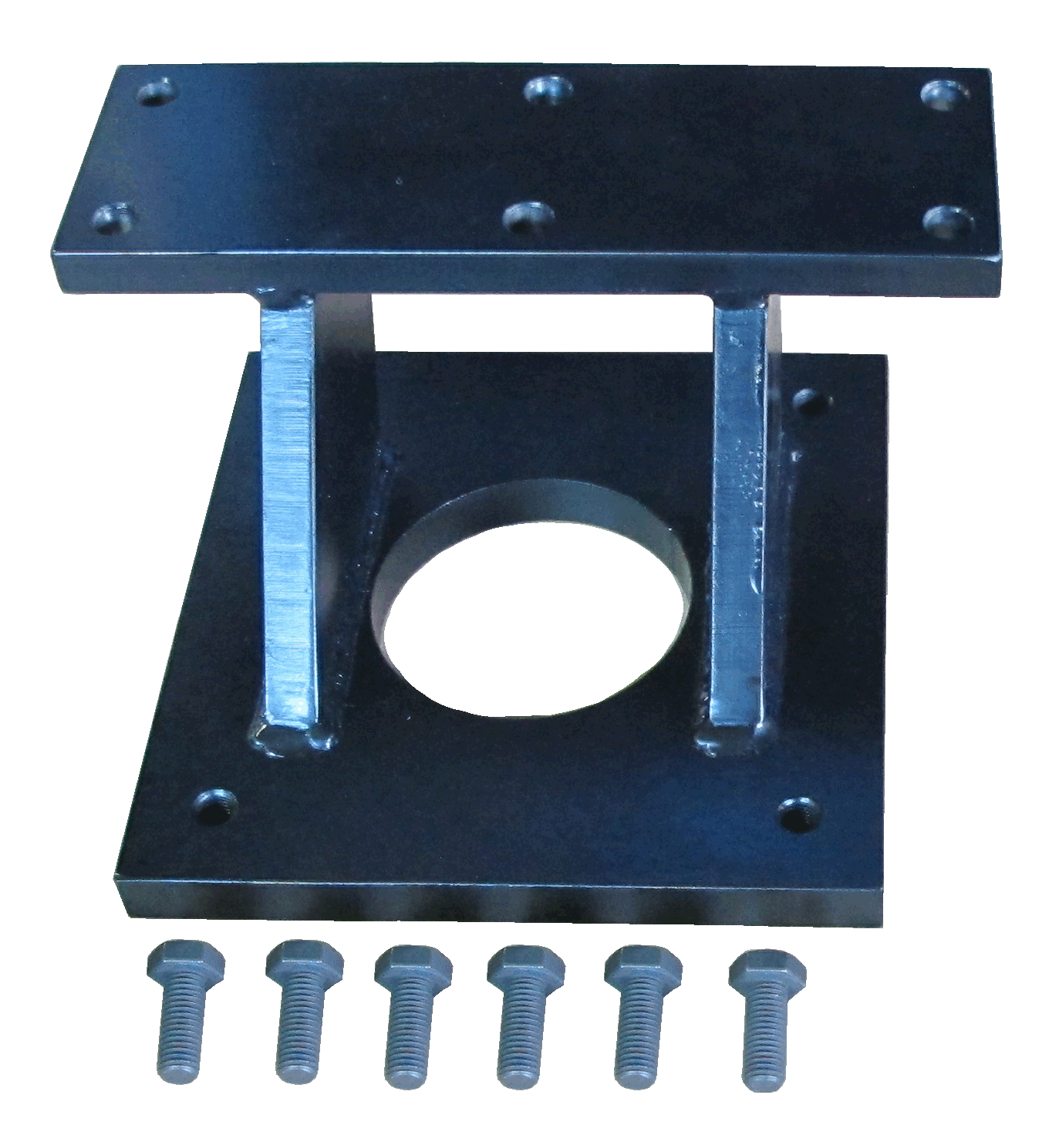

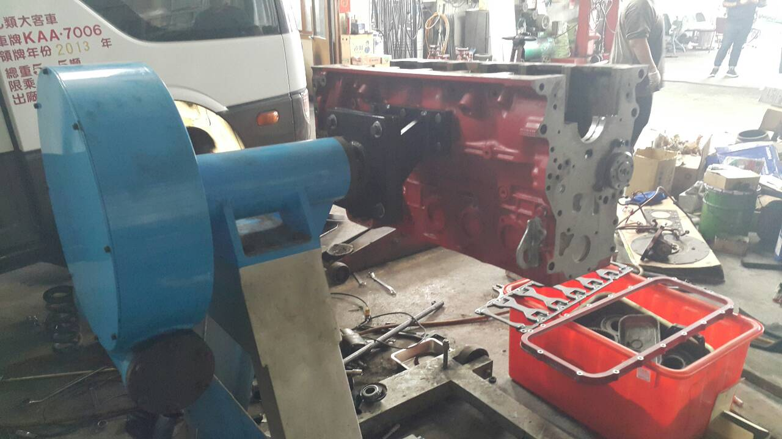
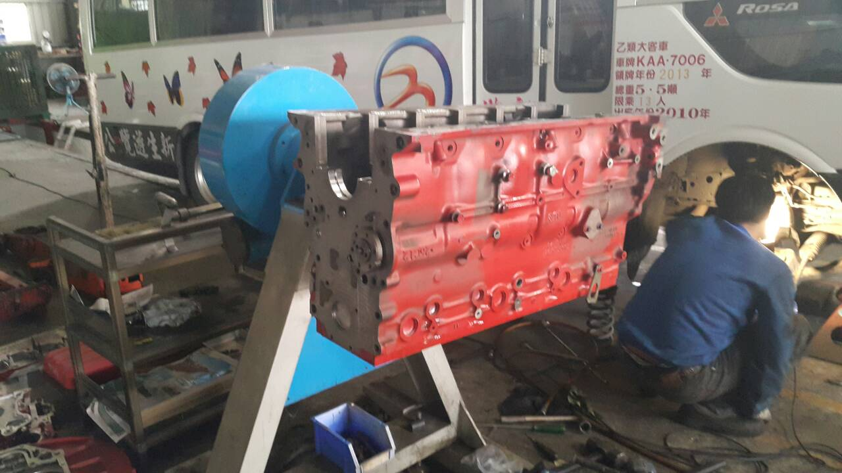

■ Please conbined with H.C.B-A1337.
■ Application: Cumins (Euro 4)/ DAF (LF 65) 17 TONS
■ Screw size : M12*P1.75*35 L (Q’ty: 6 pcs)

