
H.C.B-E1090
SCANIA PTO NUT SOCKET (Dr. 1/2”)
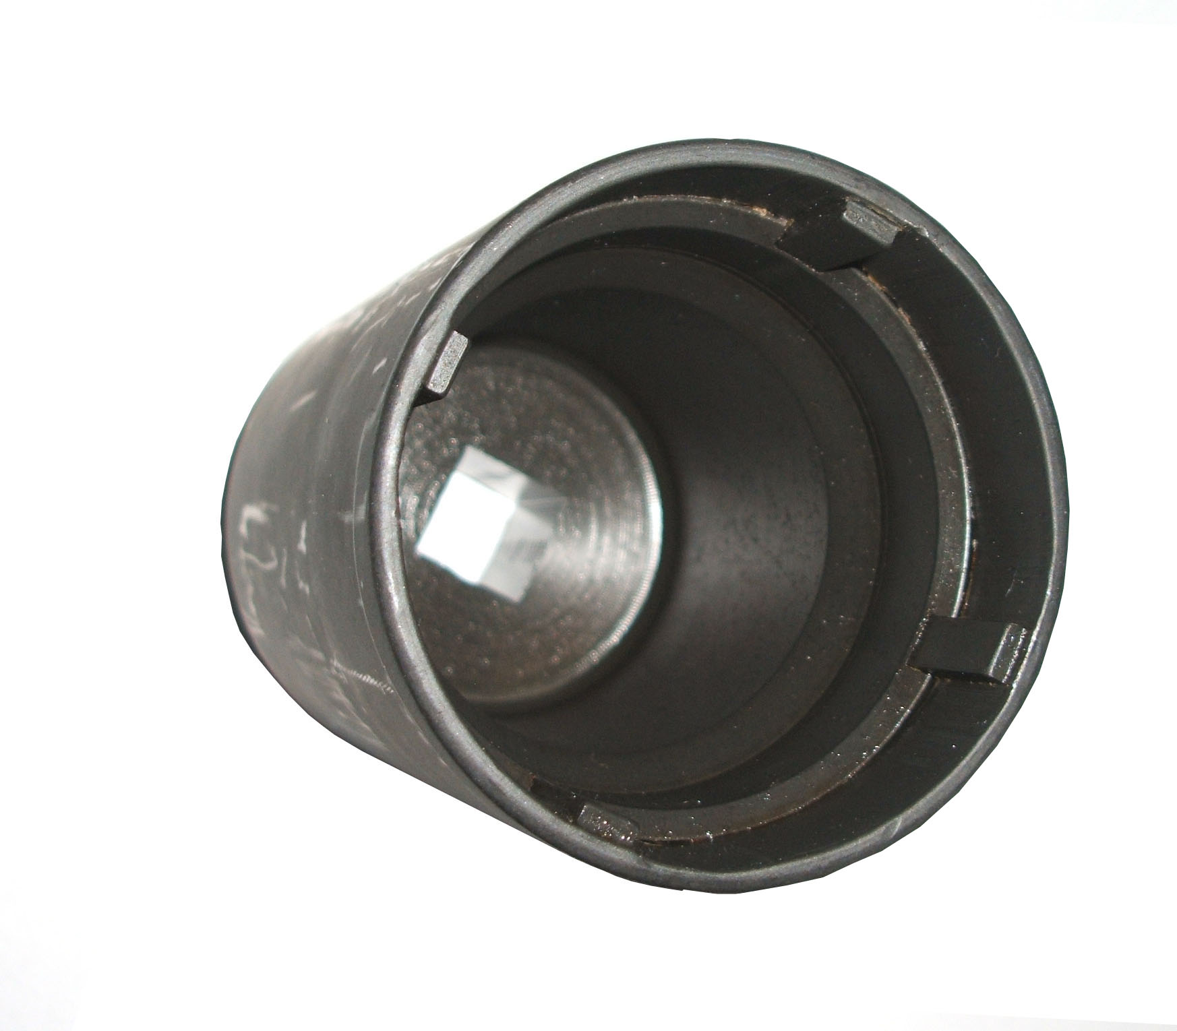
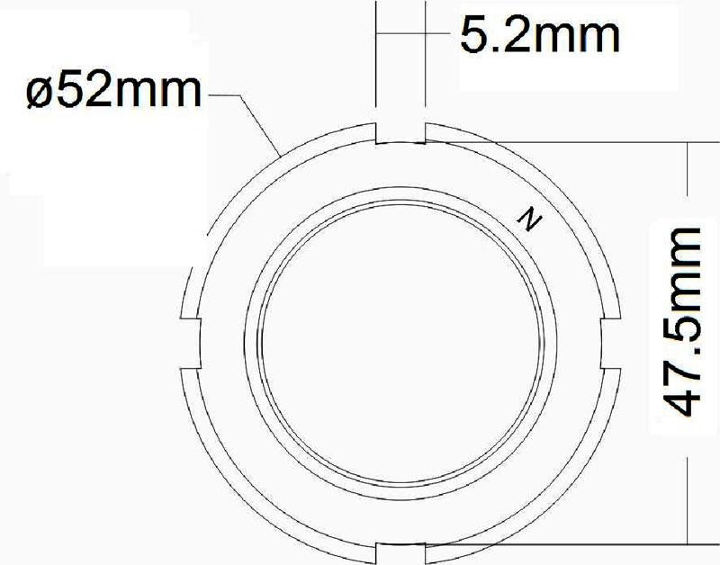

Dr. 1/2”
NUT SIZE

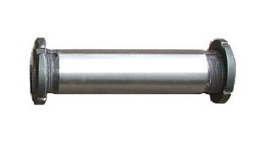
Genuine stock＜98550＞

▓ For removal / replacement of the SCANIA hauler tractor truck PTO nut, also for third axle hanger nut on the trailer.

H.C.B-E1090
SCANIA PTO NUT SOCKET (Dr. 1/2”)

Dr. 1/2”
NUT SIZE

Genuine stock＜98550＞

▓ For removal / replacement of the SCANIA hauler tractor truck PTO nut, also for third axle hanger nut on the trailer.

