
H.C.B-D1693
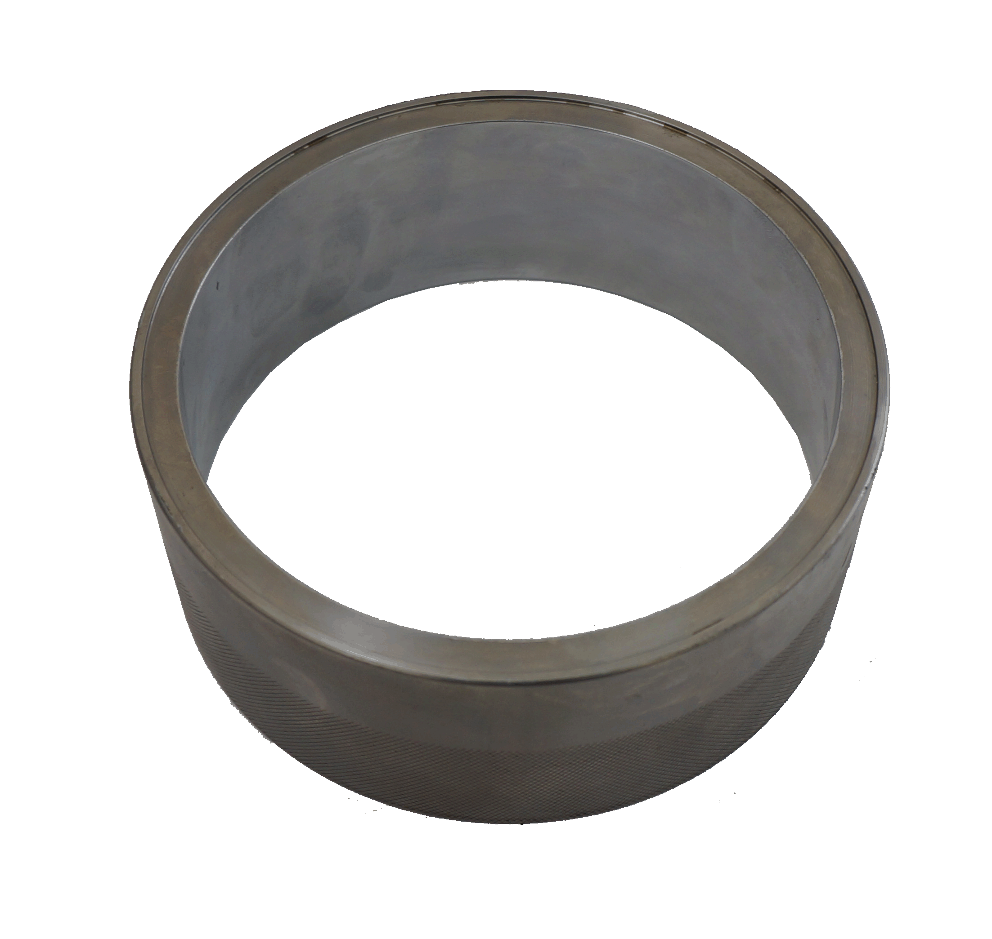
VOLVO (FM 500) (EURO 5) TRUCK PISTON RING INSTALLATION SLEEVE

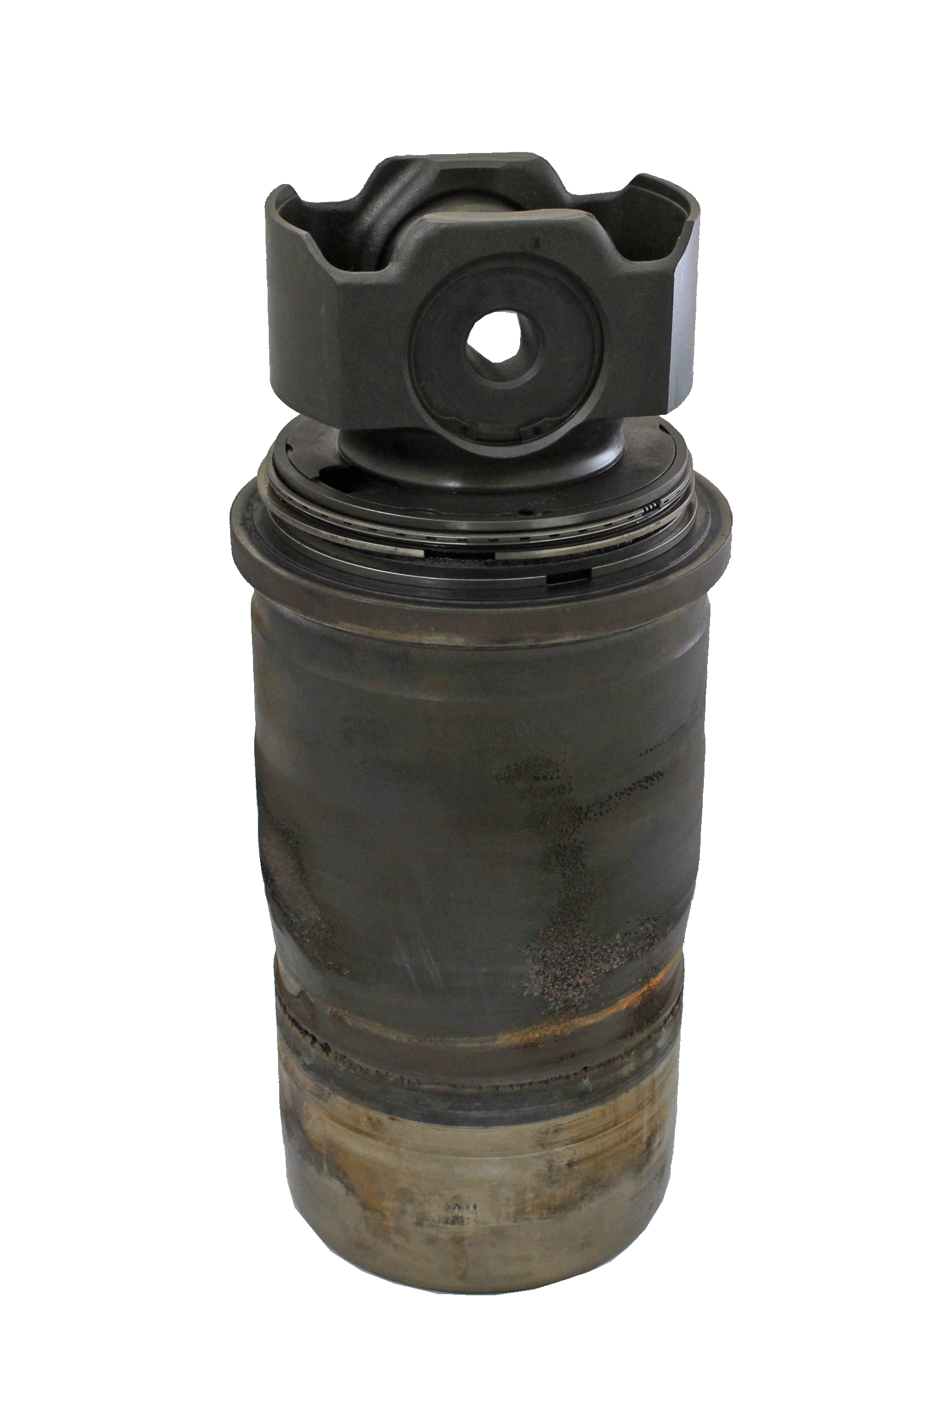

■ Special design of cone tool make piston ring into cylinder sleeve easily, save time and labor!
■ Used to guide the piston into the cylinder sleeve during piston installation.
■ Application: Volvo (FM 500) (EURO 5) Truck

