
H.C.B-D1690
Hendrickson Tri-Functional Narrow Bushing Adapter (Width)
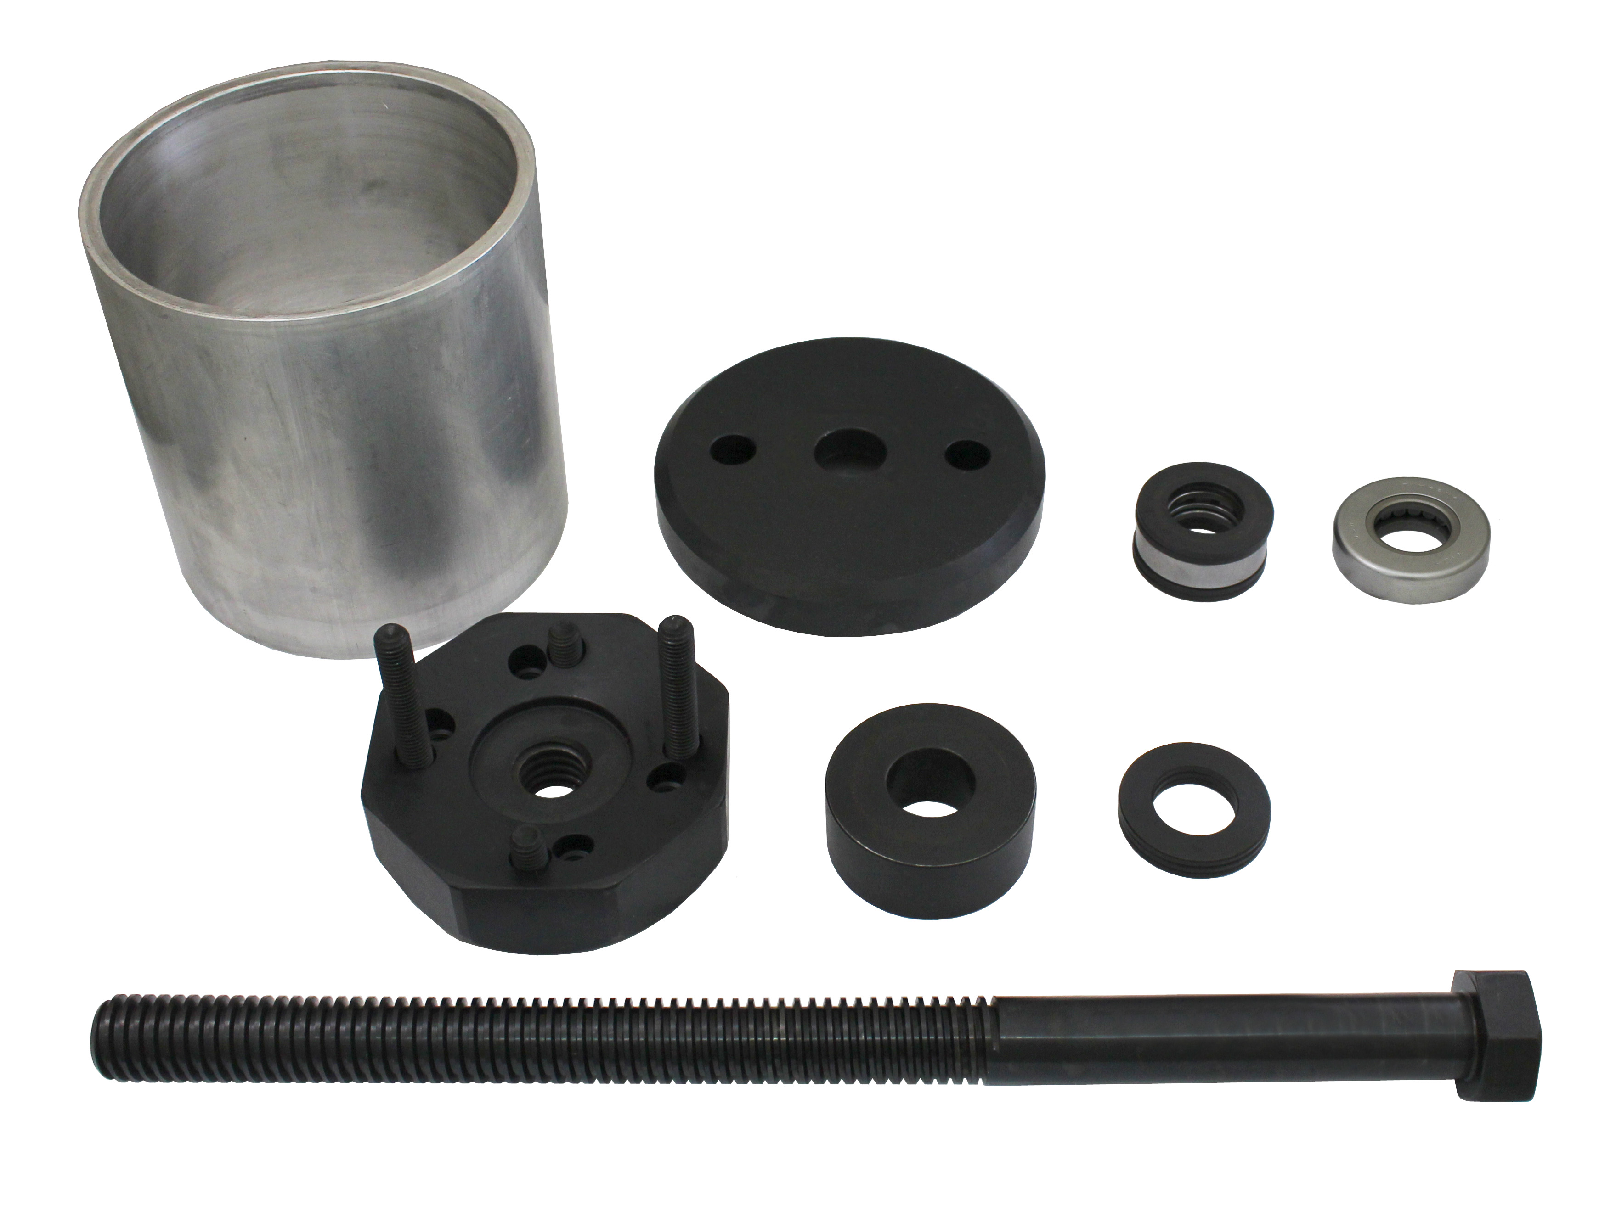
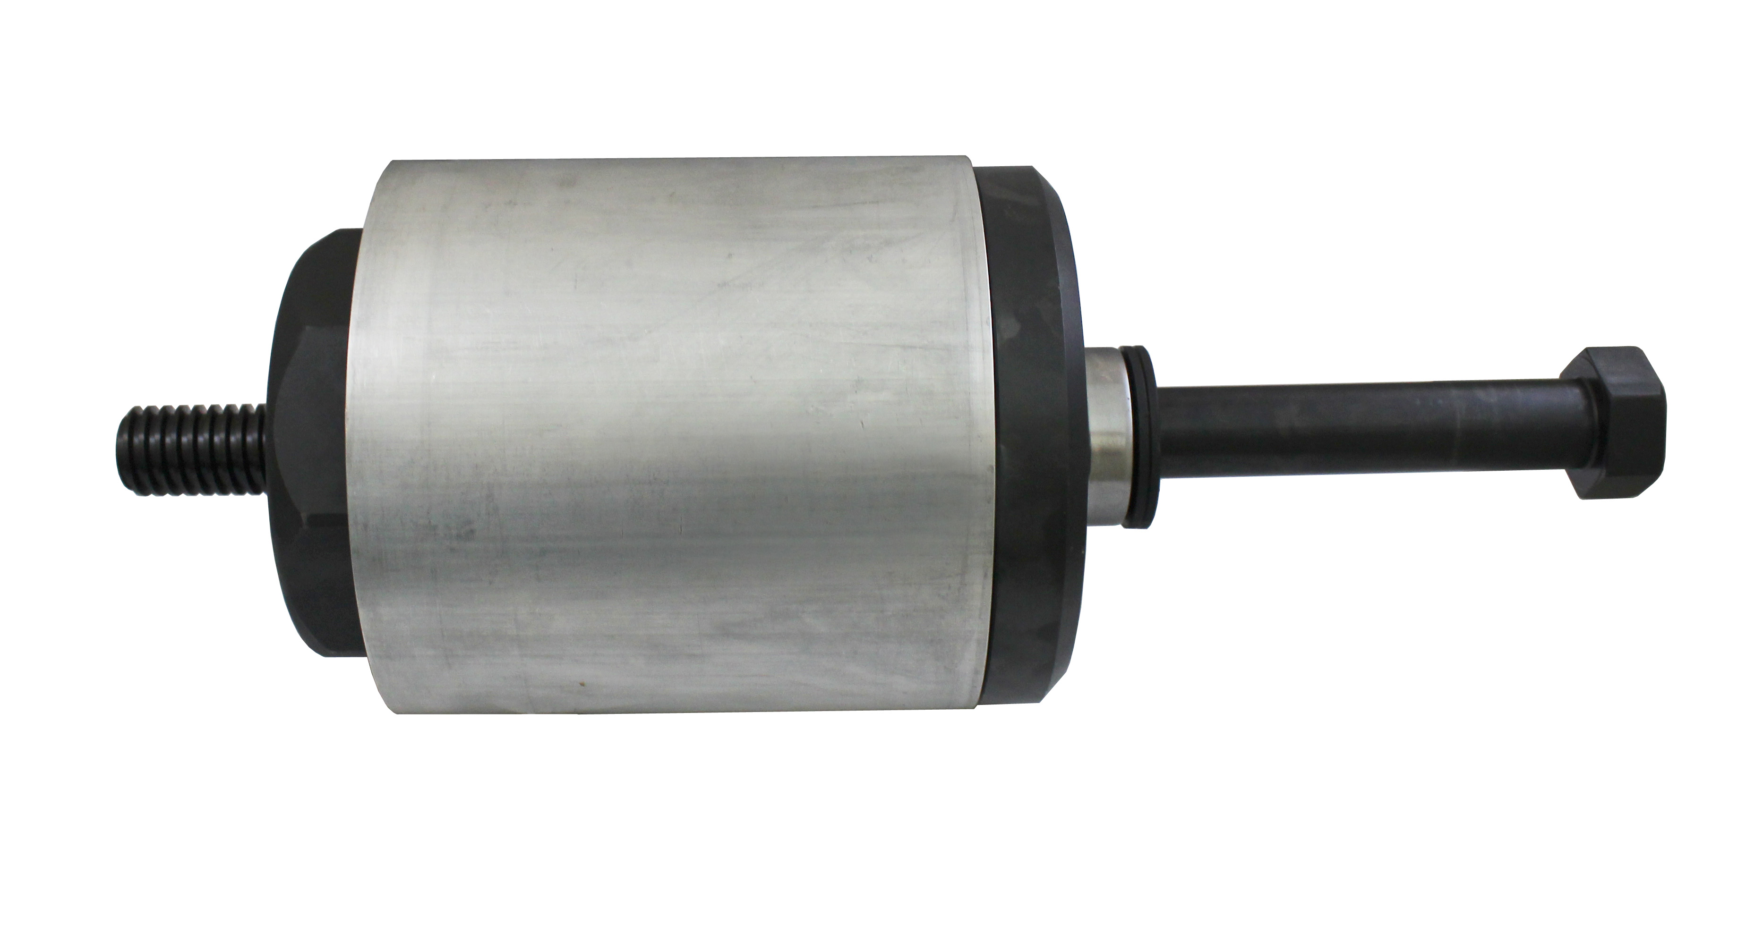

- Easily remove and install the Hendrickson Intraax Tri-Functional bushing while the suspension remains on the trailer.

