
H.C.B-D1552
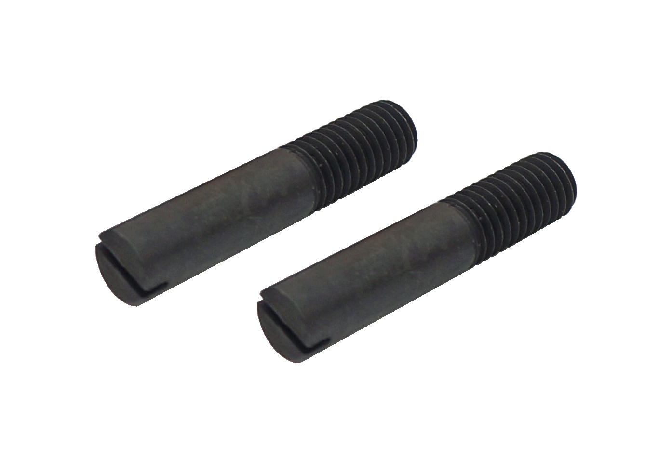
VW/ AUDI 7-SPEED DUAL CLUTCH GEARBOX GUIDE BOLTS

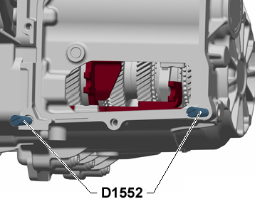

- To guide the mechatronic component during the mounting of the
mechatronic unit.
- Application:
Golf 2004 >, Golf 2009 >, Golf Plus 2005 >, Touran 2004 >,
Audi A3 2004 >, Eos 2006 >, Passat 2006 >, Passat CC 2009 >,
Scirocco 2009 >
7-speed dual clutch gearbox 0AM
- VW OEM no. ref.: T10406
H.C.B-D1552
VW/ AUDI 7-SPEED DUAL CLUTCH GEARBOX GUIDE BOLTS

- To guide the mechatronic component during the mounting of the
mechatronic unit.
- Application:
Golf 2004 >, Golf 2009 >, Golf Plus 2005 >, Touran 2004 >,
Audi A3 2004 >, Eos 2006 >, Passat 2006 >, Passat CC 2009 >,
Scirocco 2009 >
7-speed dual clutch gearbox 0AM
- VW OEM no. ref.: T10406

