
H.C.B-D1181
TRUCK SPRING PIN METAL BUSH
REMOVAL / INSTALLATION TOOL KIT
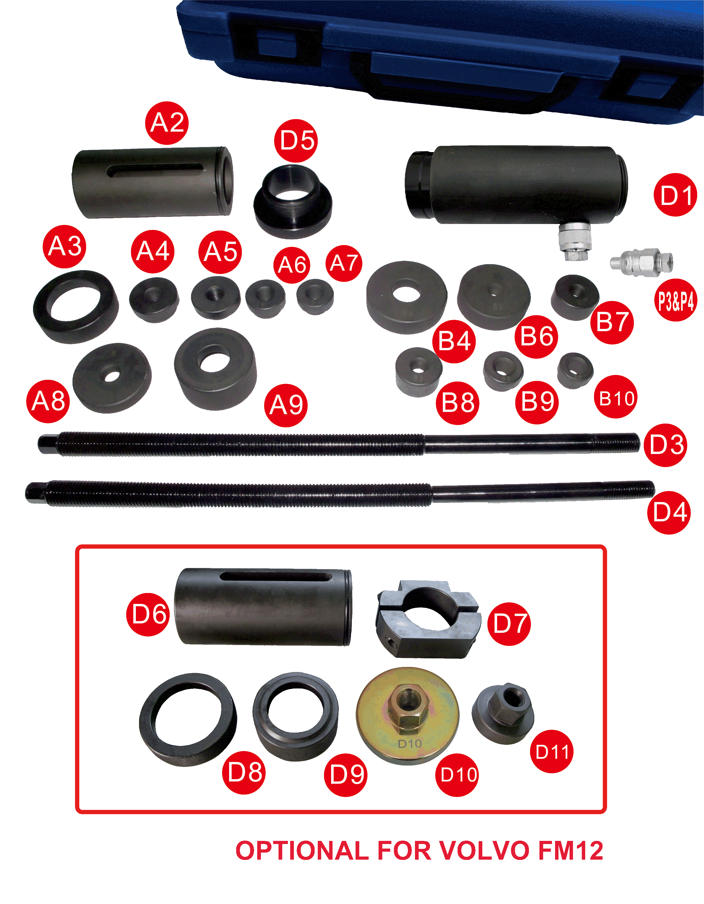

(17 TONS HYDRAULIC CYLINDER)
VIDEO

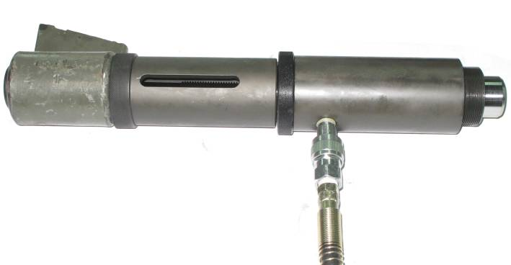  REMOVAL | 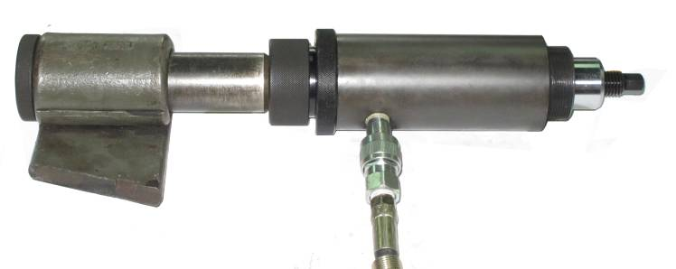  INSTALLATION
- Powerful 17 tons hydraulic cylinder helps to remove stubborn spring pins easily.
- Component No. 4~7, 9~11 is applicable for SCANIA & VOLVO trucks.
- Component No. B4, B6~B14 is applicable for ISUZU, FUSO, TOYOTA, MEDIUM-SIZED WAGON & PICKUP.
- Common parts No. 1, 2, 3 and 8
- To replace spring pin more easily. Money and labor saver.
- Optional accessory: H.C.B-B1129 HYDRAULIC HAND PUMP.
VOLVO FM12 SPRING PIN METAL BUSH REPLACEMENT:
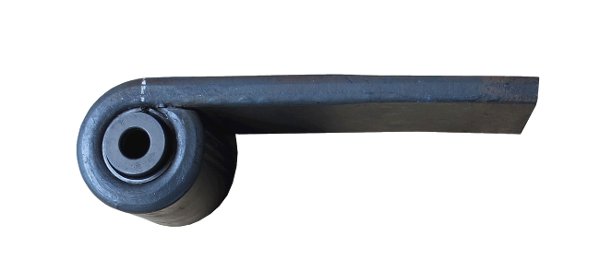
THE BUSH FROM VOLVO FM12
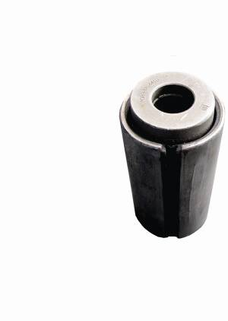
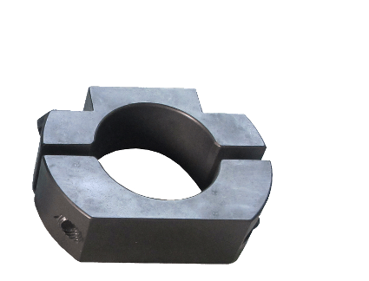
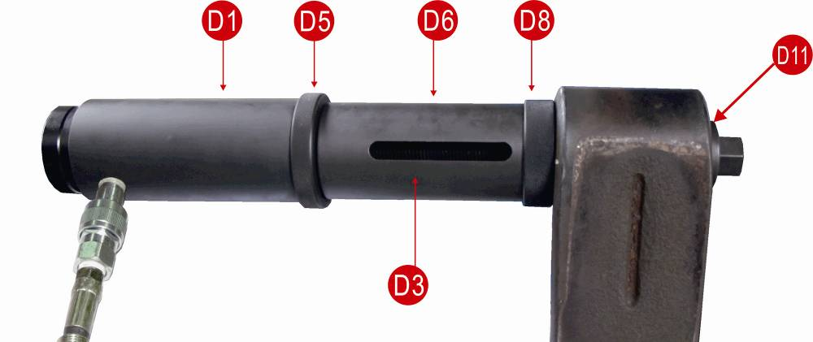
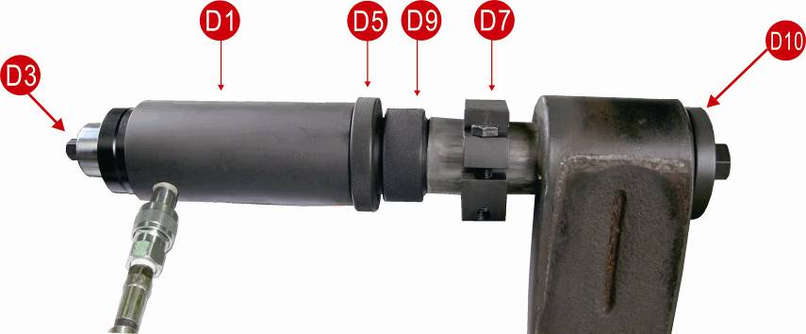
EXTRACTION:
Refer to Fig.1 Assemble components as shown.
It will take three times to extract metal bush.
INSERTION:
Refer to Fig.2 and Fig.3 ,Assemble components as shown.

Refer to Fig.2: fit new bush to clamp of component D7.

It takes three times to complete bush installation.Once new bush contacts 1/3 the hub,unwind D7 screws to loosen,then remove.Continue installing to fully fit the new bush.
Fig.1
D7
Fig.2
Fig.3

