
H.C.B-C9091

MAN DIFFERENTIAL NUT SOCKET
(H64.7, 12POINT, 1)

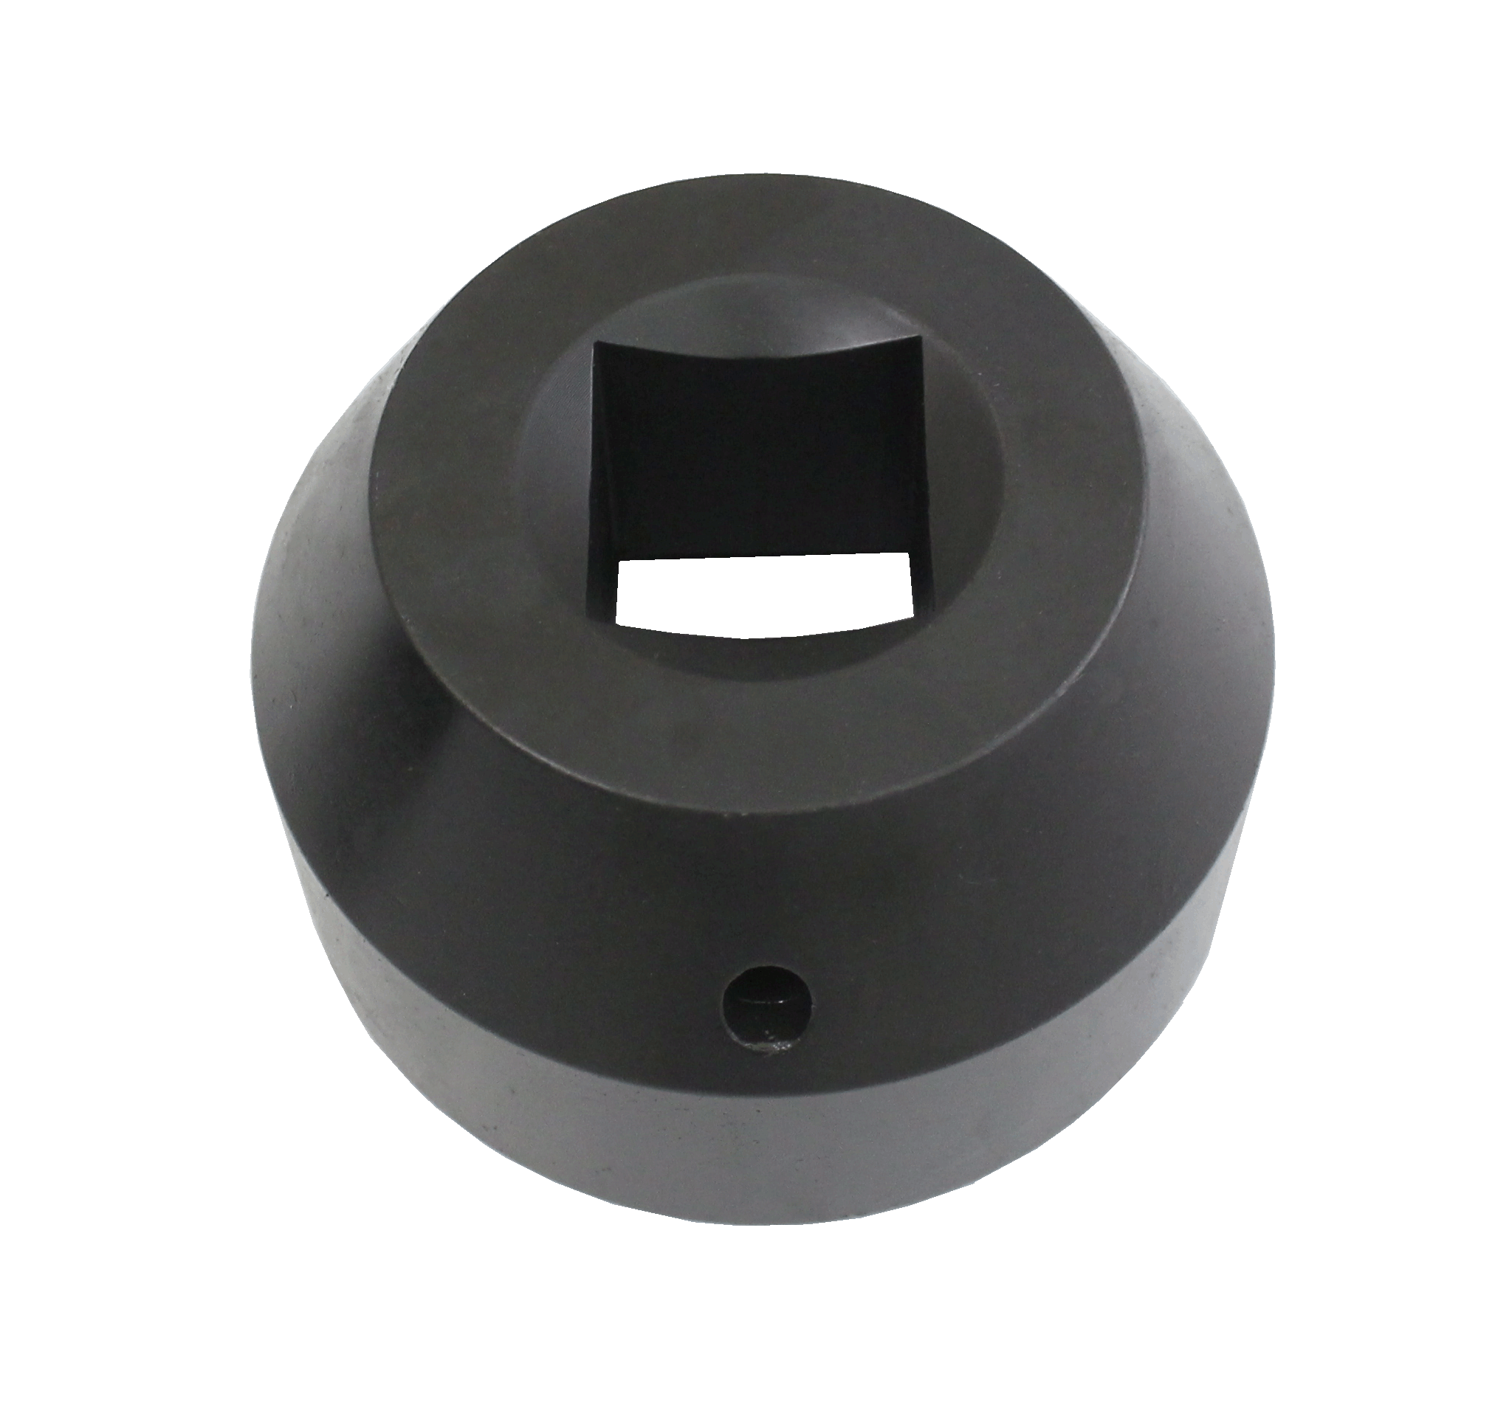
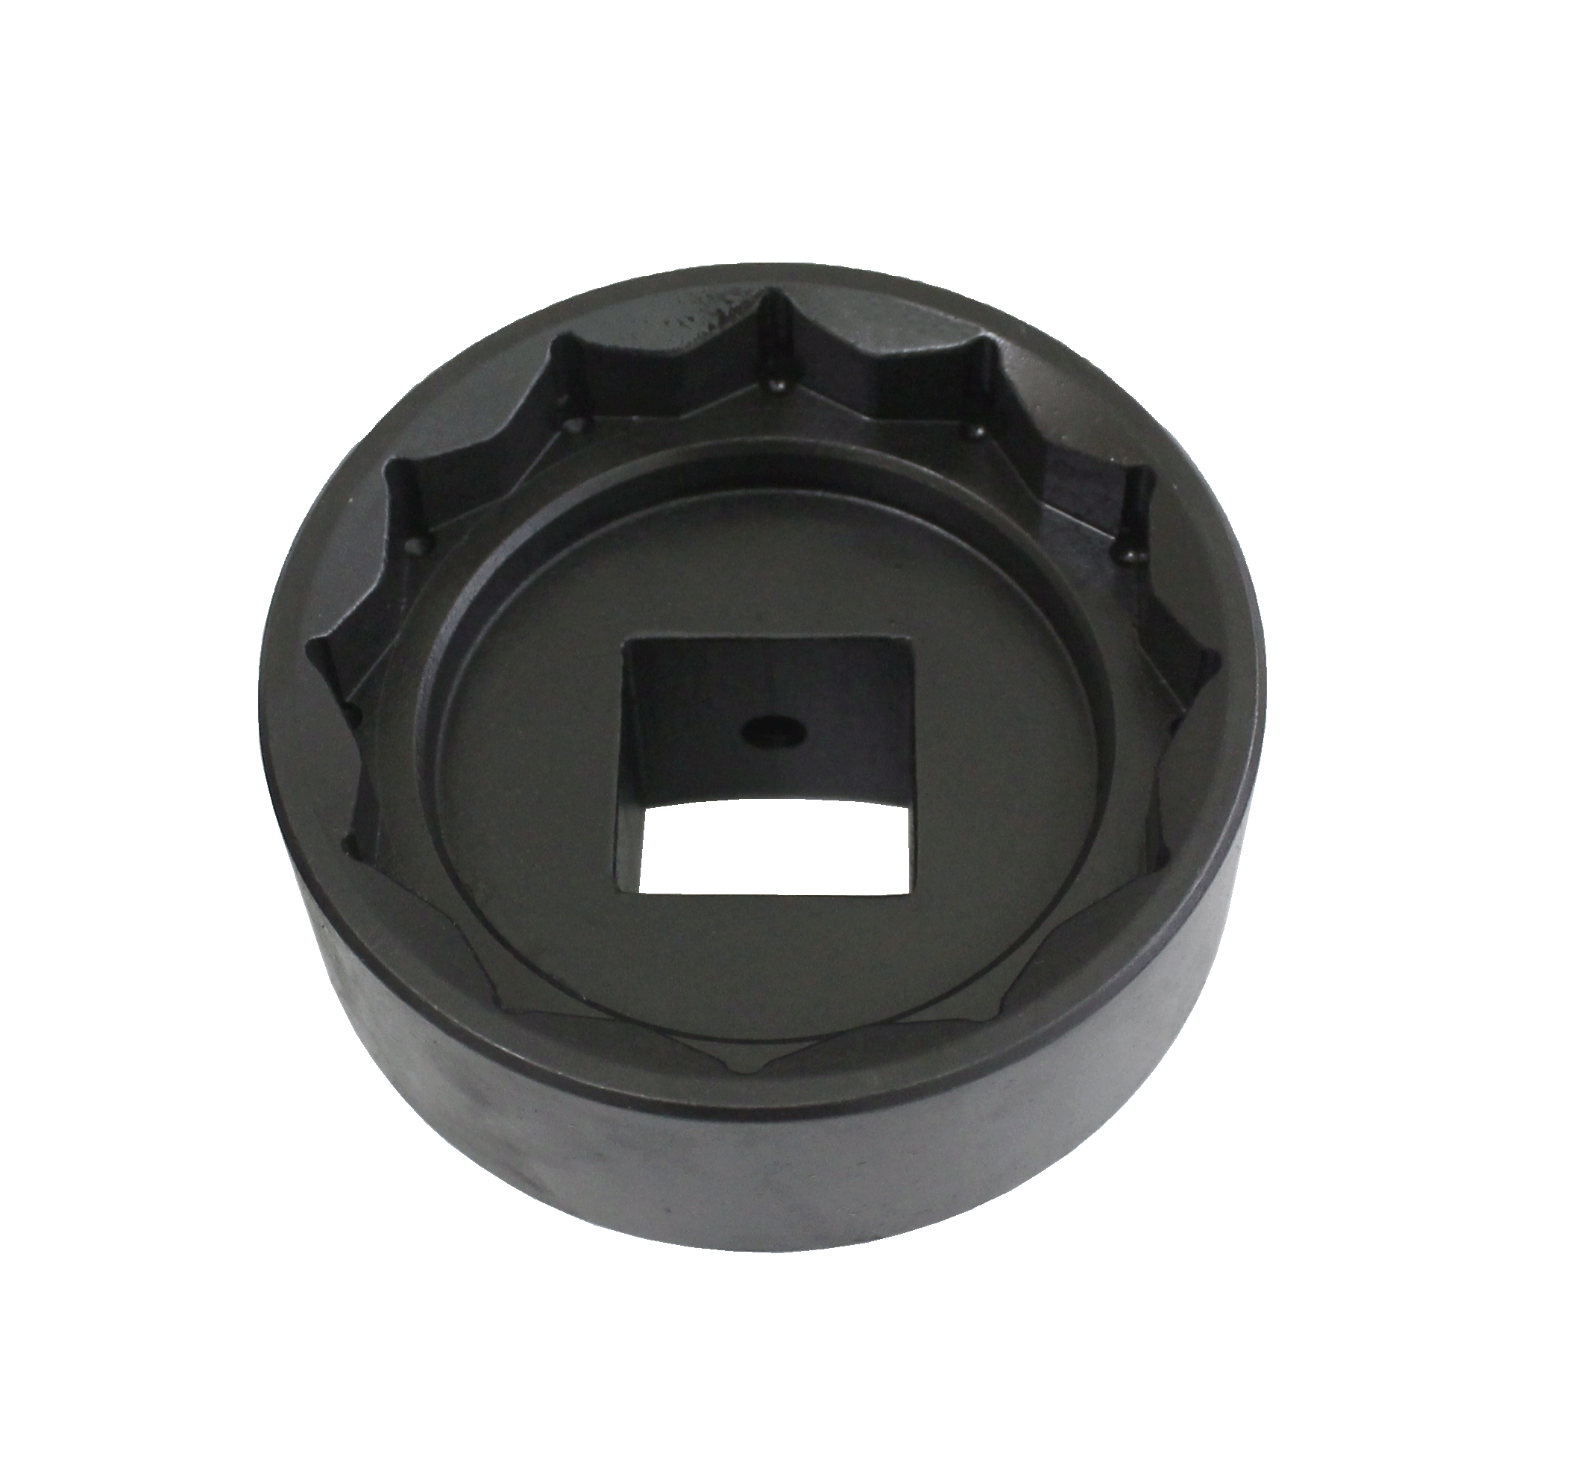

- Application: MAN/MERCEDES TRUCK
- Size: (H64.7, 12POINT, 1" )
- Nut no. ref: 9463510072
- MAN oem no. ref : 80996030176

H.C.B-C9091

MAN DIFFERENTIAL NUT SOCKET
(H64.7, 12POINT, 1)

- Application: MAN/MERCEDES TRUCK
- Size: (H64.7, 12POINT, 1" )
- Nut no. ref: 9463510072
- MAN oem no. ref : 80996030176

