
H.C.B-C9020
VOLVO MP7 D11 REAR CRANKSHAFT SEAL INSTALLER DRIFT TOOL (SLIDE IN STYLE)
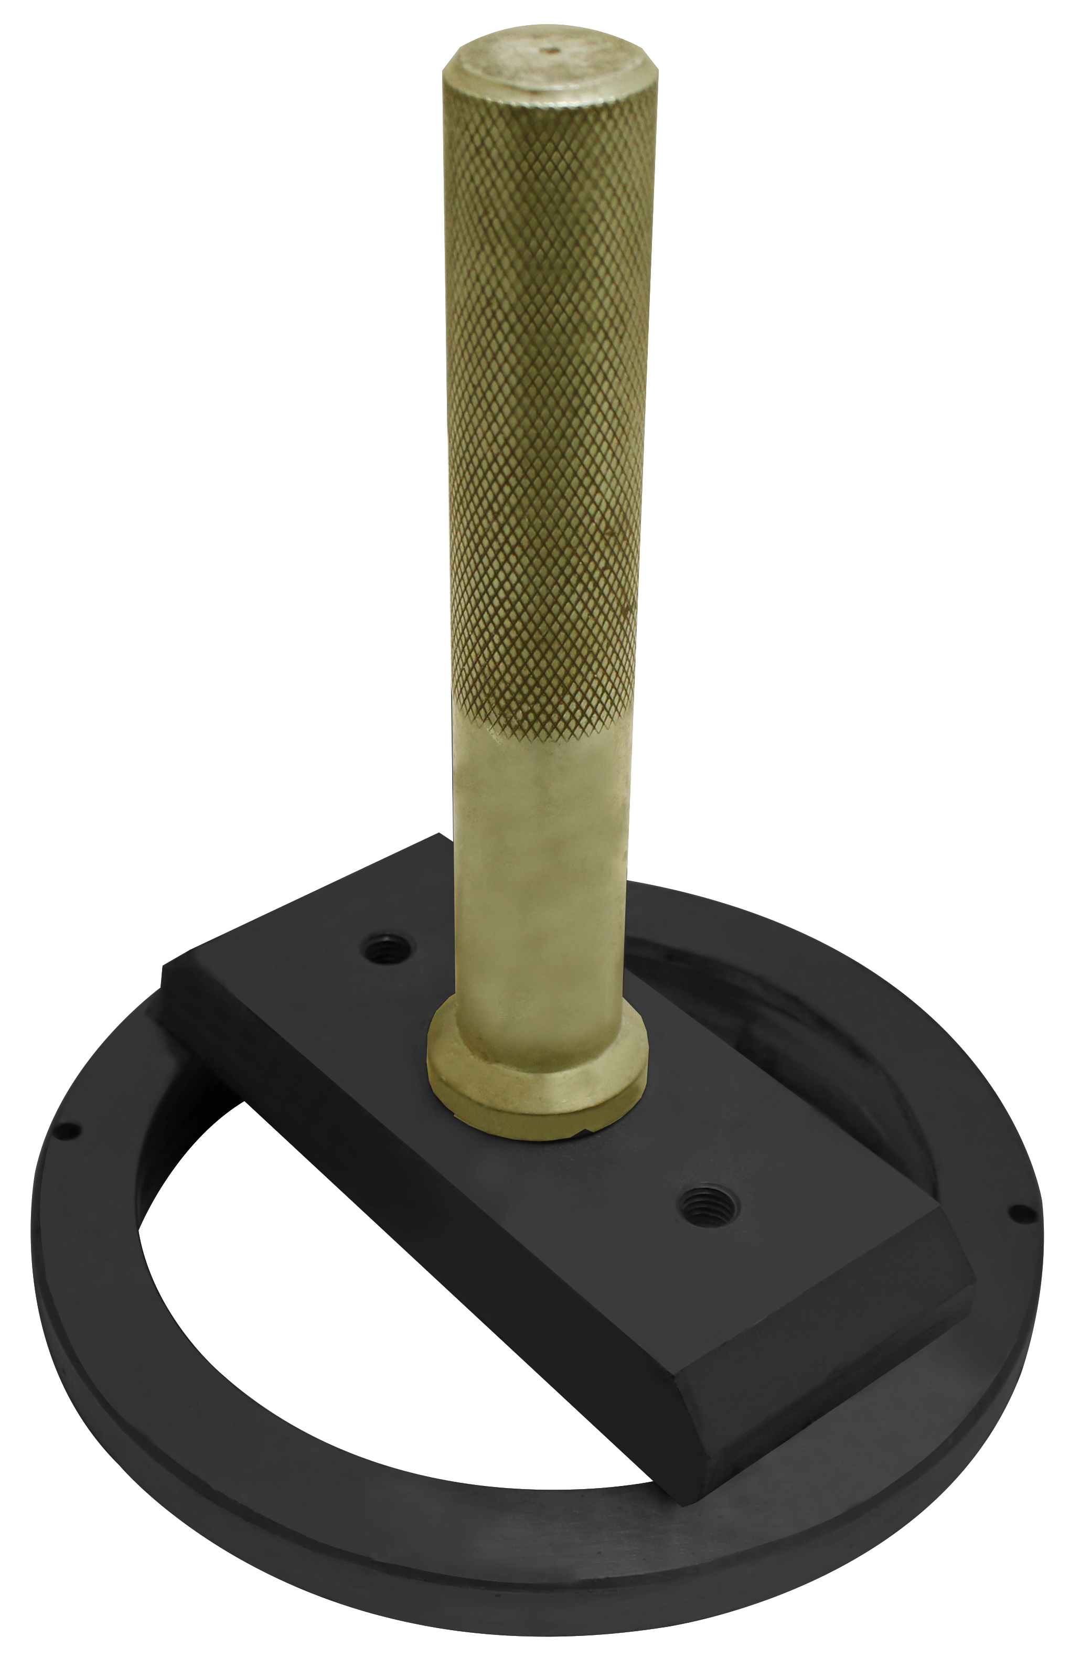

- When installing the oil seal, you won't damage the oil seal. With this tool kit will make repair be more convenient and easier.
- Application:: Mack Pinnacle MP7 11L from 2009-2016 Volvo Vectro D11 11L from 2009-2016
- OEM no. ref.: 9990113, 9992000

- Seal # : 20705740

