
H.C.B-C9018
LINER HEIGHT GAUGE
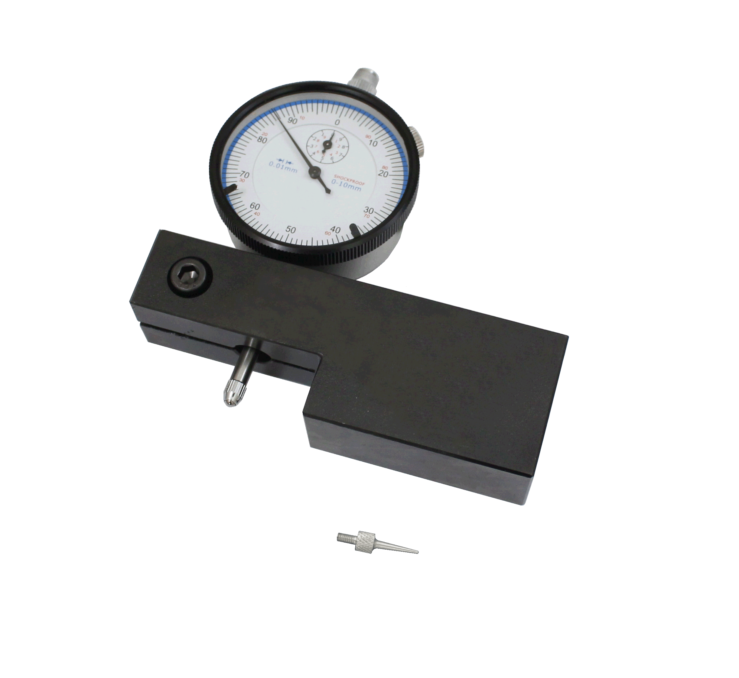

- Designed for use on variety of engine such as Cummins , Caterpillar.
- It accurately measures cylinder bore flatness and depth.
- OEM ref. :1P-2402

