
H.C.B-C2230
3/4" SQ. DRIVE HEXAGON & TX-STAR IMPACT BIT SOCKET KIT(9 PCS) (61mm) (19/21/22/23/24mm/T70/80/90/100)

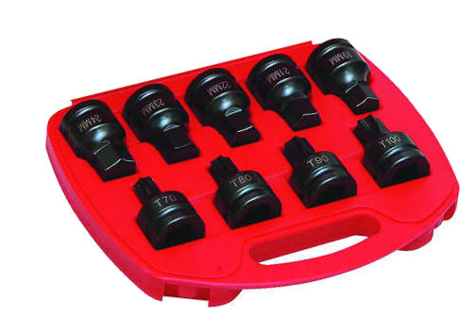

- Material : CR-MO with special blue finish or manganese phosphate
- Overall Length: 61mm
- Size: 5 - Hexagon: 19-21-22-23-24mm
4 - TX-Star: T70-80-90-100
- Durable Chrome Molybdenum steel gives optimum balance between hardness and flexibility.
- Suitable for use with any impact tool.

H.C.B-C2230
3/4" SQ. DRIVE HEXAGON & TX-STAR IMPACT BIT SOCKET KIT(9 PCS) (61mm) (19/21/22/23/24mm/T70/80/90/100)

- Material : CR-MO with special blue finish or manganese phosphate
- Overall Length: 61mm
- Size: 5 - Hexagon: 19-21-22-23-24mm
4 - TX-Star: T70-80-90-100
- Durable Chrome Molybdenum steel gives optimum balance between hardness and flexibility.
- Suitable for use with any impact tool.

