
H.C.B- C1789
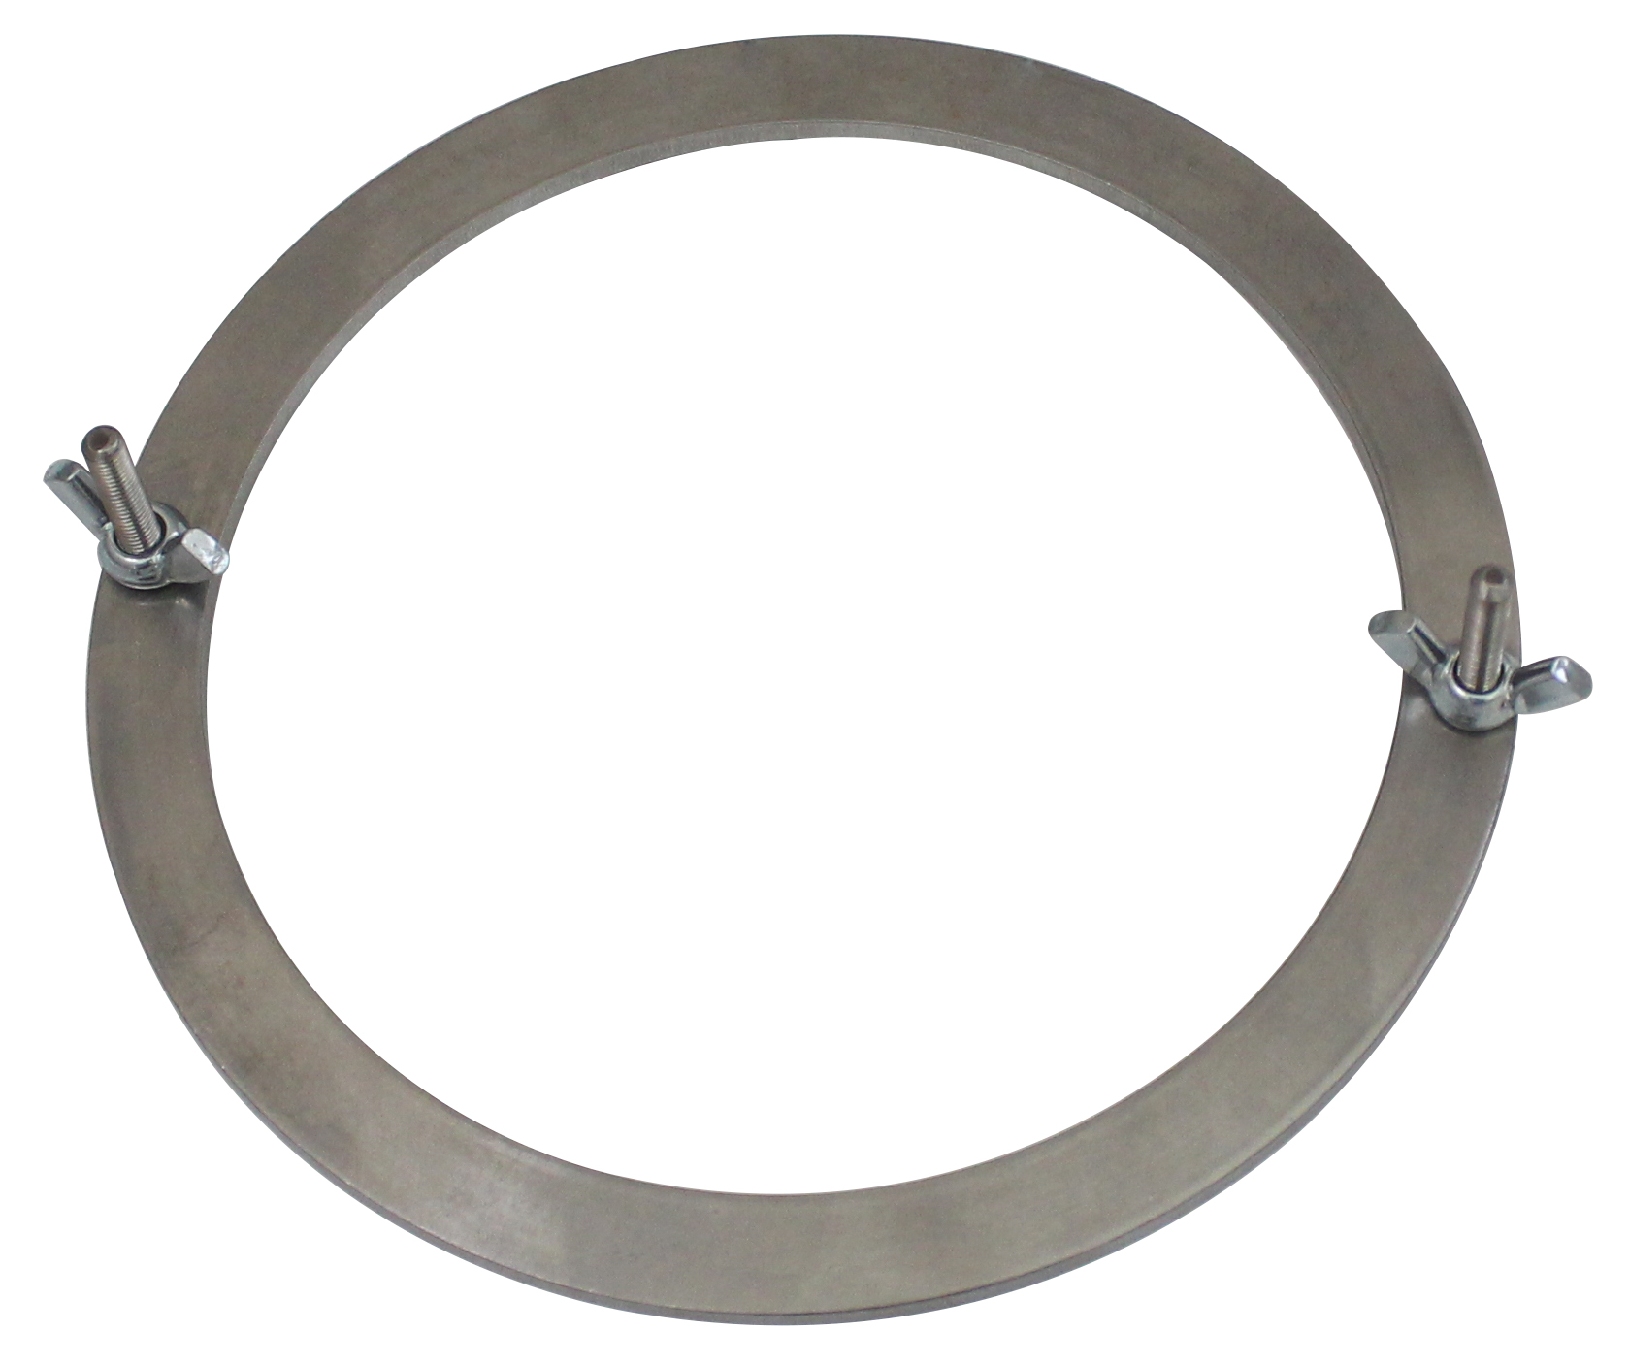
MERCEDES TRUCK (DD13/DD15) DIESEL ENGINE FRONT CRANKSHAFT OIL SEAL INSTALLATION RING TOOL

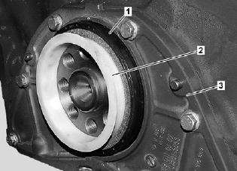

■When installing the new wax-coated front seal, do not use any lubrication. There is a new installation ring C1789, to be used in conjunction with installer/remover tool A1789
■ The new installation ring tools installs the seal to the correct depth.
■ OEM No.ref: W 541 589 00 34 00
■ Application: DD13 and DD15
5

