
H.C.B-C1766
CUMMINS B SERIES FRONT CRANKSHAFT SEAL INSTALLER - (*3824498)
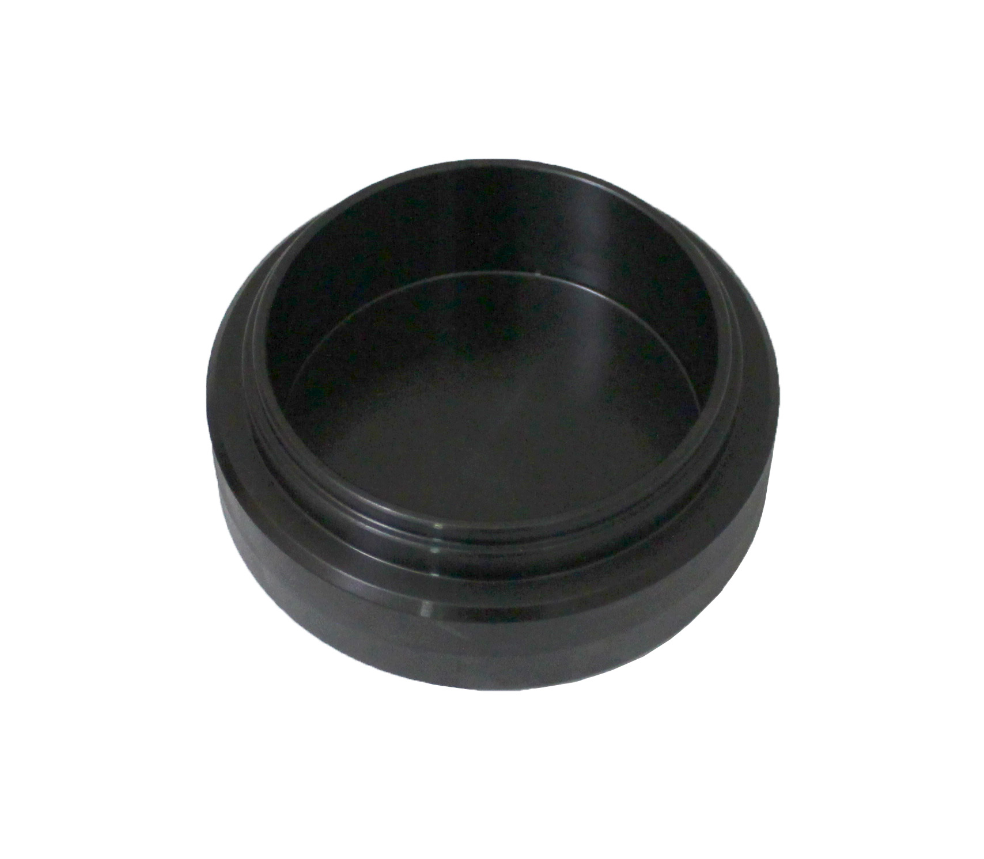

- Applications: Paccar PX-6, 1989-2016 Cummins 4BT 3.9L, B Series 5.9L, ISB 5.9L 6.7L and QSB 5.9L 6.7L.

