

**H.C.B-C1715**

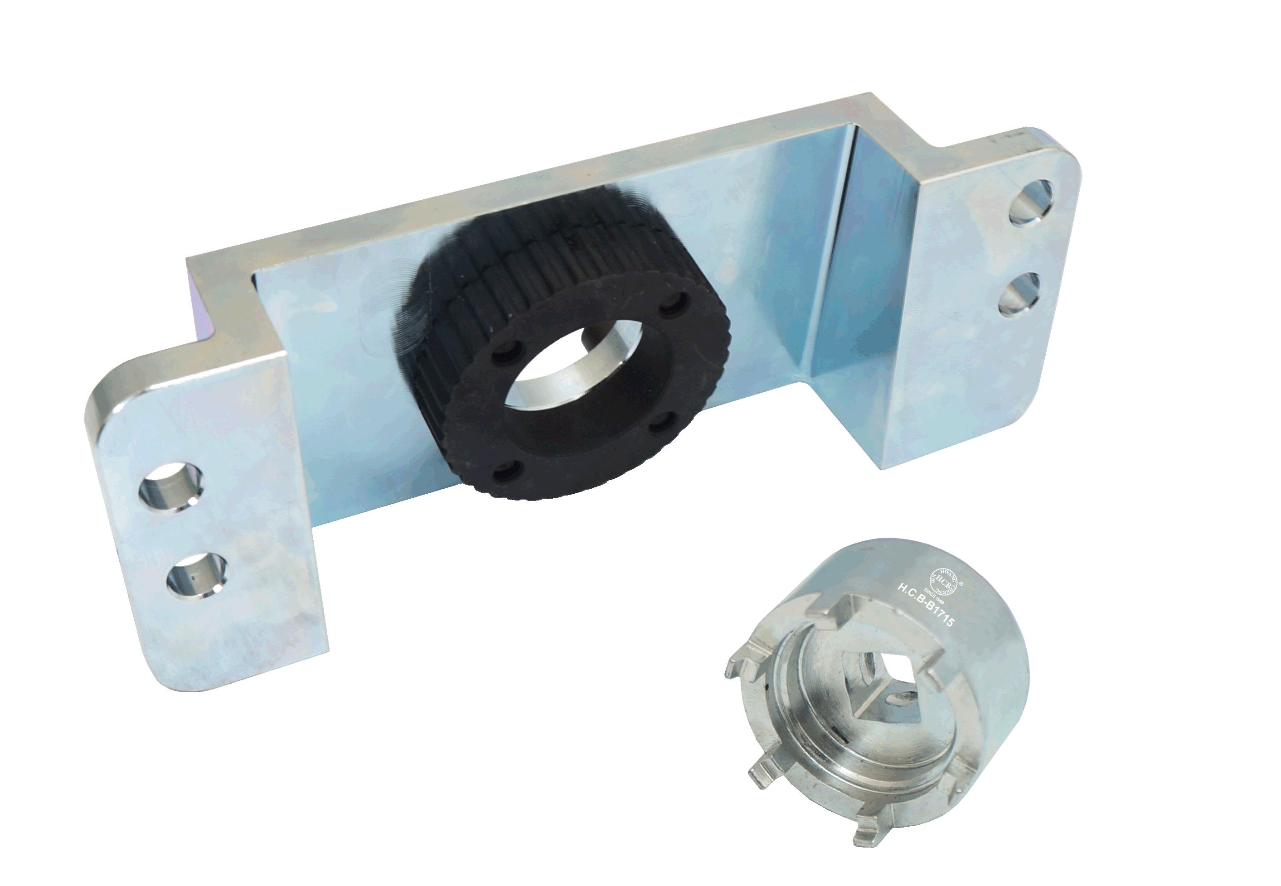**VW/ AUDI 7-SPEED DSG TOOL KIT**

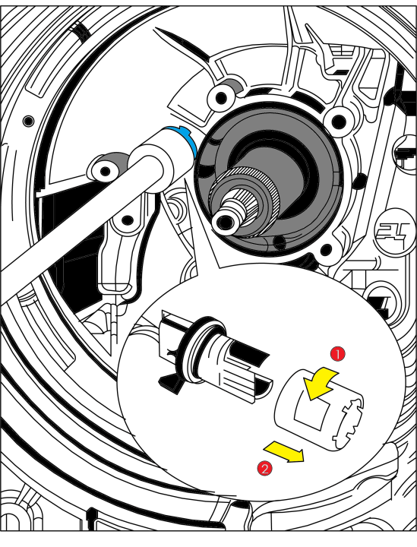

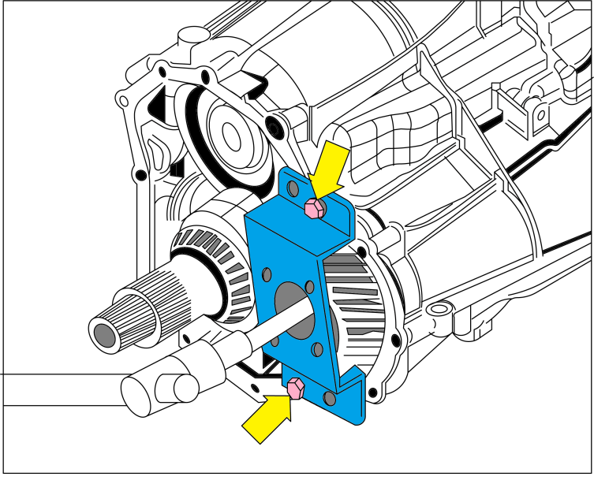

* **Used when loosening side shaft and** releasing connector on sensor module **on gearbox 0B2.**
* **Application:**  
  Type / model: Audi A4 2008 >, Audi A5 Cabriolet 2009 >, Audi Q5 2008 >, Audi A5 Coupe 2008 >, Audi A5 Sportback 2008 >, Audi A7 Sportback 2011 > with gearbox 0B2.
* **VW OEM no. ref.: T40217,** **T40228**