
H.C.B-C1627
VOLVO (FM) TRUCK LIFTING AXLE BEARING/ OIL SEAL INSTALLER

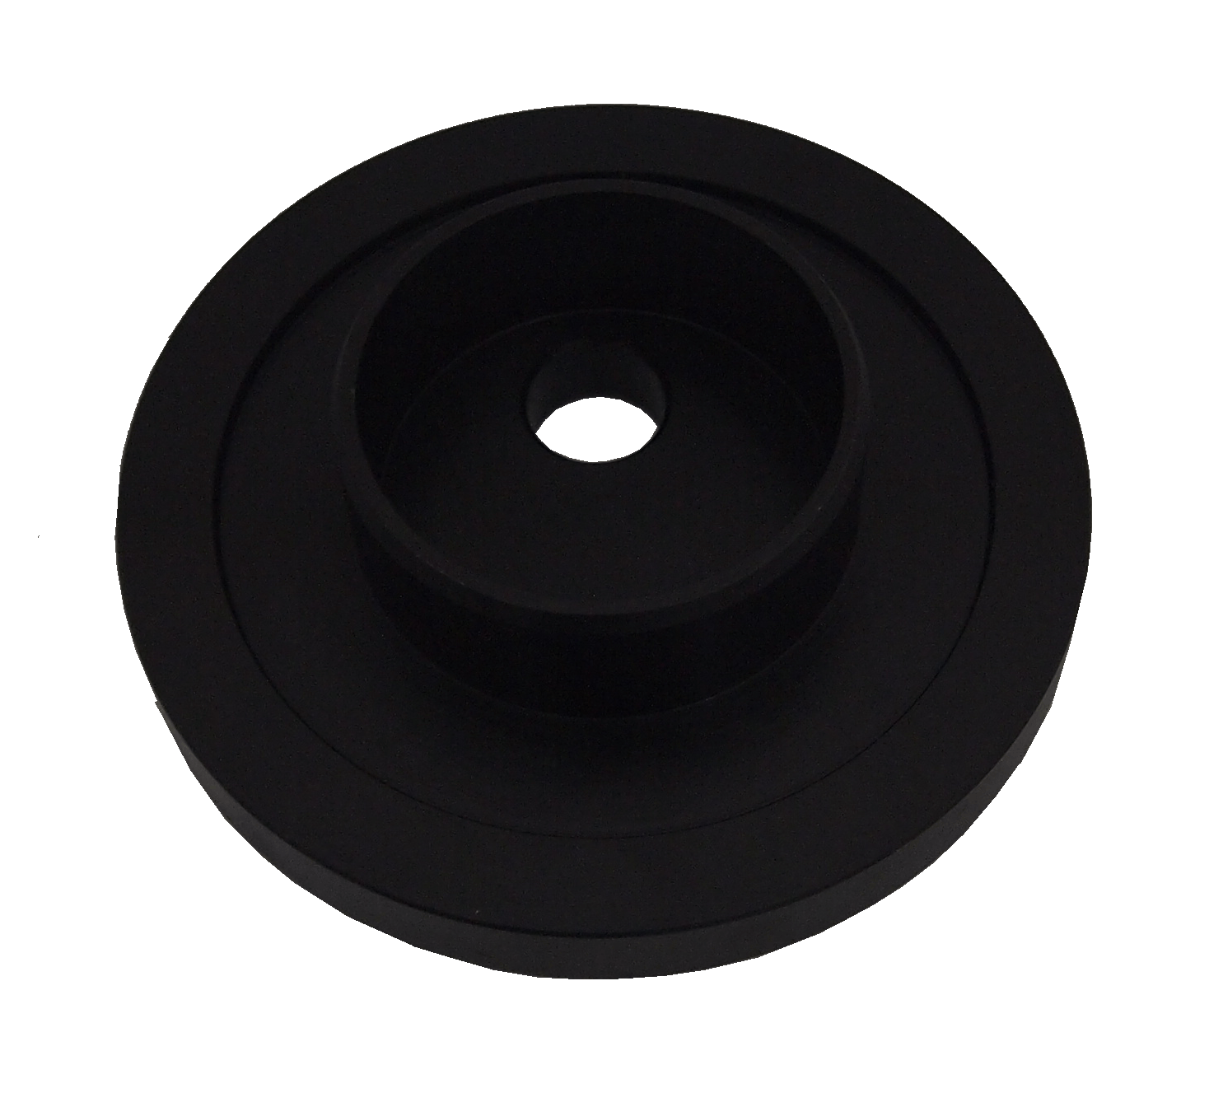

■ Instruction：This tool can help you install the lifting axle bearing or oil seal with even force. Avoid bad installation.

■ Application：VOLVO(FM) truck.

■ OEM no. ref: F-566427

H.C.B-C1627
VOLVO (FM) TRUCK LIFTING AXLE BEARING/ OIL SEAL INSTALLER

■ Instruction：This tool can help you install the lifting axle bearing or oil seal with even force. Avoid bad installation.

■ Application：VOLVO(FM) truck.

■ OEM no. ref: F-566427

