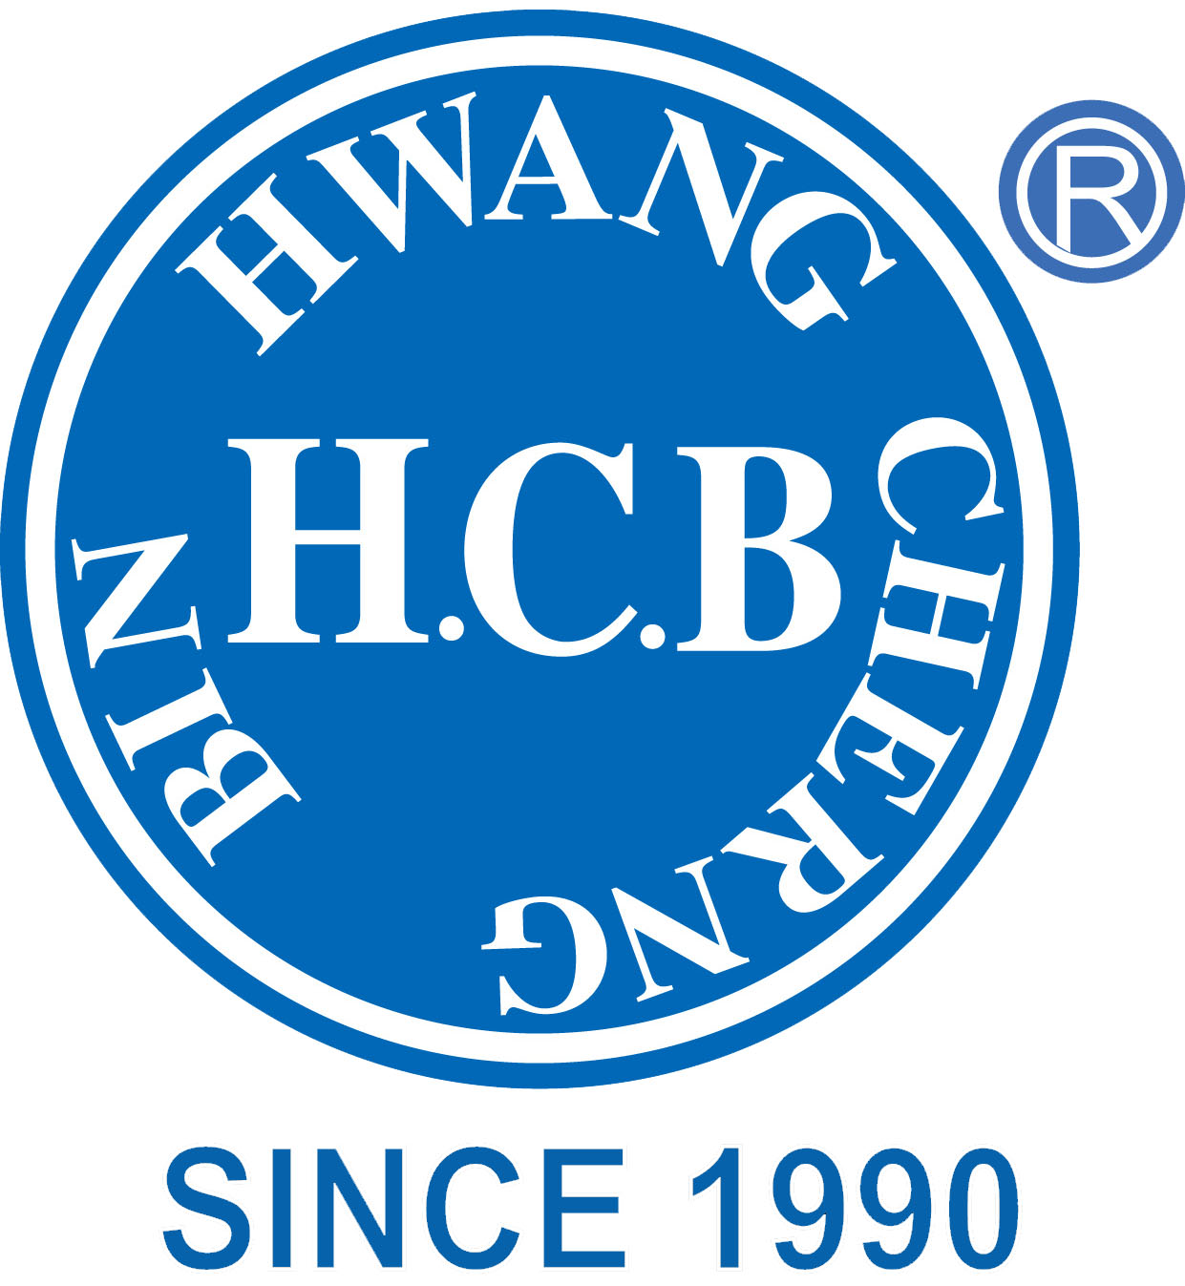
H.C.B-C1461
HYUNDAI TUCSON WHEEL LUG SOCKET
(Dr. 1/2, L: 85 mm, M21)
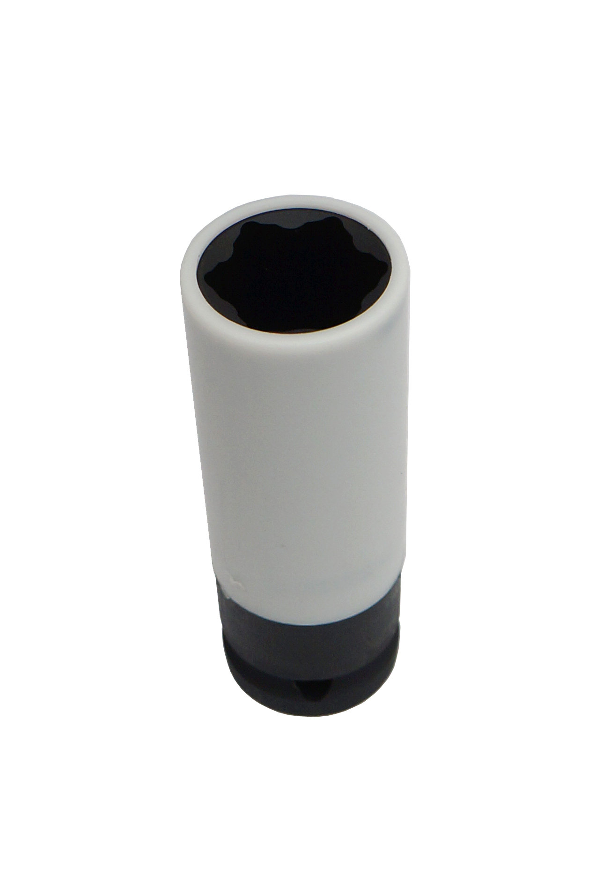
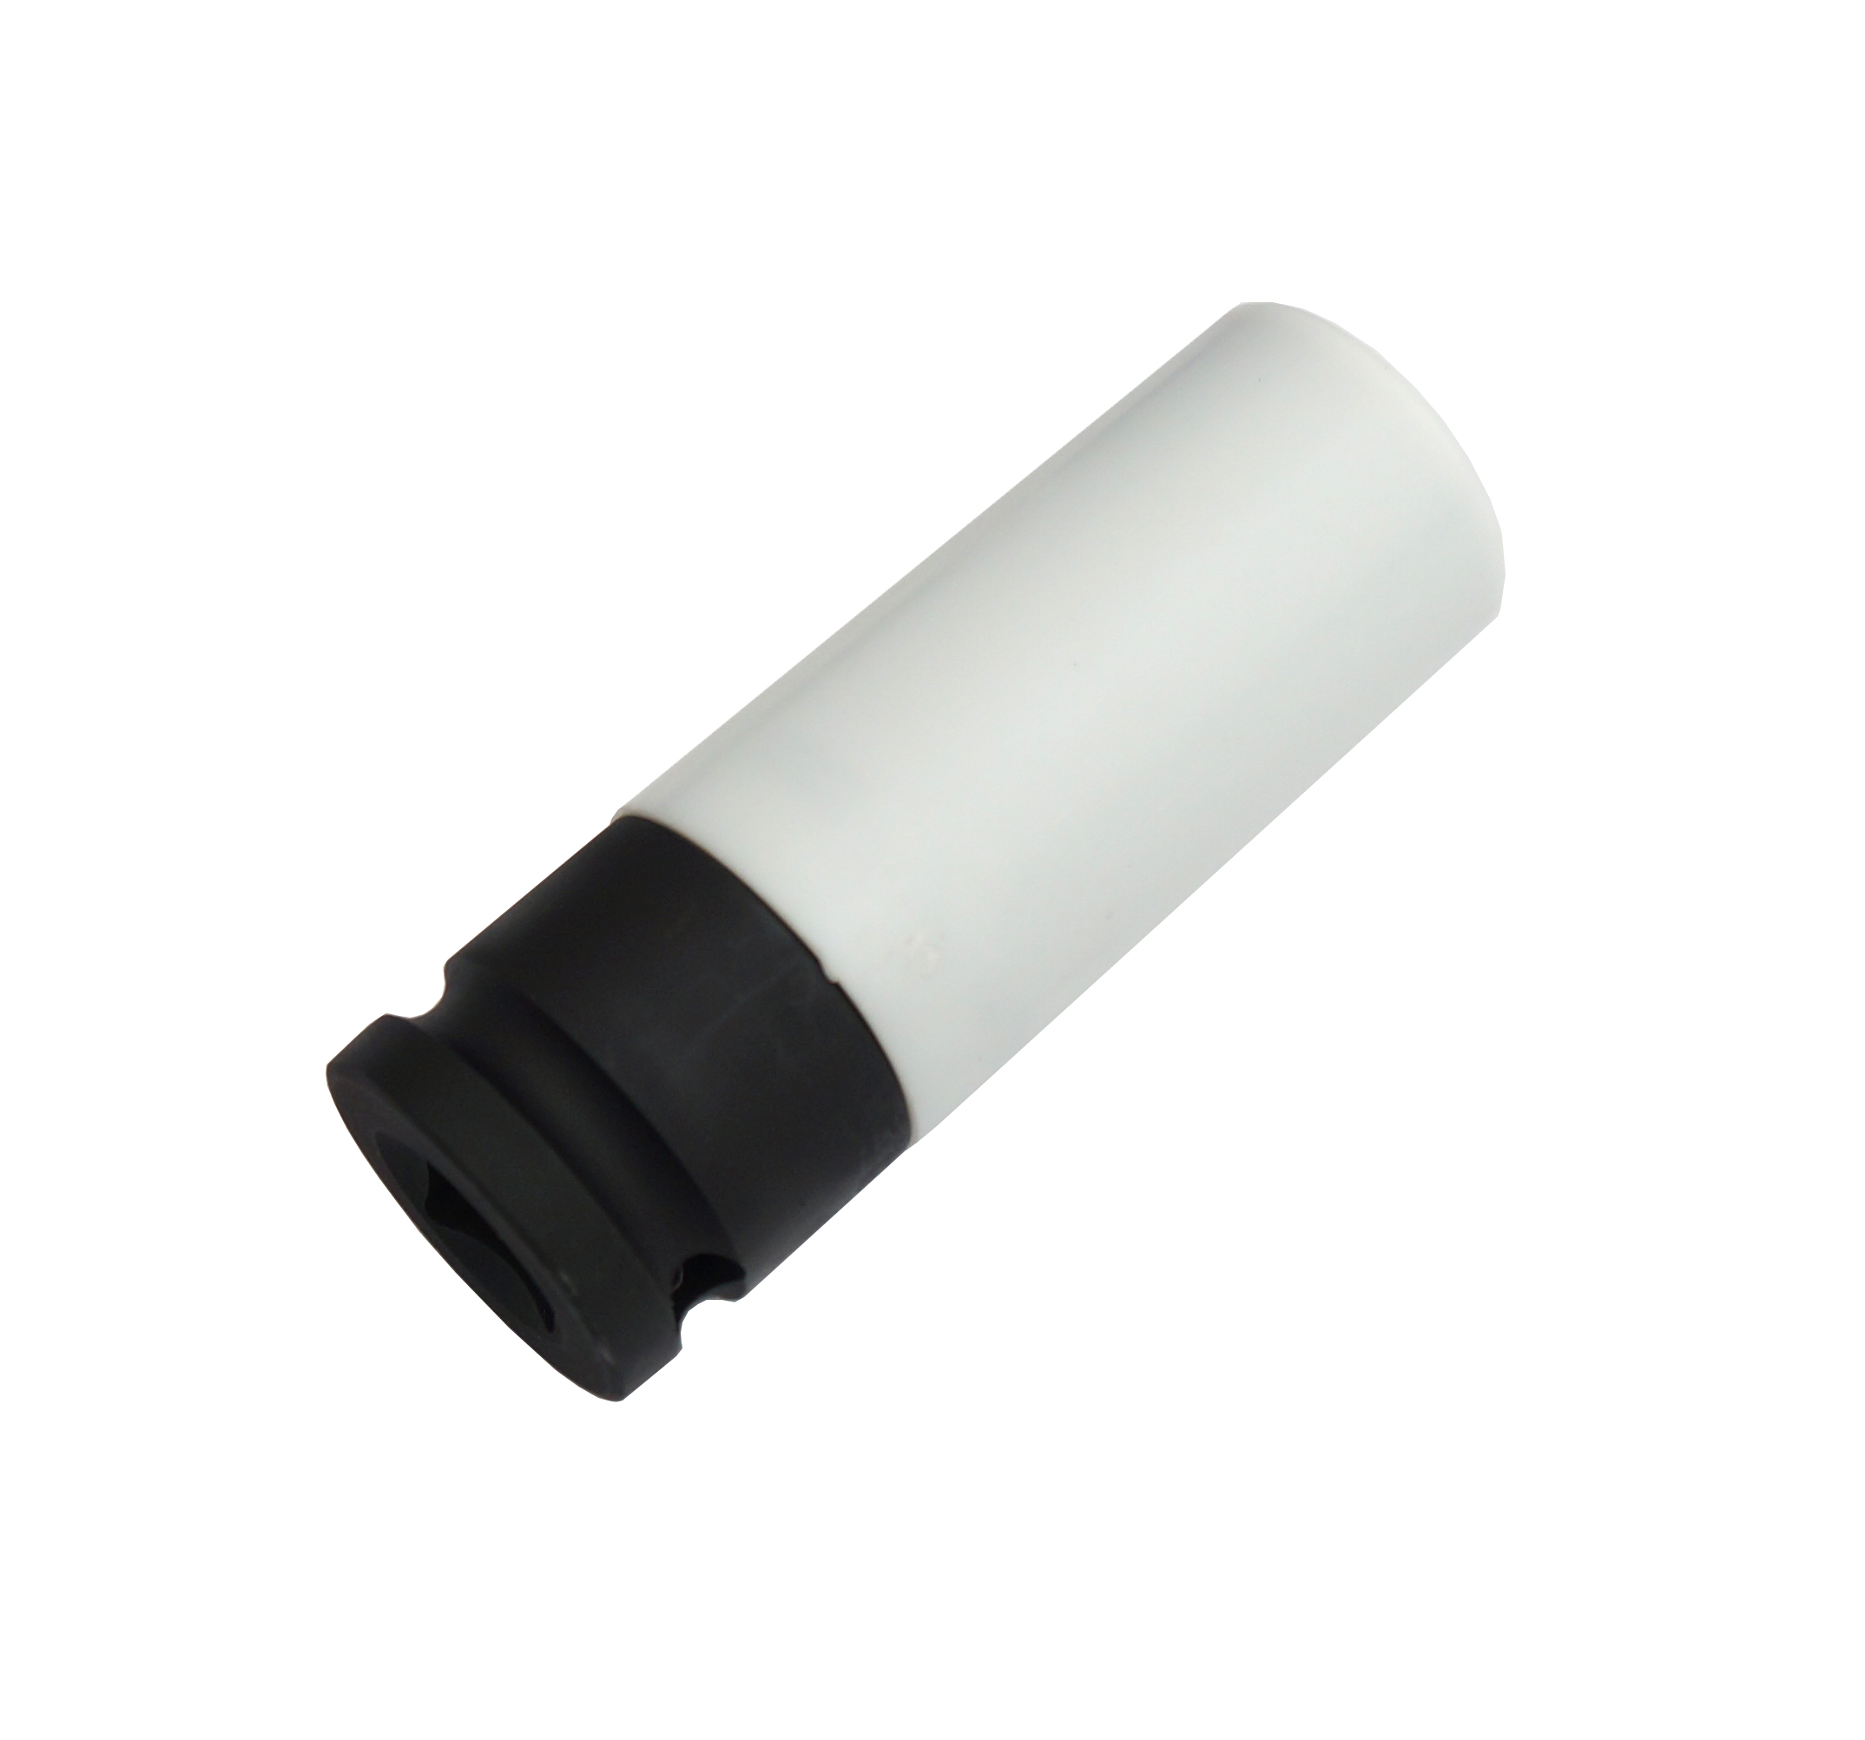

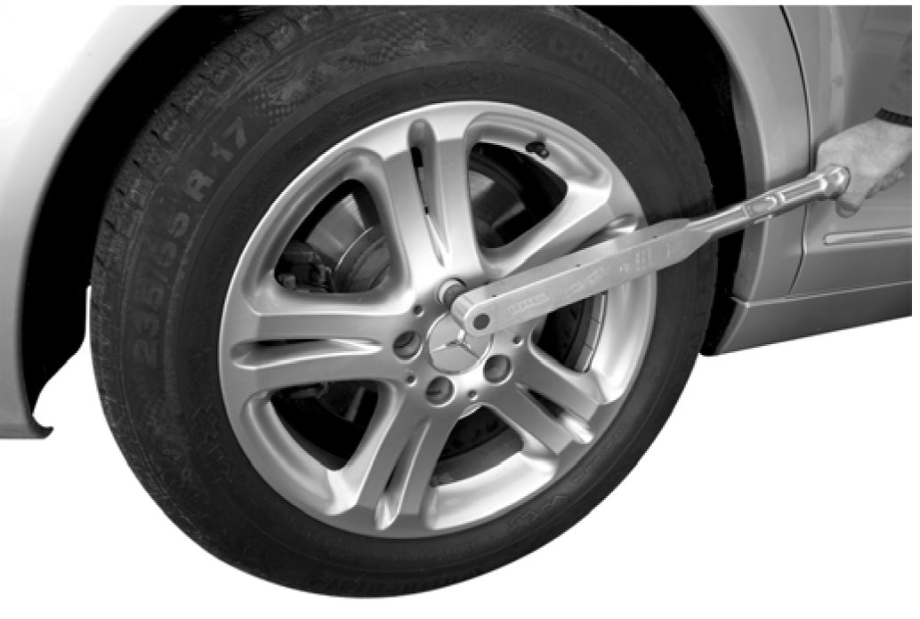

- Plastic insert to protect the surface of the wheel bolts.
- Rotating outside plastic sleeve to protect the rims when screwing the wheel bolts - no aluminium corrosion through prevention of scratches.
- Application: HYUNDAI i30, Tucson and KIA, and
HINO truck year 2003~2006 or after year 2010.
- Long design
- With borehole for locking pin or safety spring and grove for O-ring
- Total length (for E-Class): 86 mm
- Drive: Square, hollow 12.5 mm (1/2 inch)
- Diameter d2 (drive side): 31 mm
- Genuine no.: 103251, S23401-11840-A
H.C.B-C1461
HYUNDAI TUCSON WHEEL LUG SOCKET
(Dr. 1/2, L: 85 mm, M21)

- Plastic insert to protect the surface of the wheel bolts.
- Rotating outside plastic sleeve to protect the rims when screwing the wheel bolts - no aluminium corrosion through prevention of scratches.
- Application: HYUNDAI i30, Tucson and KIA, and
HINO truck year 2003~2006 or after year 2010.
- Long design
- With borehole for locking pin or safety spring and grove for O-ring
- Total length (for E-Class): 86 mm
- Drive: Square, hollow 12.5 mm (1/2 inch)
- Diameter d2 (drive side): 31 mm
- Genuine no.: 103251, S23401-11840-A

