
H.C.B-C1329
MAN TGA DRIVE AXLE NUT SOCKET
(Dr. 3/4”, 165 mm)

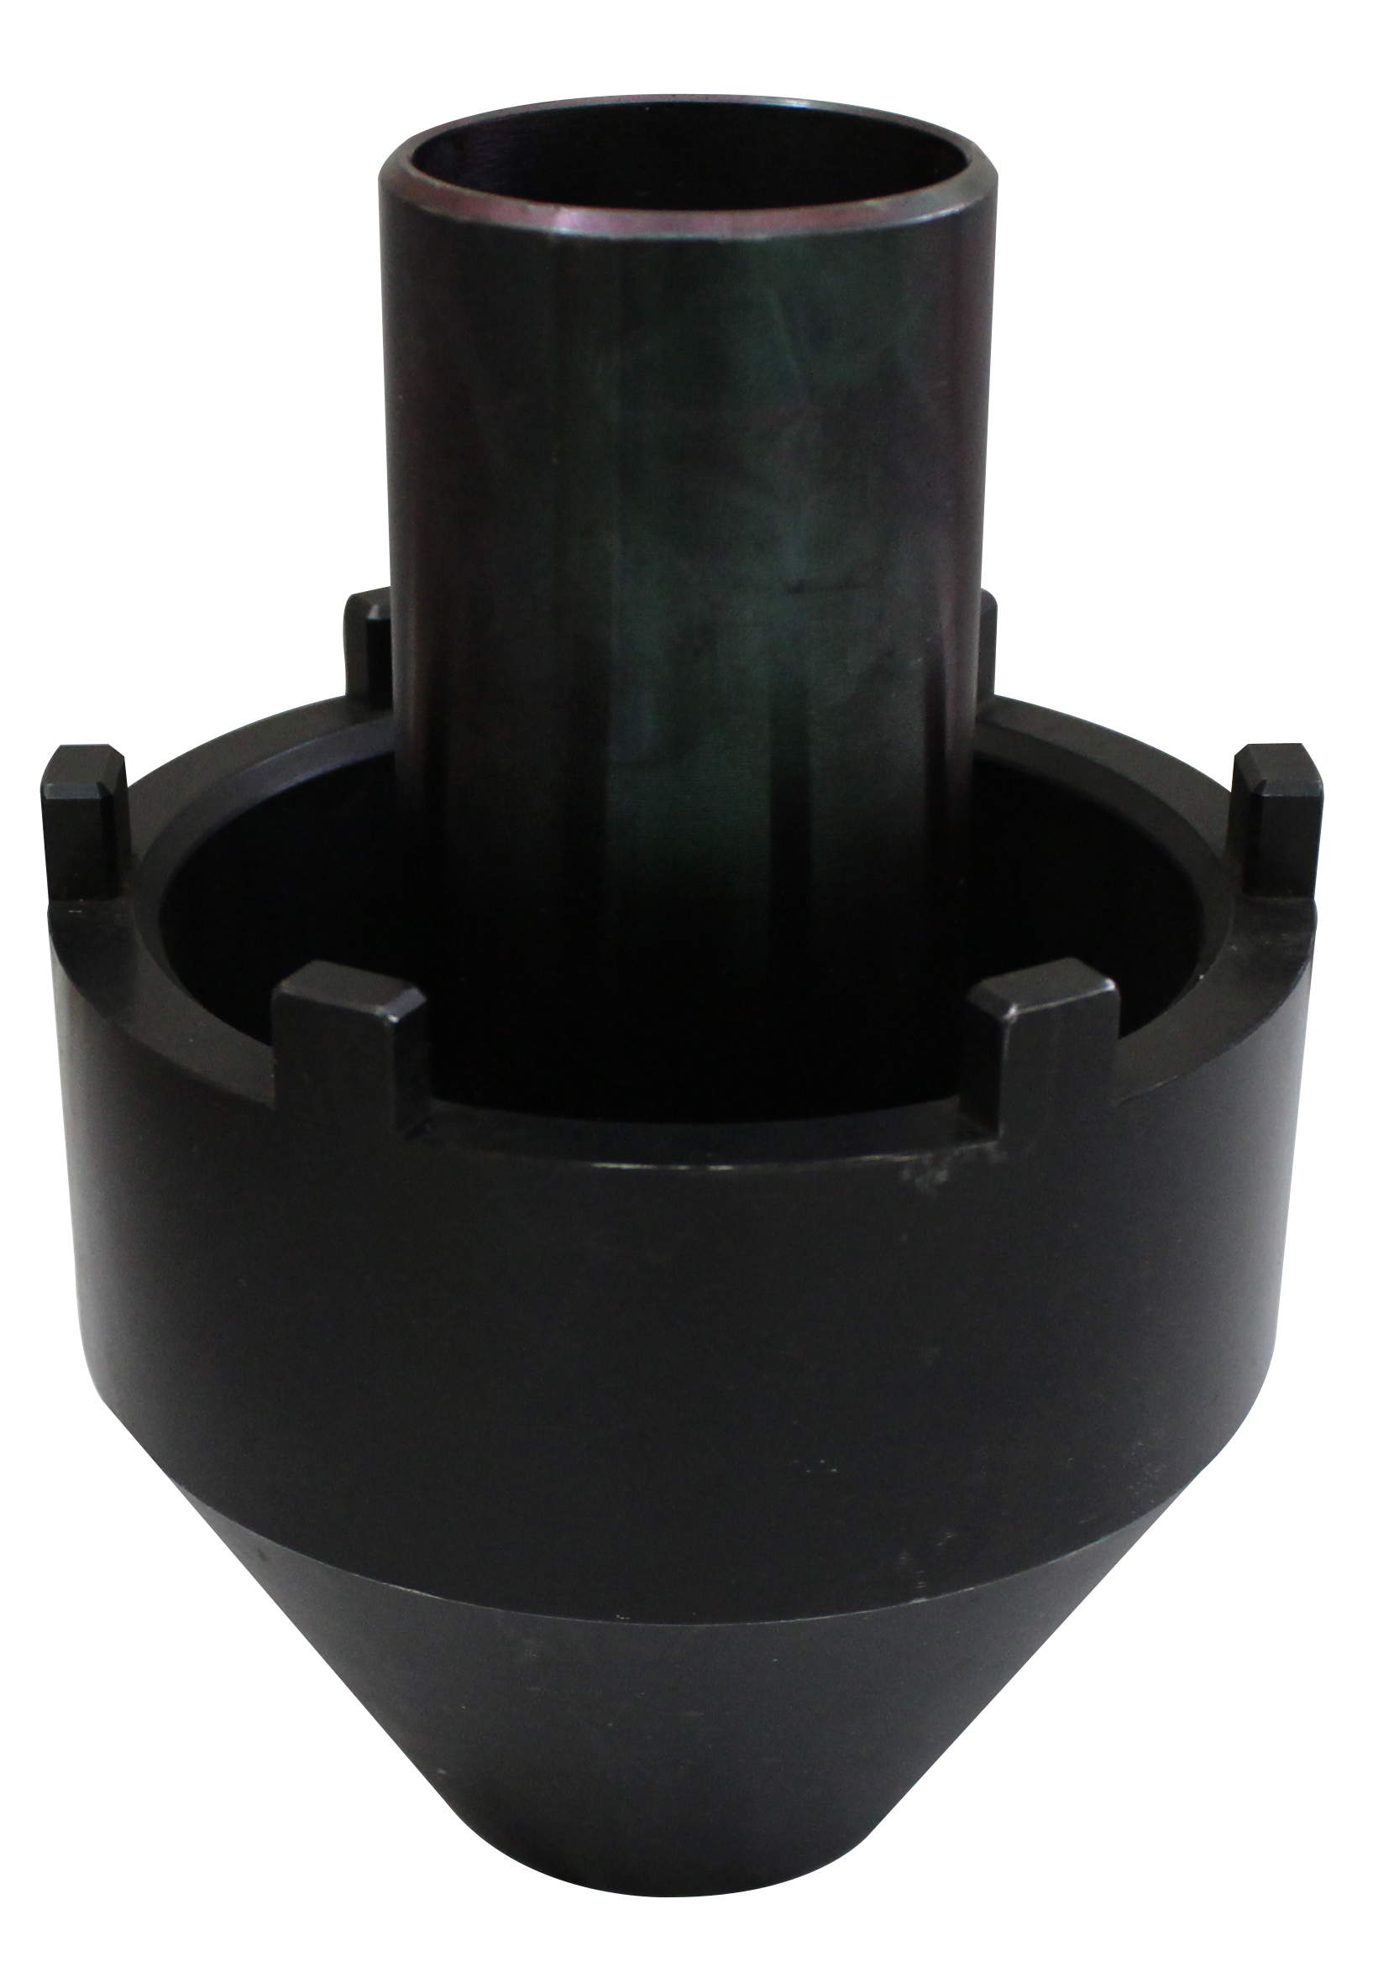

- Fix bearing while removing or installing the truck nut.
- Use the air wrench or rod to control the nut to tighten
or loosen bearing.
- Application :MAN-TGA DRIVE AXLE
- OEM no.ref: 80.99603.6001

H.C.B-C1329
MAN TGA DRIVE AXLE NUT SOCKET
(Dr. 3/4”, 165 mm)

- Fix bearing while removing or installing the truck nut.
- Use the air wrench or rod to control the nut to tighten
or loosen bearing.
- Application :MAN-TGA DRIVE AXLE
- OEM no.ref: 80.99603.6001

