
H.C.B-C1283
FUWA WHEEL SHAFT COVER SOCKET (Dr. 1", 8 POINTS, 106 mm)

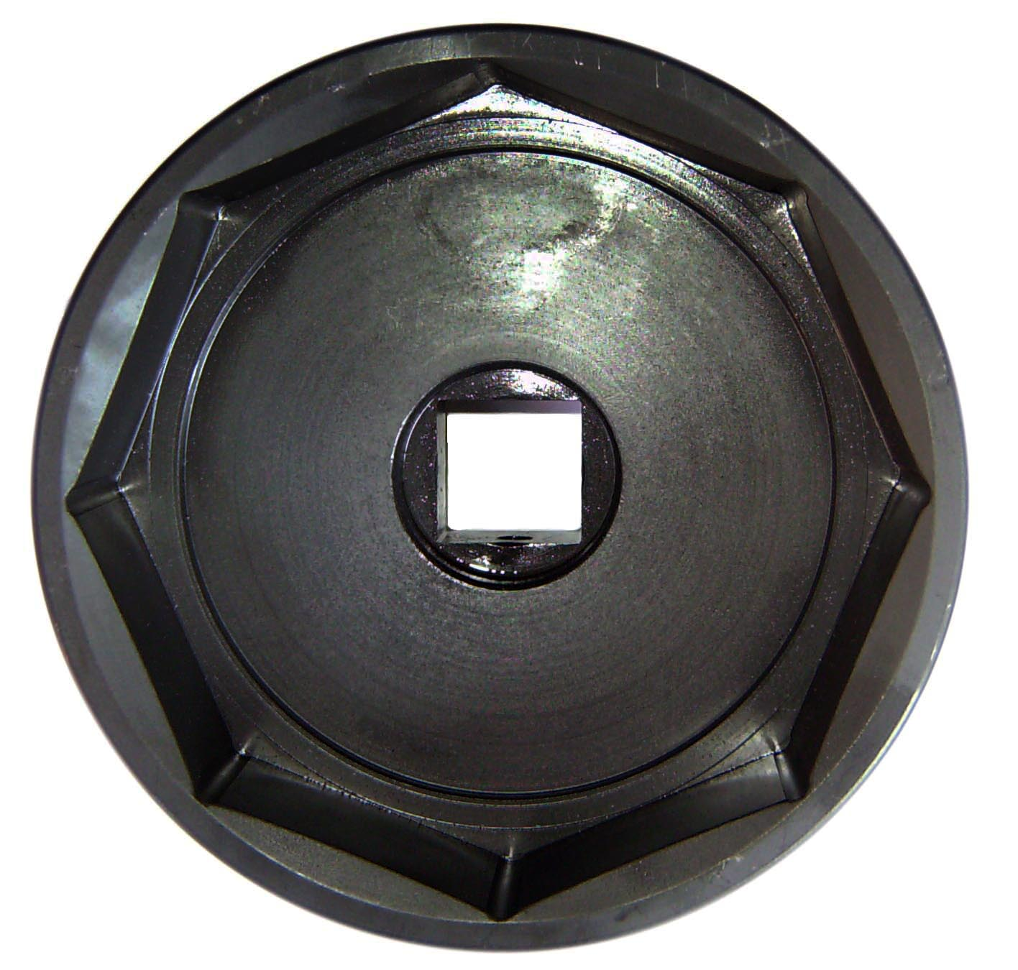
Dr. 1”

106mm

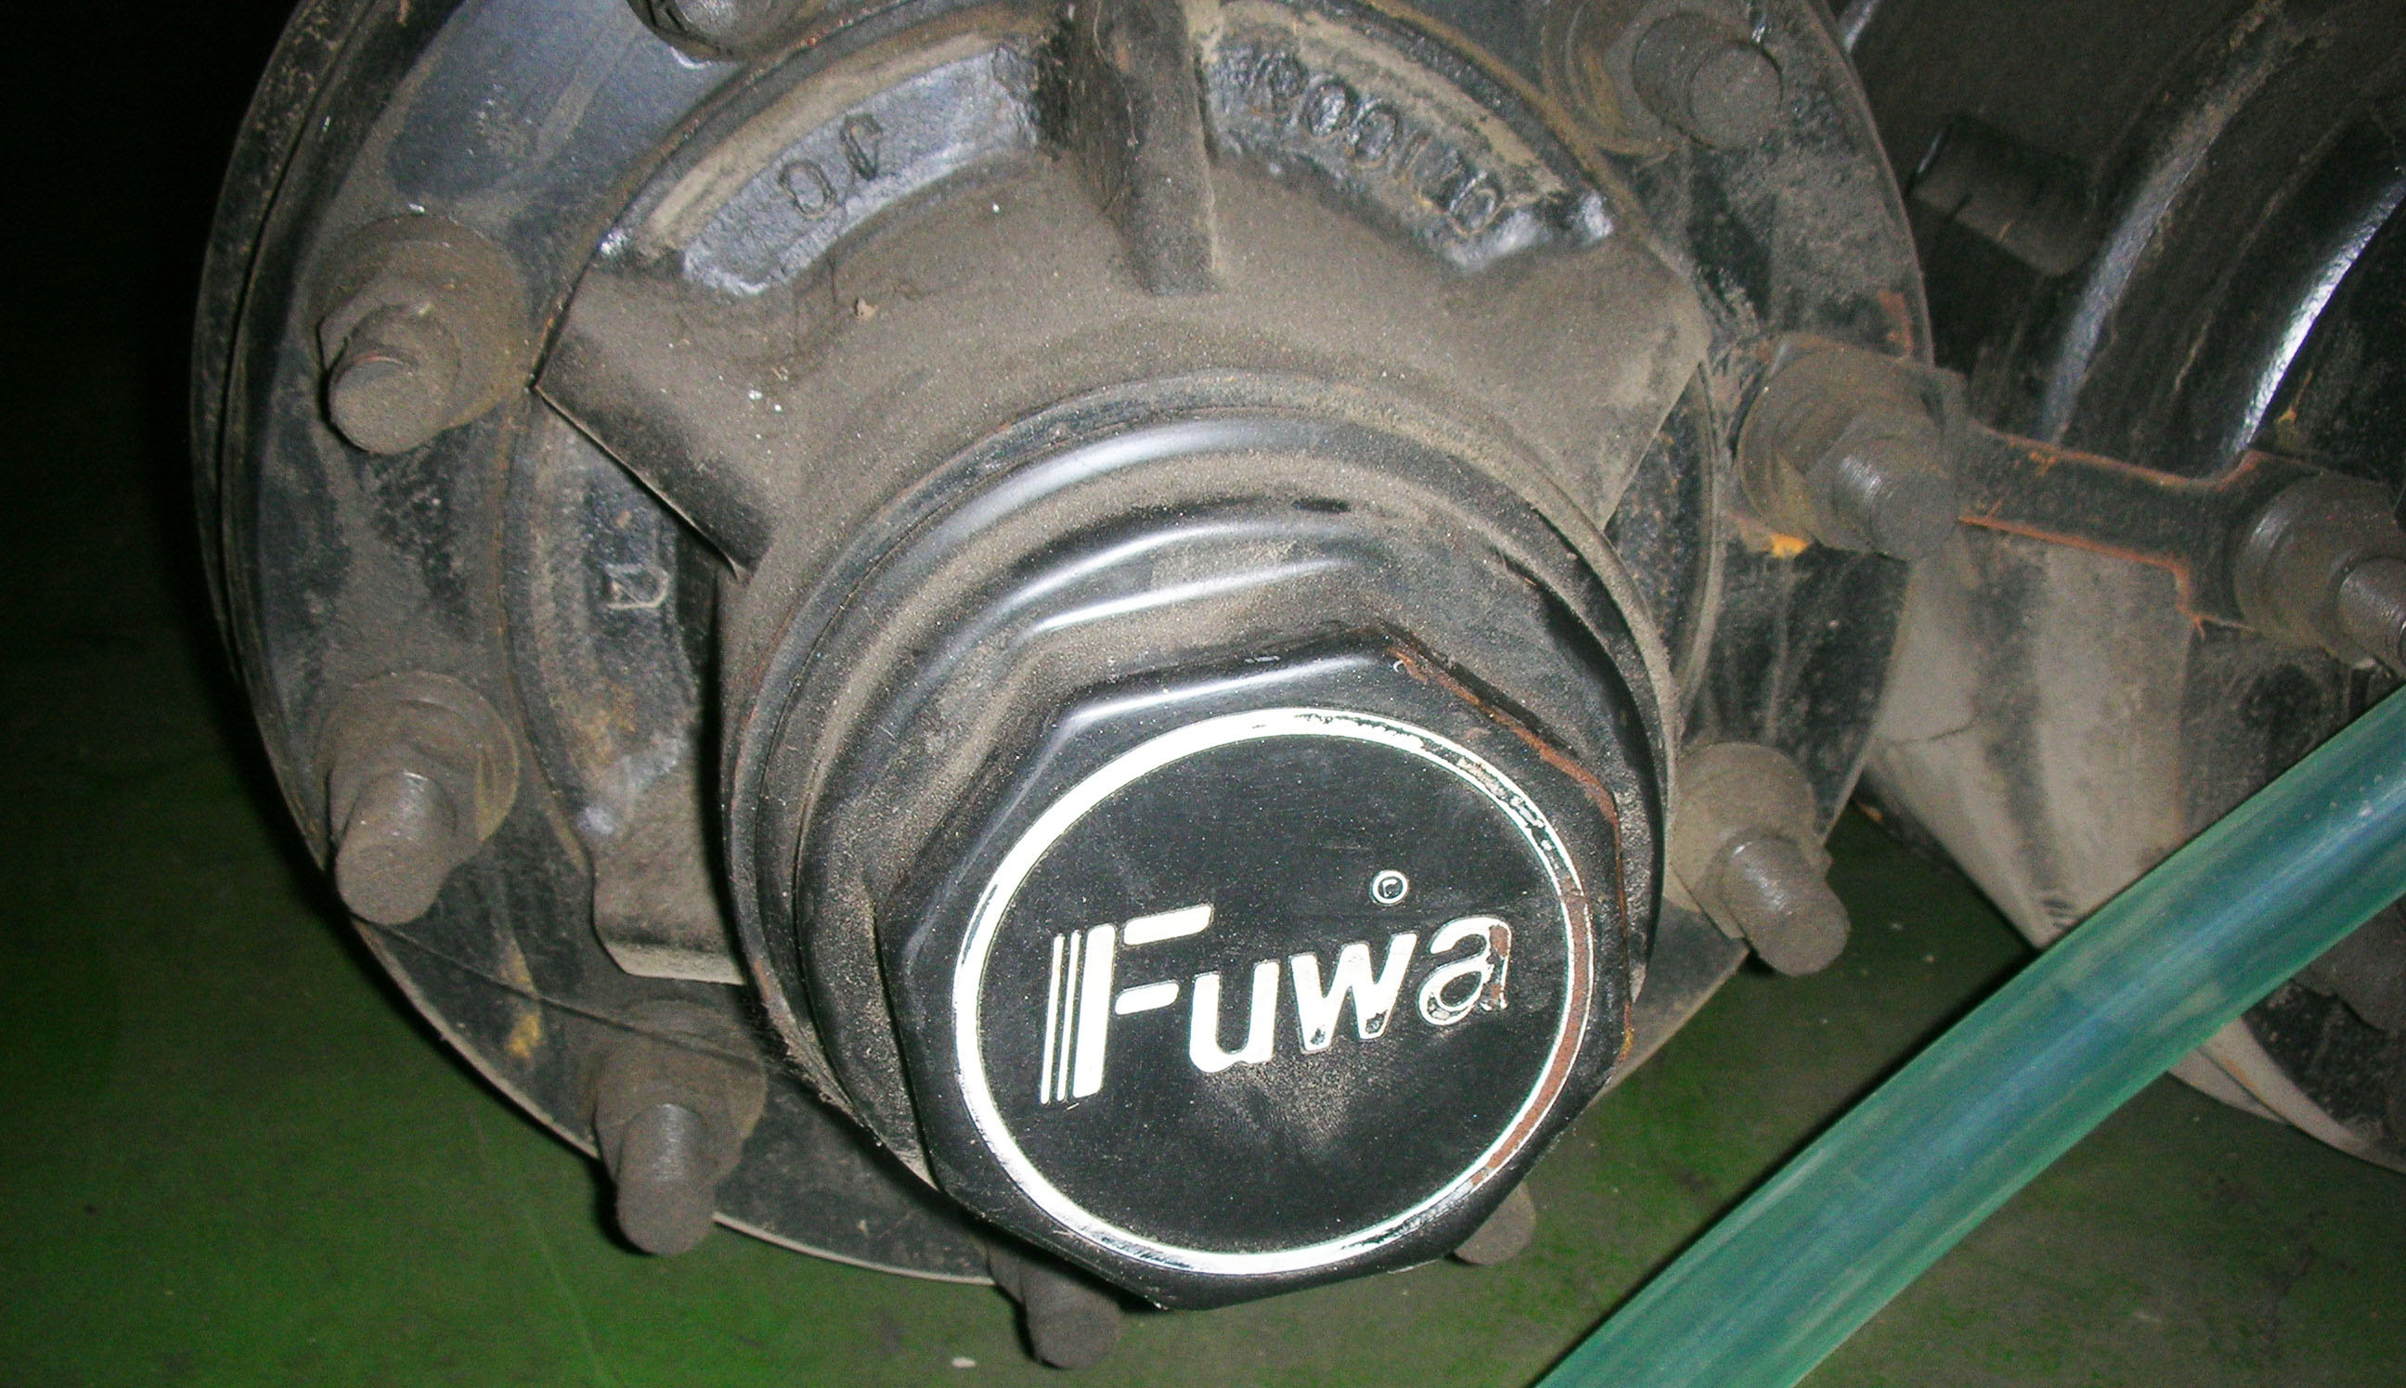

- The socket for extracting / installing rear axle cover.
- Application: FUWA

