
H.C.B-C1091
SCANIA TRUCK FRONT WHEEL AXLES HUB EXTRACTOR (W/HYDRAULIC)
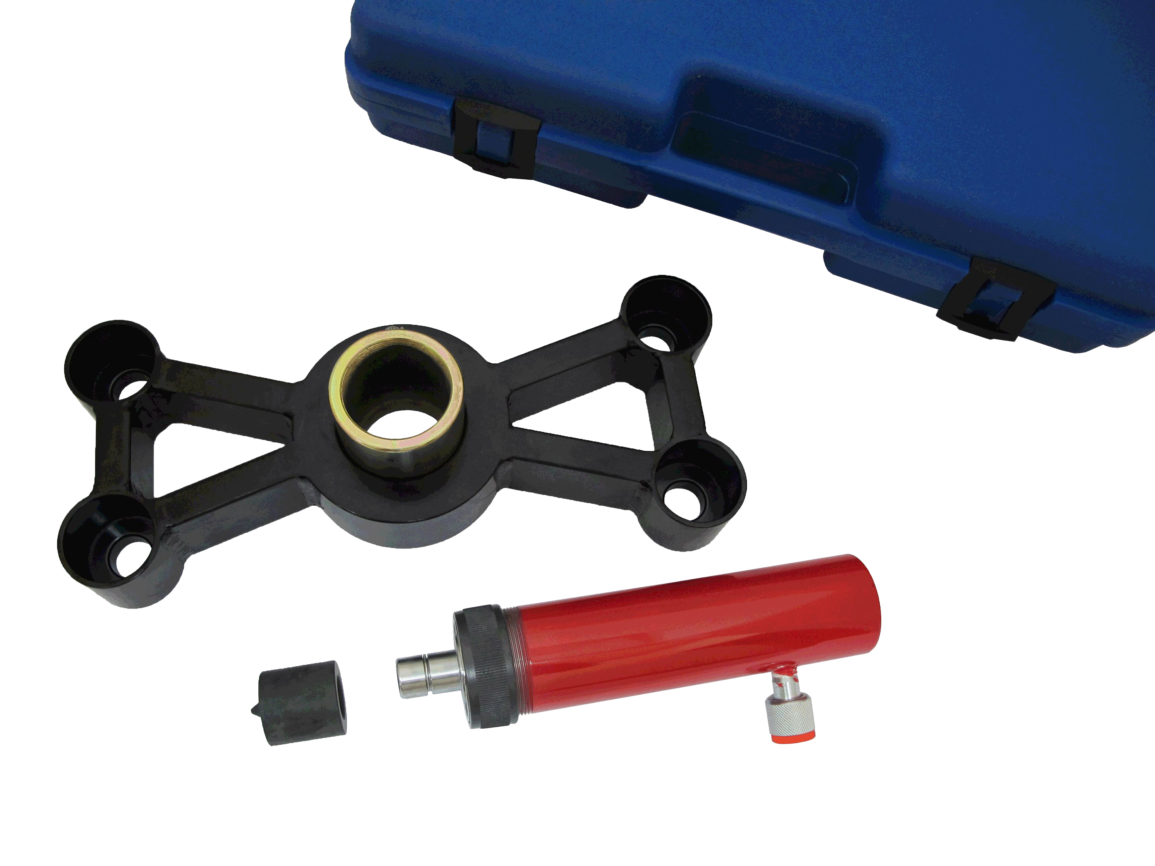

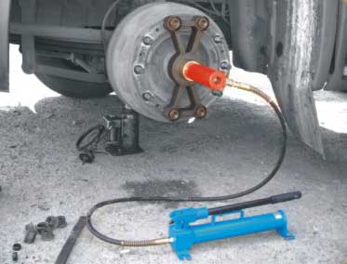


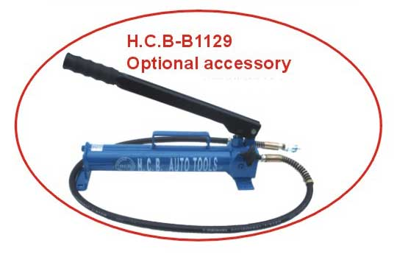
▇ The tool can be easily operated if combine with H.C.B-B1129 (Hydraulic Hand Pump) and save time while SCANIA axle bearing got stuck due to over heat.
Caution: Before demolish the screws, you should loosen
the wheel brakes first to keep it idle.

