
H.C.B-B9091

MERCEDES PINION NUT SOCKET
(6 POINT, Dr.1", 62mm)
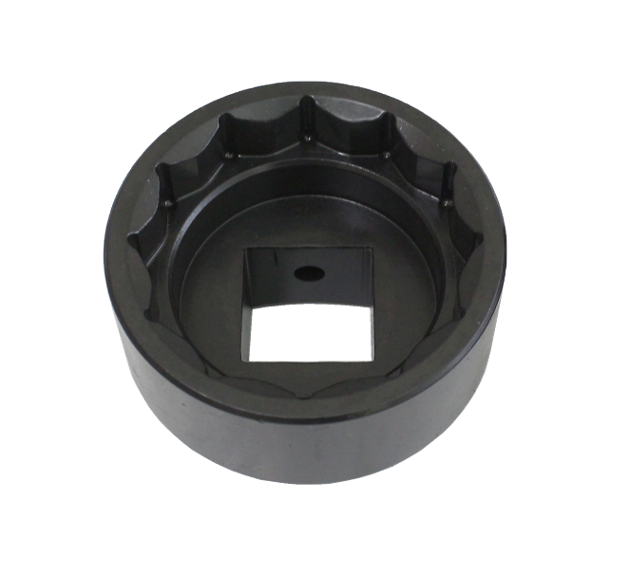
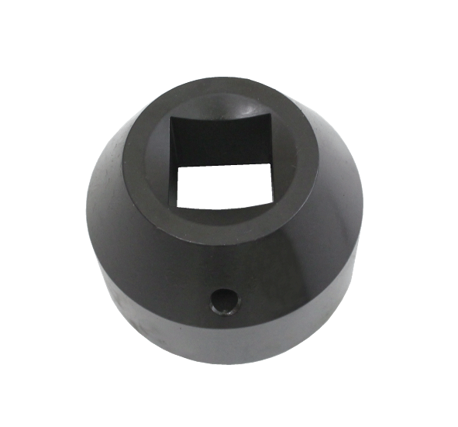

- When install / removal the pinion nut , use this tool to achieve proper torque specifications and stake the nut to the pinion
- Torque Spec for front pioion-516ft lbs
- Torque Spec for rear pinion -627ft lbs
- Application: Mercedes / Freightliner
- Nut no. ref: 0619AD

H.C.B-B9091

MERCEDES PINION NUT SOCKET
(6 POINT, Dr.1", 62mm)

- When install / removal the pinion nut , use this tool to achieve proper torque specifications and stake the nut to the pinion
- Torque Spec for front pioion-516ft lbs
- Torque Spec for rear pinion -627ft lbs
- Application: Mercedes / Freightliner
- Nut no. ref: 0619AD

