
H.C.B-B6111

VOLVO/RENAULT BAYONET RING TOOL
FOR AIR DRYER CARTRIDGES
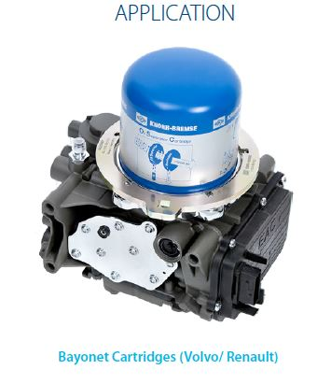

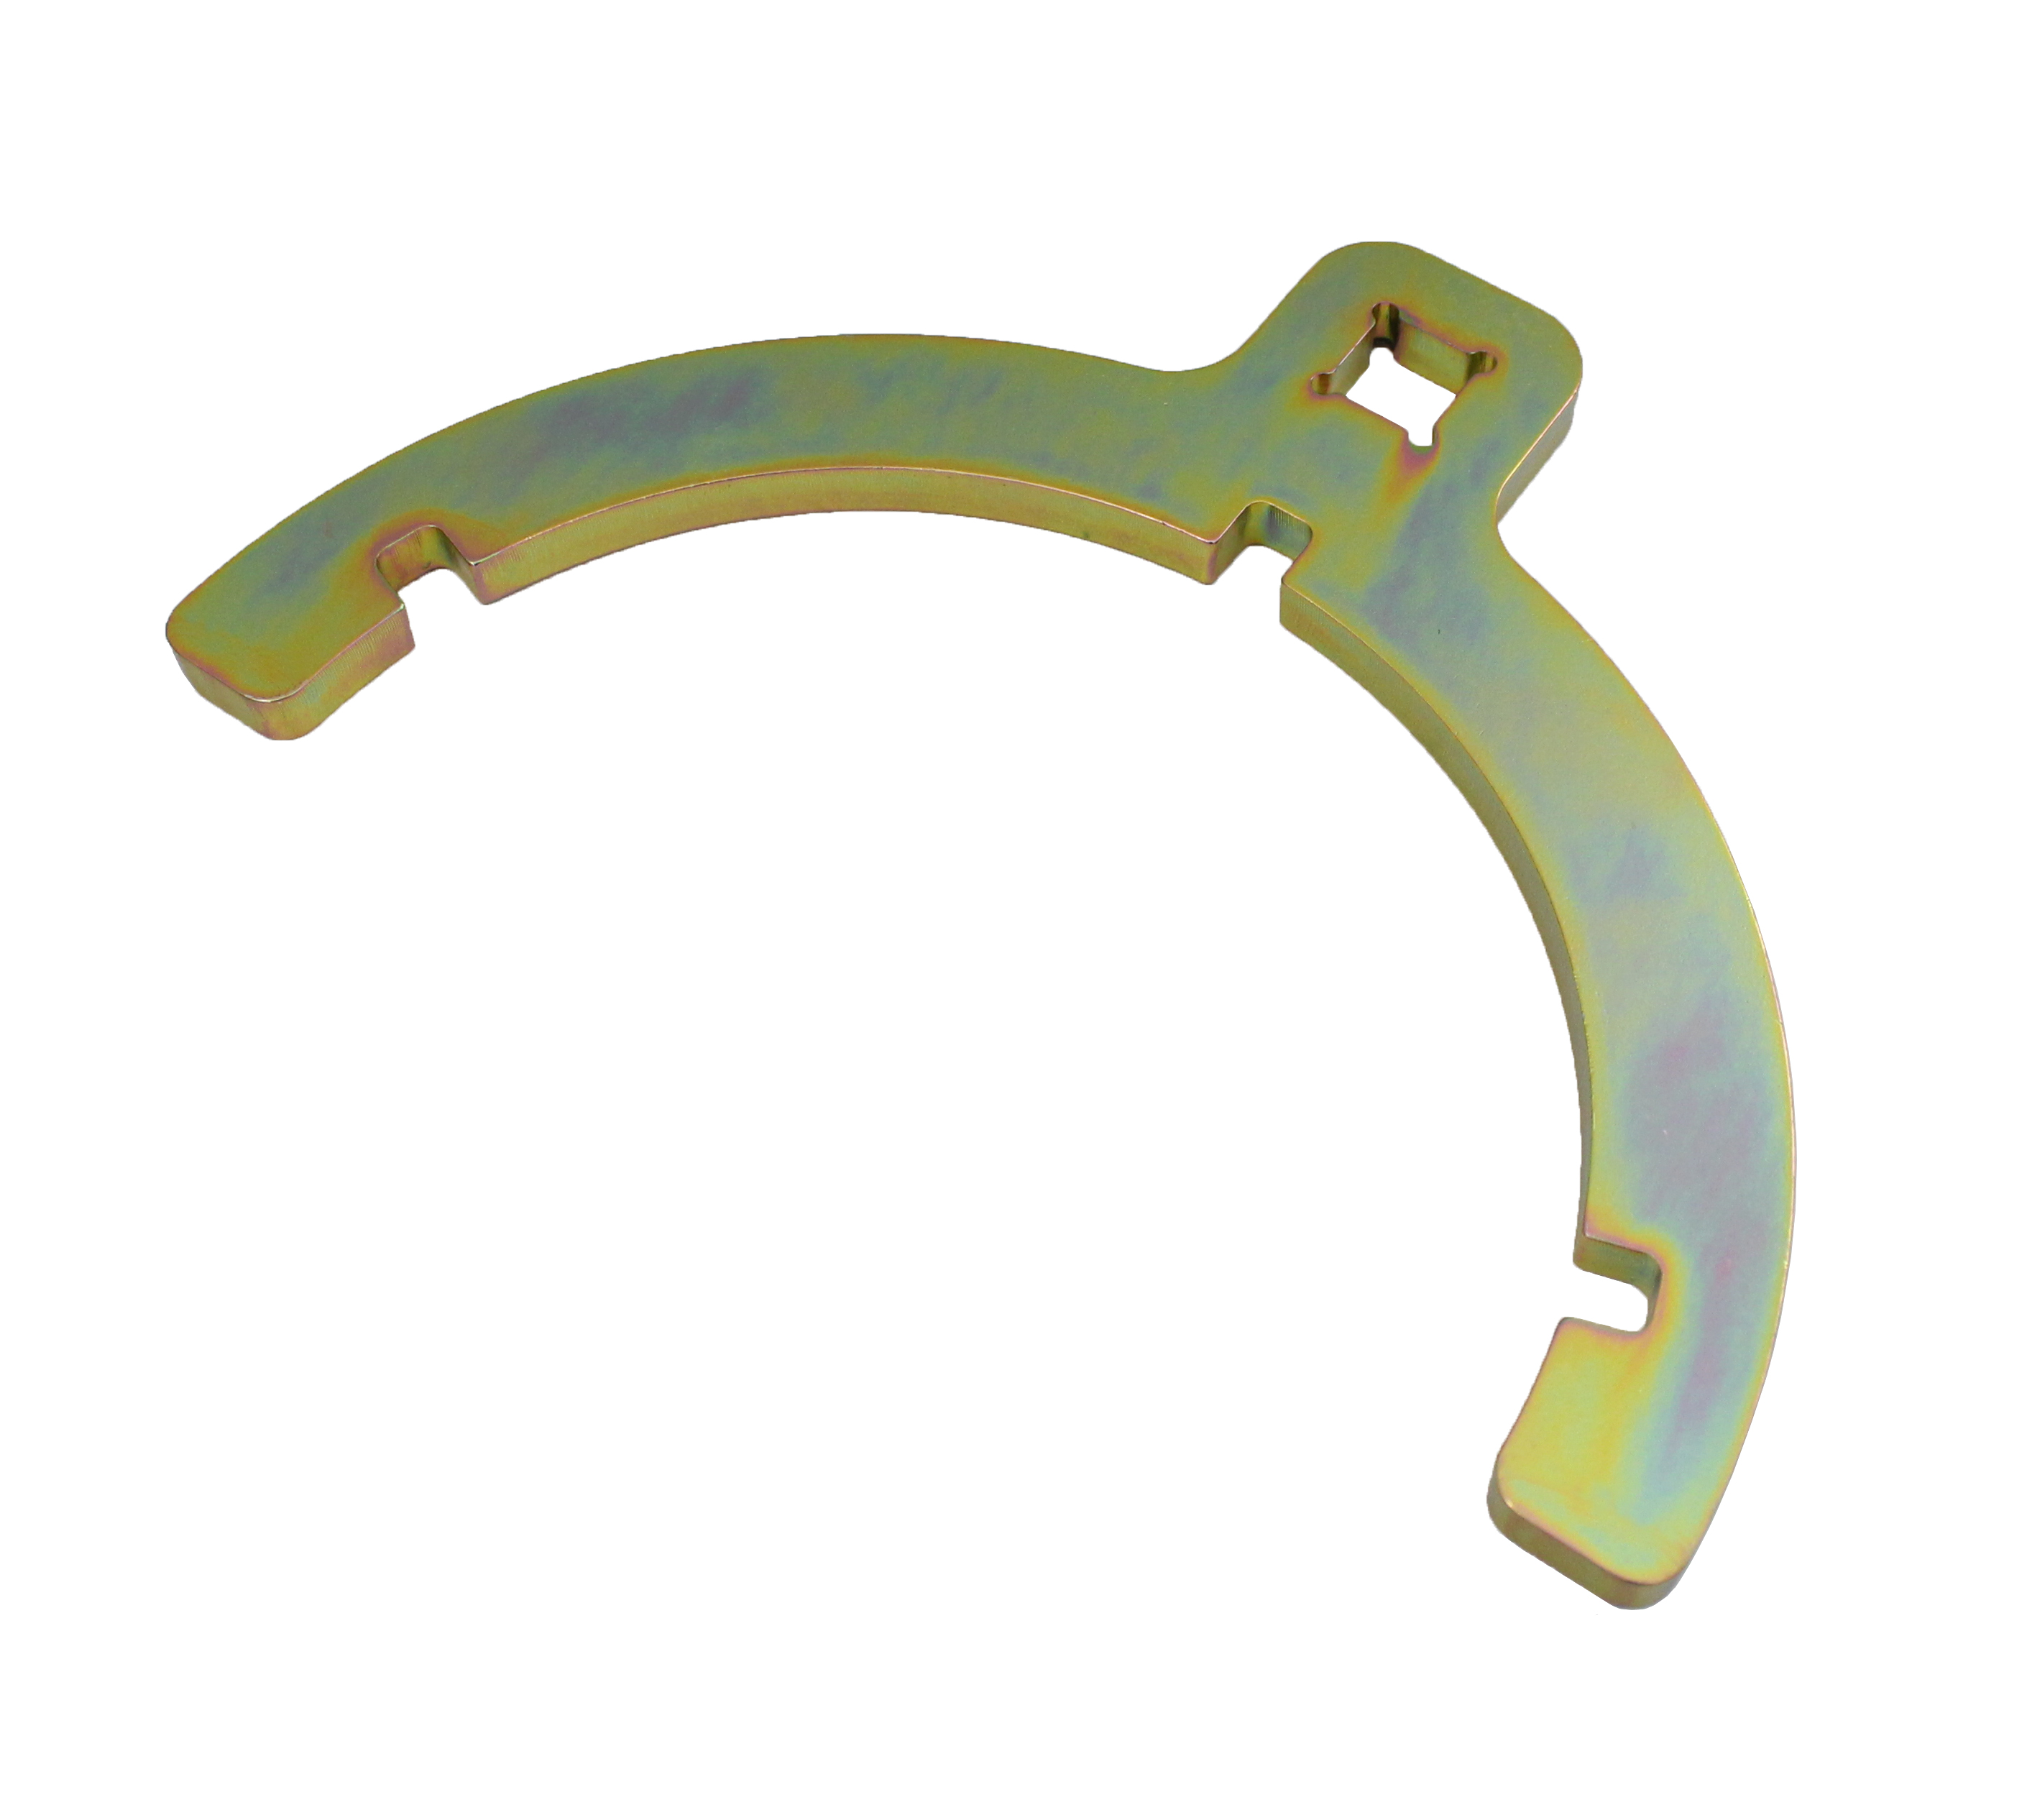

- Service Instruction for releasing and tightening the bayonet ring with the Truck Services
- special tooling for bayonet rings

- This service instruction was created to support the safe release and tightening of the bayonet ring on bayonet cartridges.

- The procedure should be performed only by well-trained persons in a clean working environment.

- Application: VOLVO/ RENAULT
- OEM no.ref.: K162153K50

