
H.C.B-B2199
RENAULT ENGINE TIMING TOOL SET

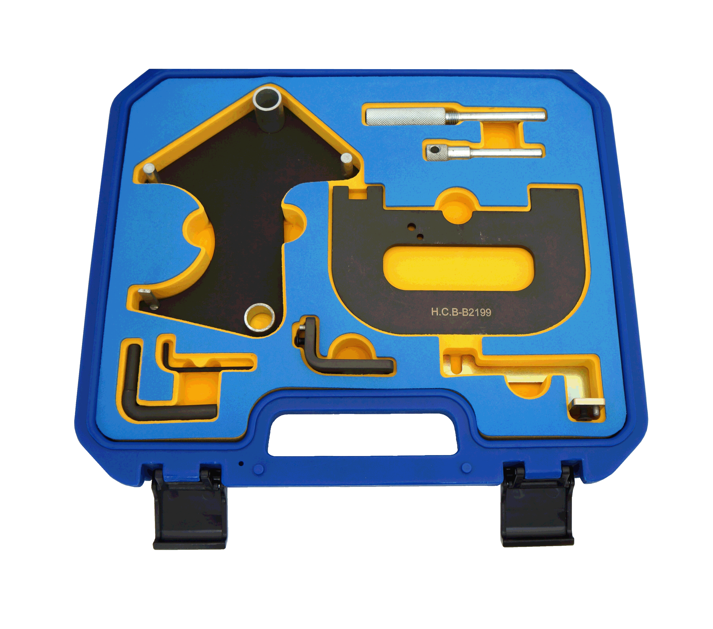

Ref | Parts no. | OEM ref | Description
1 |  | MOT 1490-01 | Camshaft Pulley Alignment Tool
2 |  | MOT 1496 | Camshaft Setting Tool
3 |  | MOT 1489 | Crankshaft Locking Pin
4 |  | Mot 1054 | Crankshaft Timing Pin
5 |  | Mot 1750 | Mounting Bracket
6
7
8

- Petrol Engine Setting/Locking Kit - Renault 1.4, 1.6, 1.8, 2.0 16v K4J, K4M, F4P, F4R(t) - Belt Drive
- Updated kit suitable for timing belt replacement on 1.4, 1.6, 1.8 and 2.0 engines fitted in Renault vehicles.
- Kit features updated camshaft setting plate which avoids the camshaft position sensor on later 1.4 and 1.6 engines
OEM Tools: | 1490
Renault/Nissan: | Mot861, Mot1054, Mot1489, Mot1496, Mot1750.
Vauxhall/Opel: | KM-6031, KM-6233
Applications:
Renault: | Avantime (00-03), Clio II (99-06), Clio III/Sport (05-13), Espace/Grand Espace (98-02), Espace/Grand Espace IV (02-10), Kangoo/Trekka (01-09), Kangoo II/Be Bop (08-12), Laguna (98-01), Laguna II (01-07), Laguna III (07-13), Logan/MCV (05-11), Megane (99-03), Megane II (02-10), Megane III/Sport (08-13), Megane/Scenic (99-00), Modus (04-08), Modus/Grand Modus II (08-13), Scenic/RX4 (99-03), Scenic/Grand Scenic II (03-09), Scenic/Grand Scenic III (09-13), Trafic II (01-11), Twingo II/Sport (08-13), Vel Satis (00-10)  Clio (98-06), Laguna (98-07), Megane (98-08), Scenic (98-08)
Nissan: | Kubistar X76 (03-09), Primastar X83 (02-11)
Vauxhall/Opel: | Vivaro (01-11)
Engine Codes:
K4J 1.4 16v: | 700, 710, 711, 712, 713, 714, 715, 730, 732, 740, 750, 770, 780
K4M 1.6 16v: | 690, 700, 701, 704, 706, 708, 709, 710, 711, 712, 714, 716, 718, 720, 724, 730, 732, 734, 740, 743, 744, 745, 746, 748, 750, 752, 753, 760, 761, 764, 766, 782, 790, 791, 792, 794, 800, 801, 802, 804, 812, 813, 824, 830, 831, 846, 848, 854, 858, 862, 866
F4P 1.8 16v: | 720, 722, 760, 770, 771, 772, 773, 774, 775
F4R(t) 2.0 16v: | 700, 701, 712, 713, 714, 715, 720, 722, 730, 732, 740, 741, 744, 746, 762, 763, 764, 765, 766, 767, 770, 771, 774, 776, 780, 784, 786, 787, 790, 791, 792, 794, 795, 796, 797, 800, 802, 810, 811, 820, 830, 832, 867, 870, 874, 886, 887, 896, 897

