
H.C.B-B2183
HYDRAULIC BUSH EXTRACTOR (EXTRA LARGER PARTS)

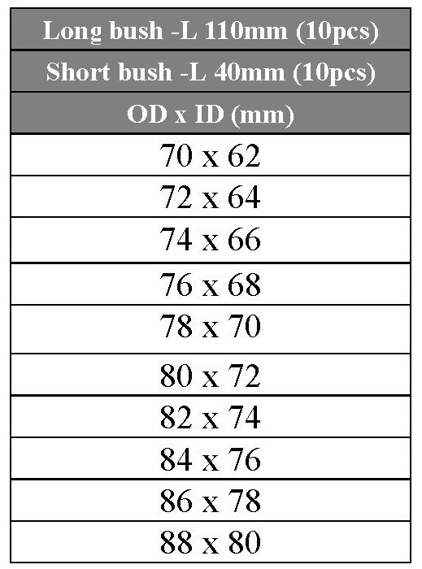
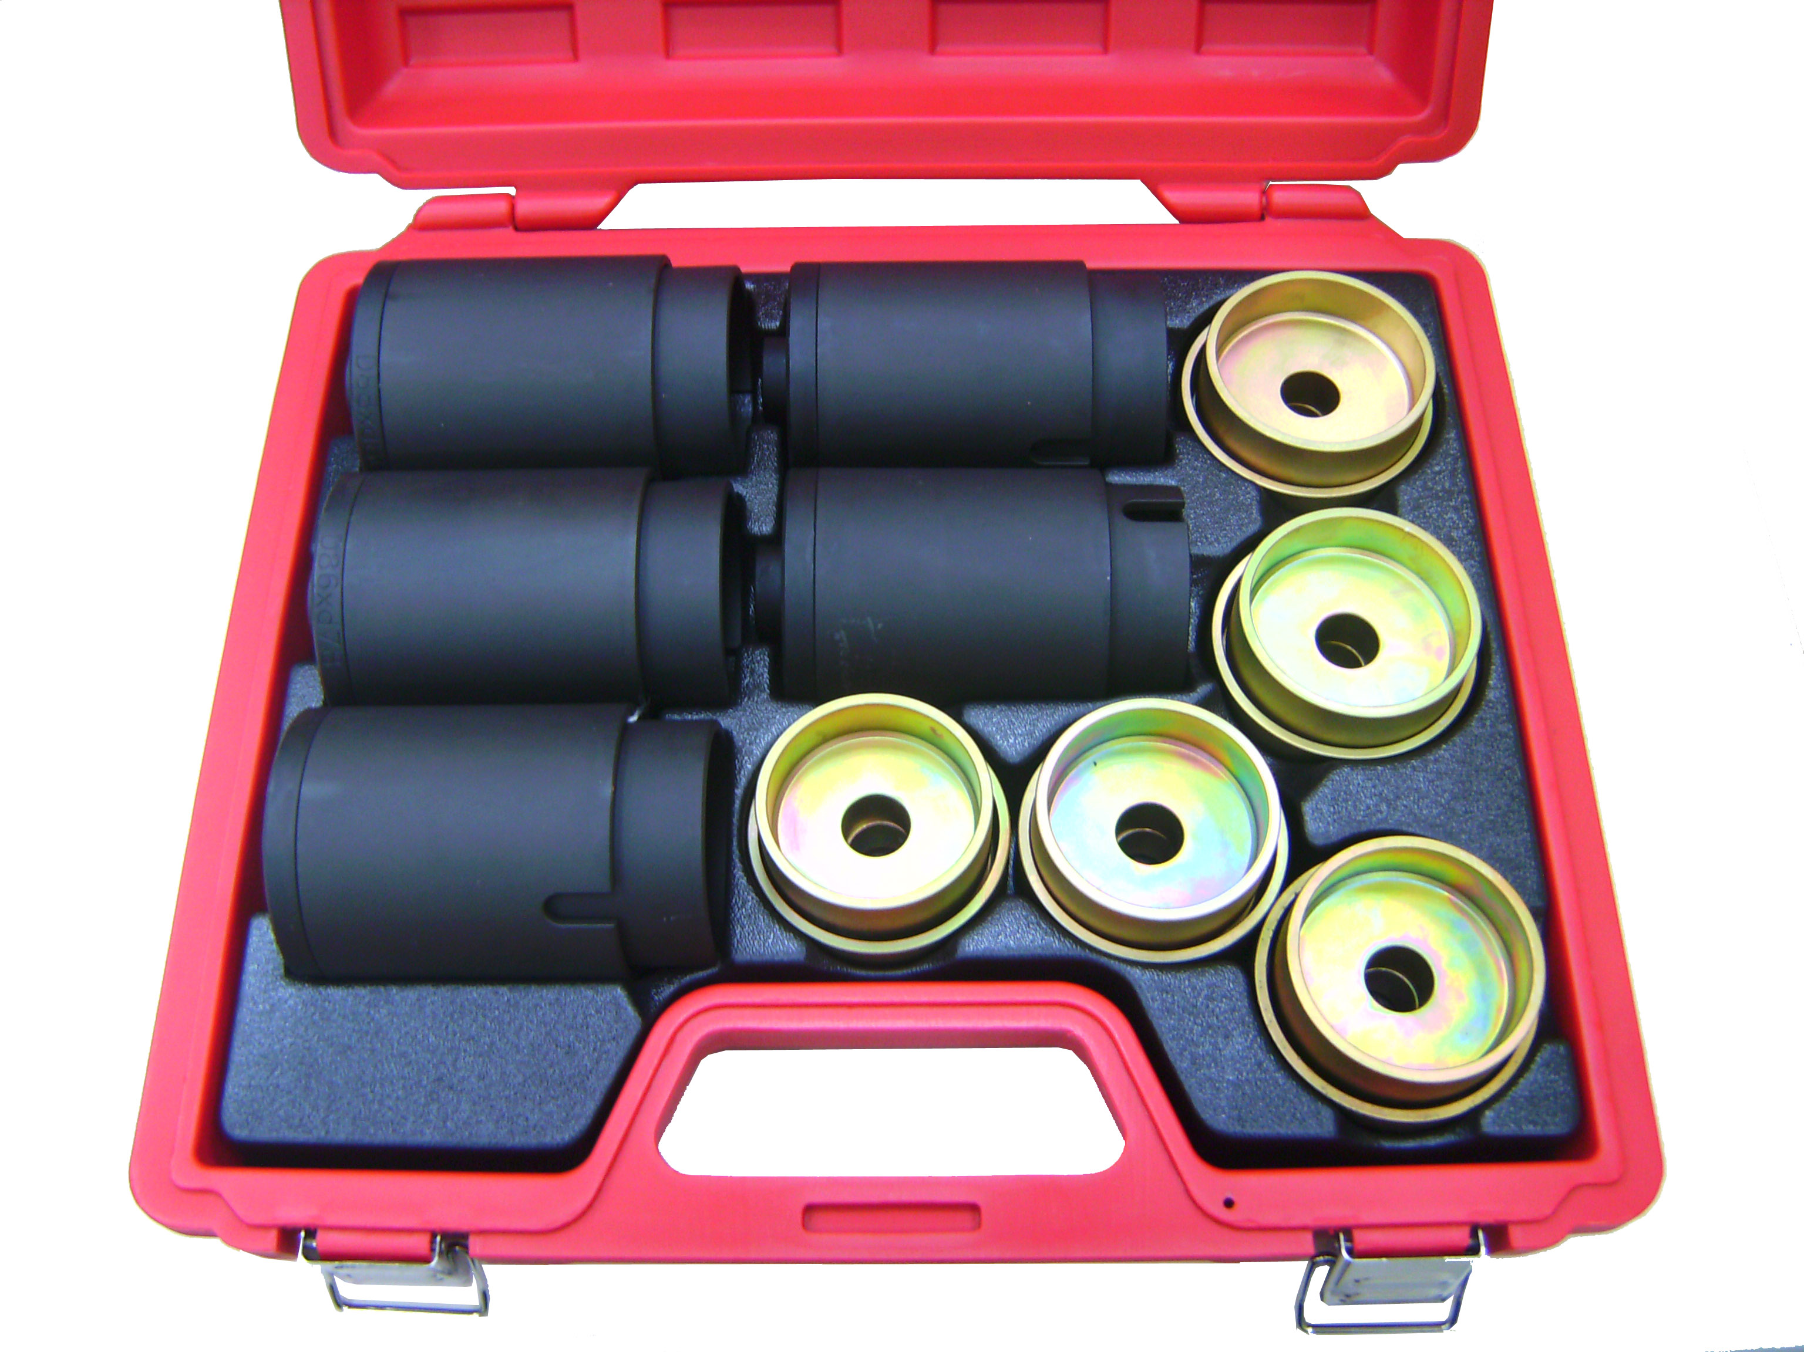

- To combine with hydraulic cylinder of A2183.
- 10 parts from (φ62~φ80, in 2 mm increment), 2 pcs per part.

