
H.C.B-B2132
MAN STAR-E IMPACT SOCKET KIT
(FOR HGV CYLINDER-HEAD BOLT)
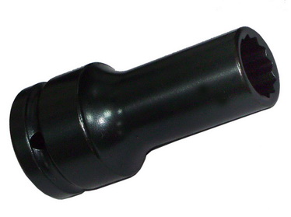
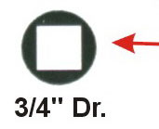
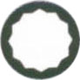
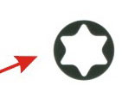
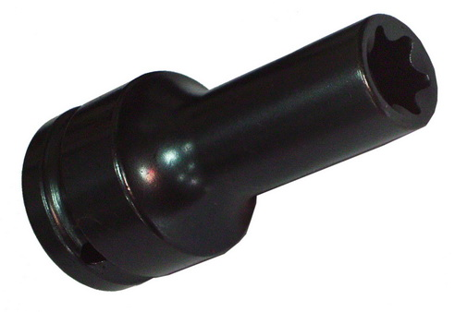
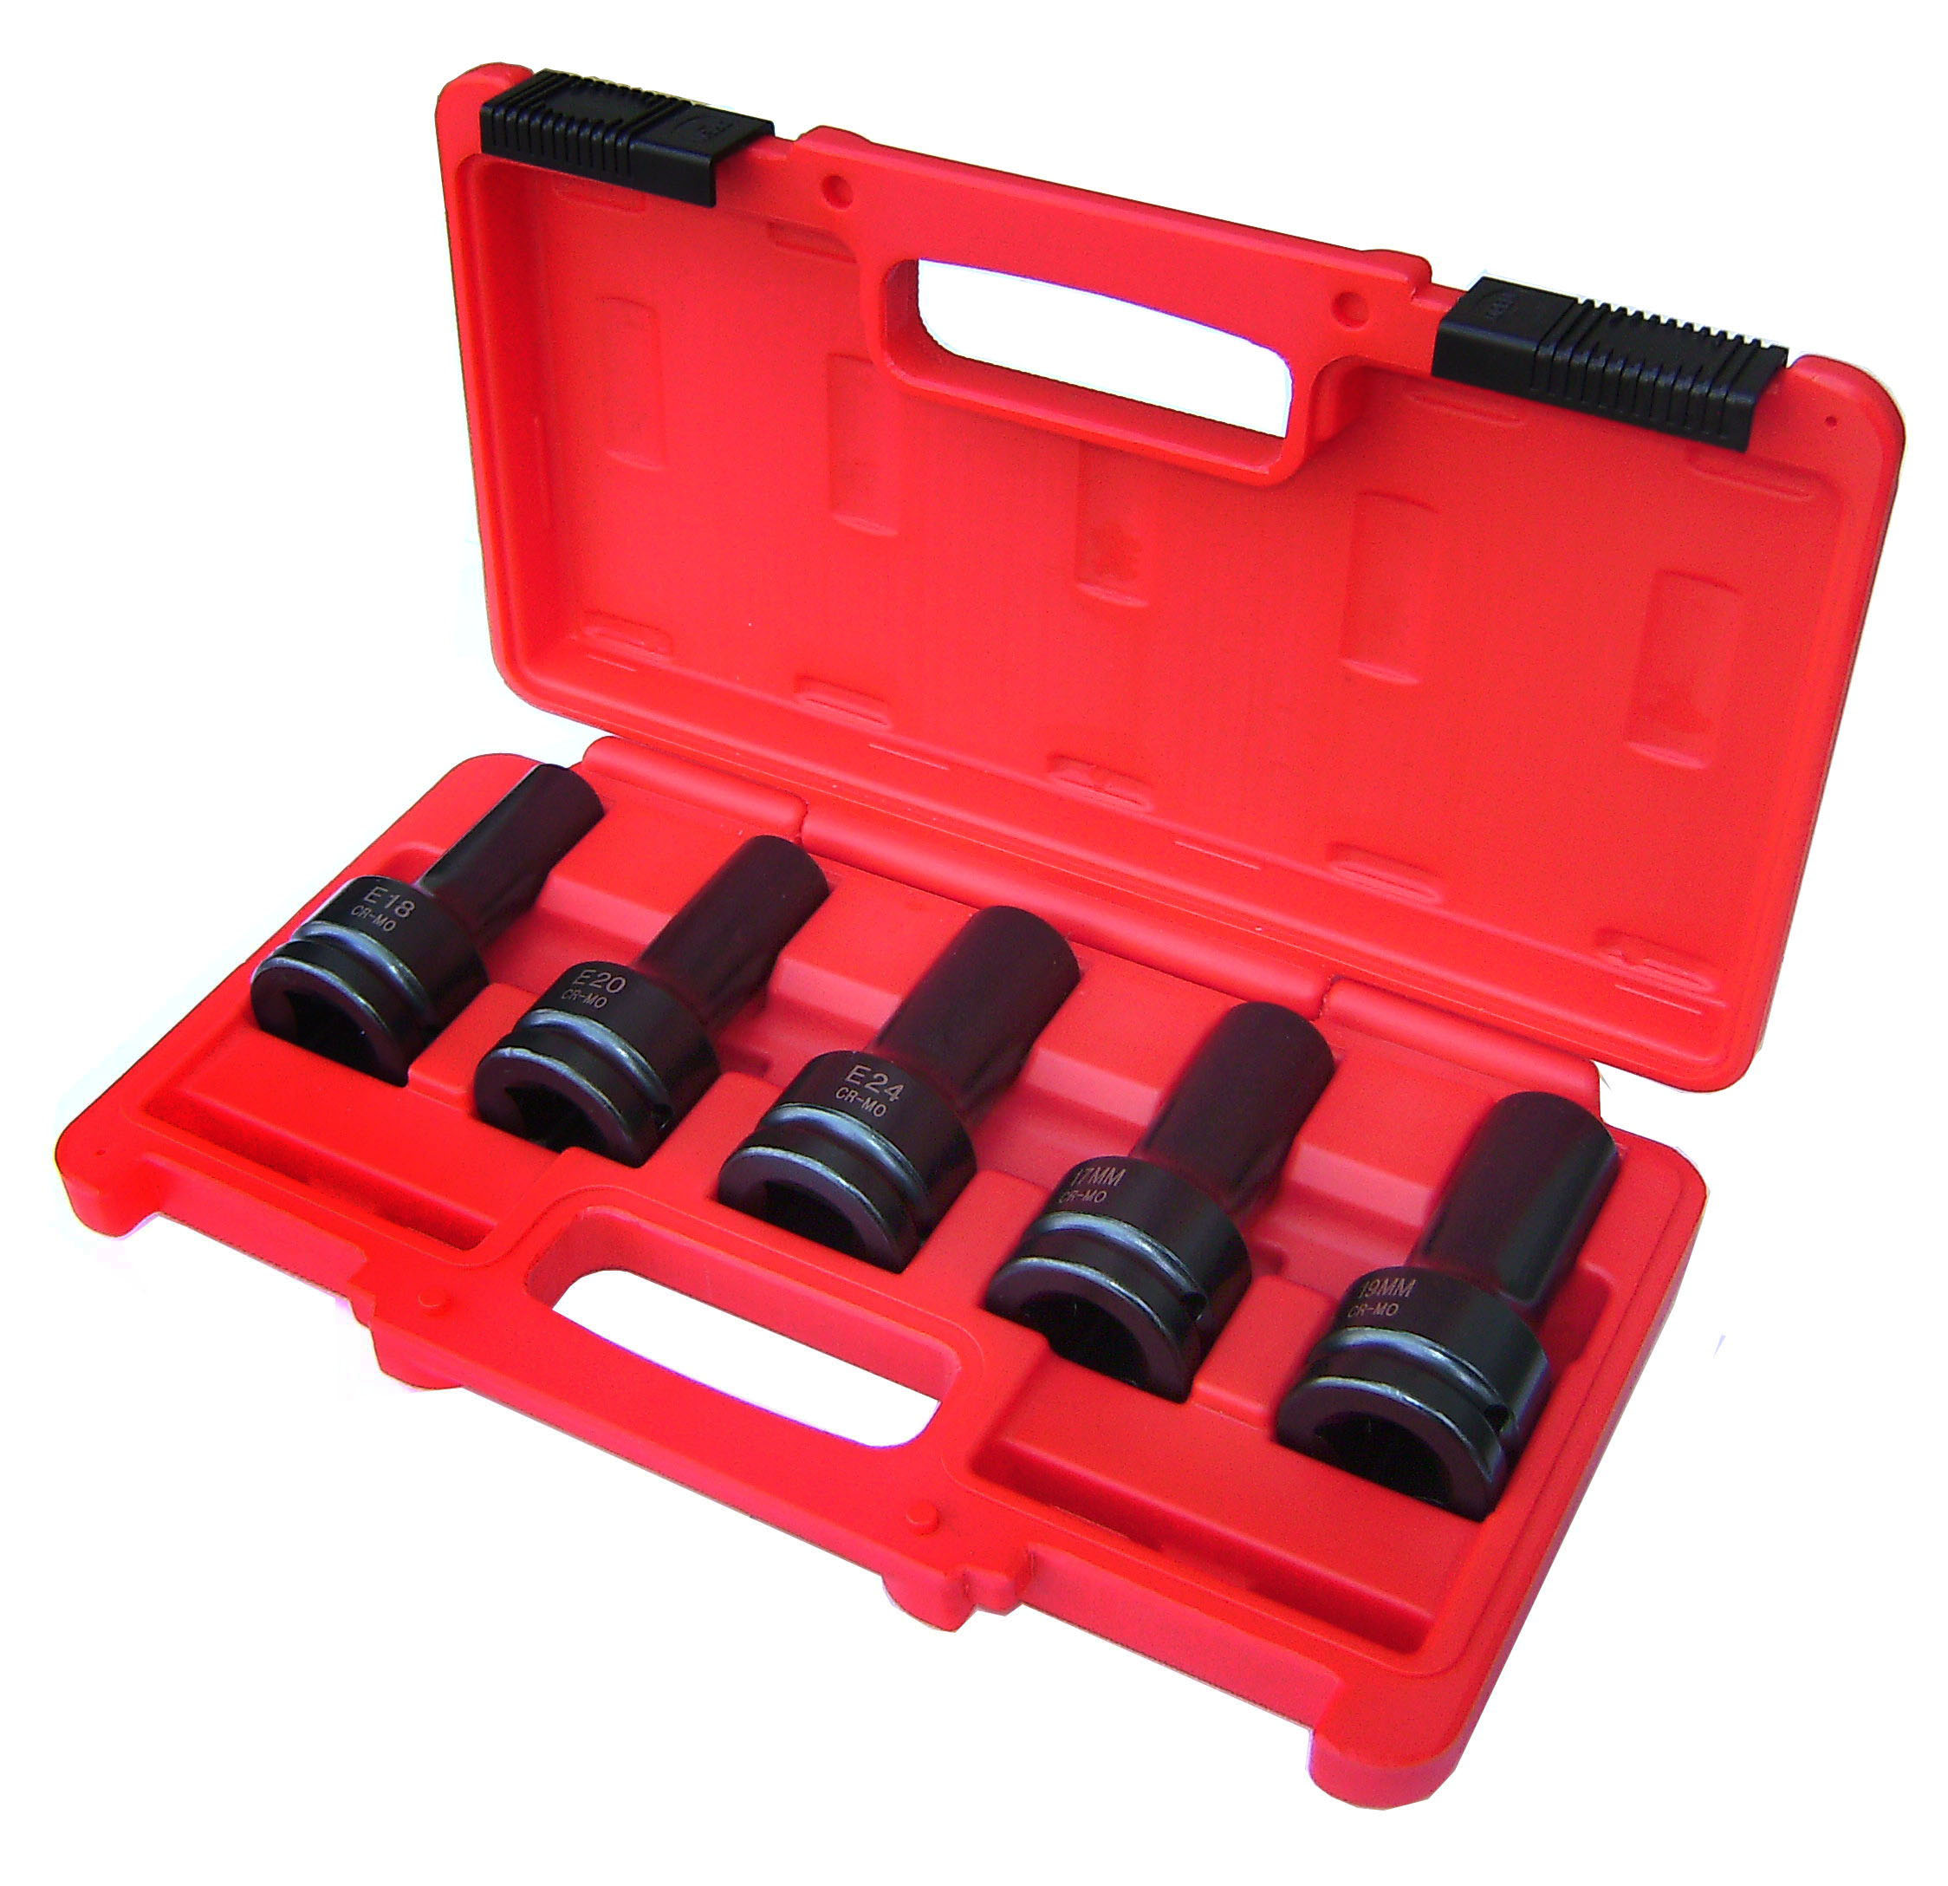
90mm
90mm

▉ Suitable for impact wrenches
▉ Reinforced design
▉ Chrome-Vanadium special steel / Surface burnished
▉Dr. 3/4”, 90 mm
Item No. | Applicable Model | Size
H.C.B-B2132-17 | For Mercedes-Benz engines 400, 420 | 12 points, 17 mm, Dr. 3/4”
H.C.B-B2132-19 | For Mercedes-Benz engines 300, 400 | 12 points, 19mm, Dr. 3/4”
H.C.B-B2132-E18 | For MAN commercial vehicles M 2000 and MAN busses with D 08 engines | E18, Dr. 3/4”
H.C.B-B2132-E20 | For MAN commercial vehicles F 2000,  F 90, F 8 and MAN busses with D 25 and D 28 engines | E20, Dr. 3/4”
H.C.B-B2132-E24 | For MAN commercial vehicles with Common Rail engine (D20) | E24, Dr. 3/4”
