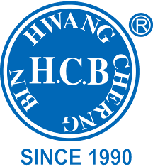
H.C.B-B2113
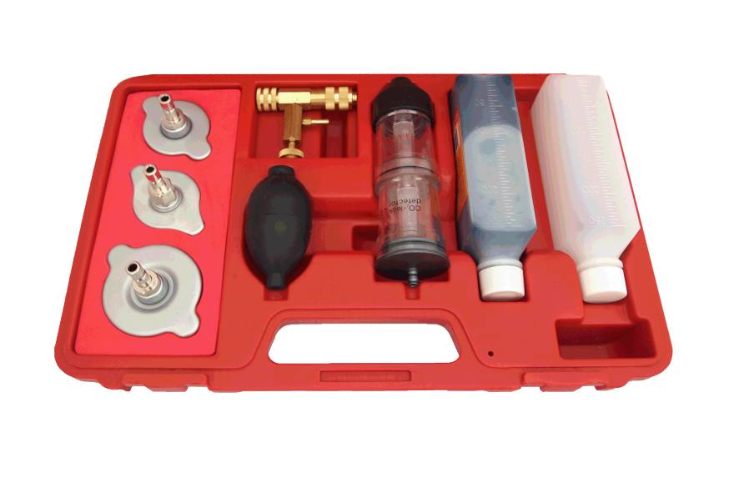
LEAK-CHECK FOR COMBUSTION WITH 3PCS RADIATOR CAP

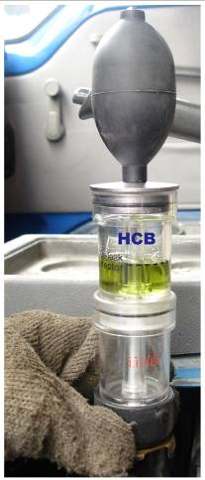

- Spots and locates combustion leaks quickly in cracked or warped heads, leaky gaskets or cracked block. Use leak-check in the radiator opening with engine idling. The blue test liquid will turn into yellow to green in 60 seconds if there is a combustion leak, no matter how small. Get exact location of leak by disconnecting one spark plug at a time and retest. Complete to proof of leak.
- Applicable :
#3 radiator cap: BENZ (W123/W126/W124/W201), GM (Buick), Jeep.
#4 radiator cap: Peugeot, Subaru, Chrysler, Acura, GM (Nova, Spectrum, Sprint), Mitsubishi, Nissan, Mazda, Toyota, Infiniti, GEO, Suzuki, Isuzu, Benz.
#5 radiator cap: Honda, Toyota, Suzuki, Mitsubishi, Chrysler, Acura.

