
H.C.B-B2111
UNIVERSAL ADJUSTABLE FUEL TANK LID REMOVER / INSTALLER(IMPROVEMENT)

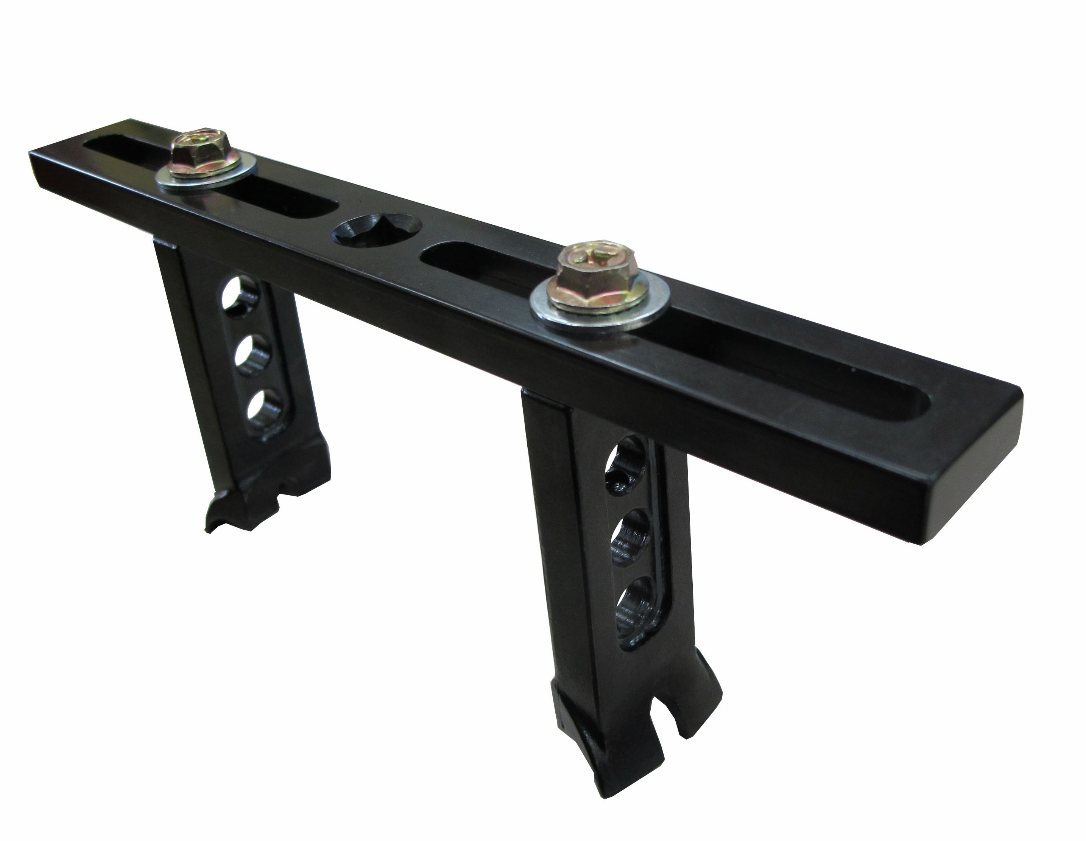
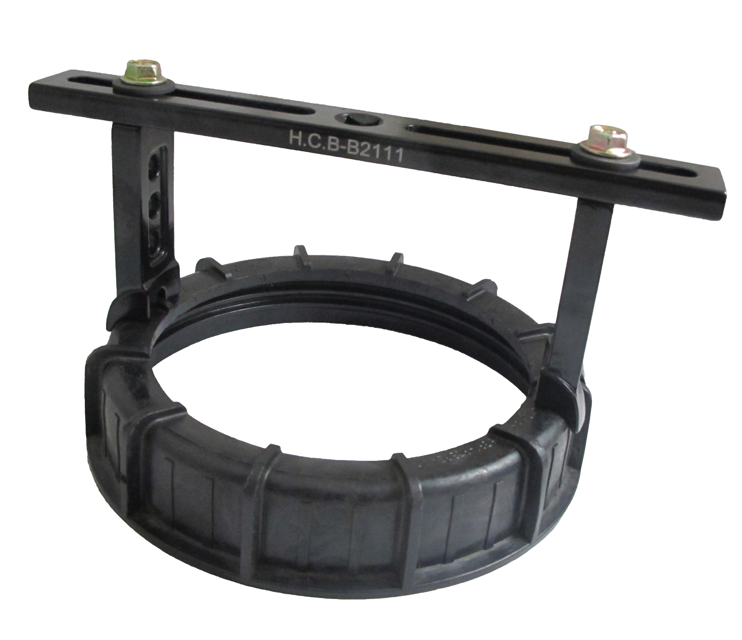

- Jaw adjustable rang: 122~199 mm, suitable for different fuel tank lid.
- Special jaws design to remove/ install the tank closely.
- Uses with Dr. 3/8" wrench.

H.C.B-B2111
UNIVERSAL ADJUSTABLE FUEL TANK LID REMOVER / INSTALLER(IMPROVEMENT)

- Jaw adjustable rang: 122~199 mm, suitable for different fuel tank lid.
- Special jaws design to remove/ install the tank closely.
- Uses with Dr. 3/8" wrench.

