
H.C.B-B2090
1/2" x M10S CYLINDER HEAD BOLT TOOL (100 mm)
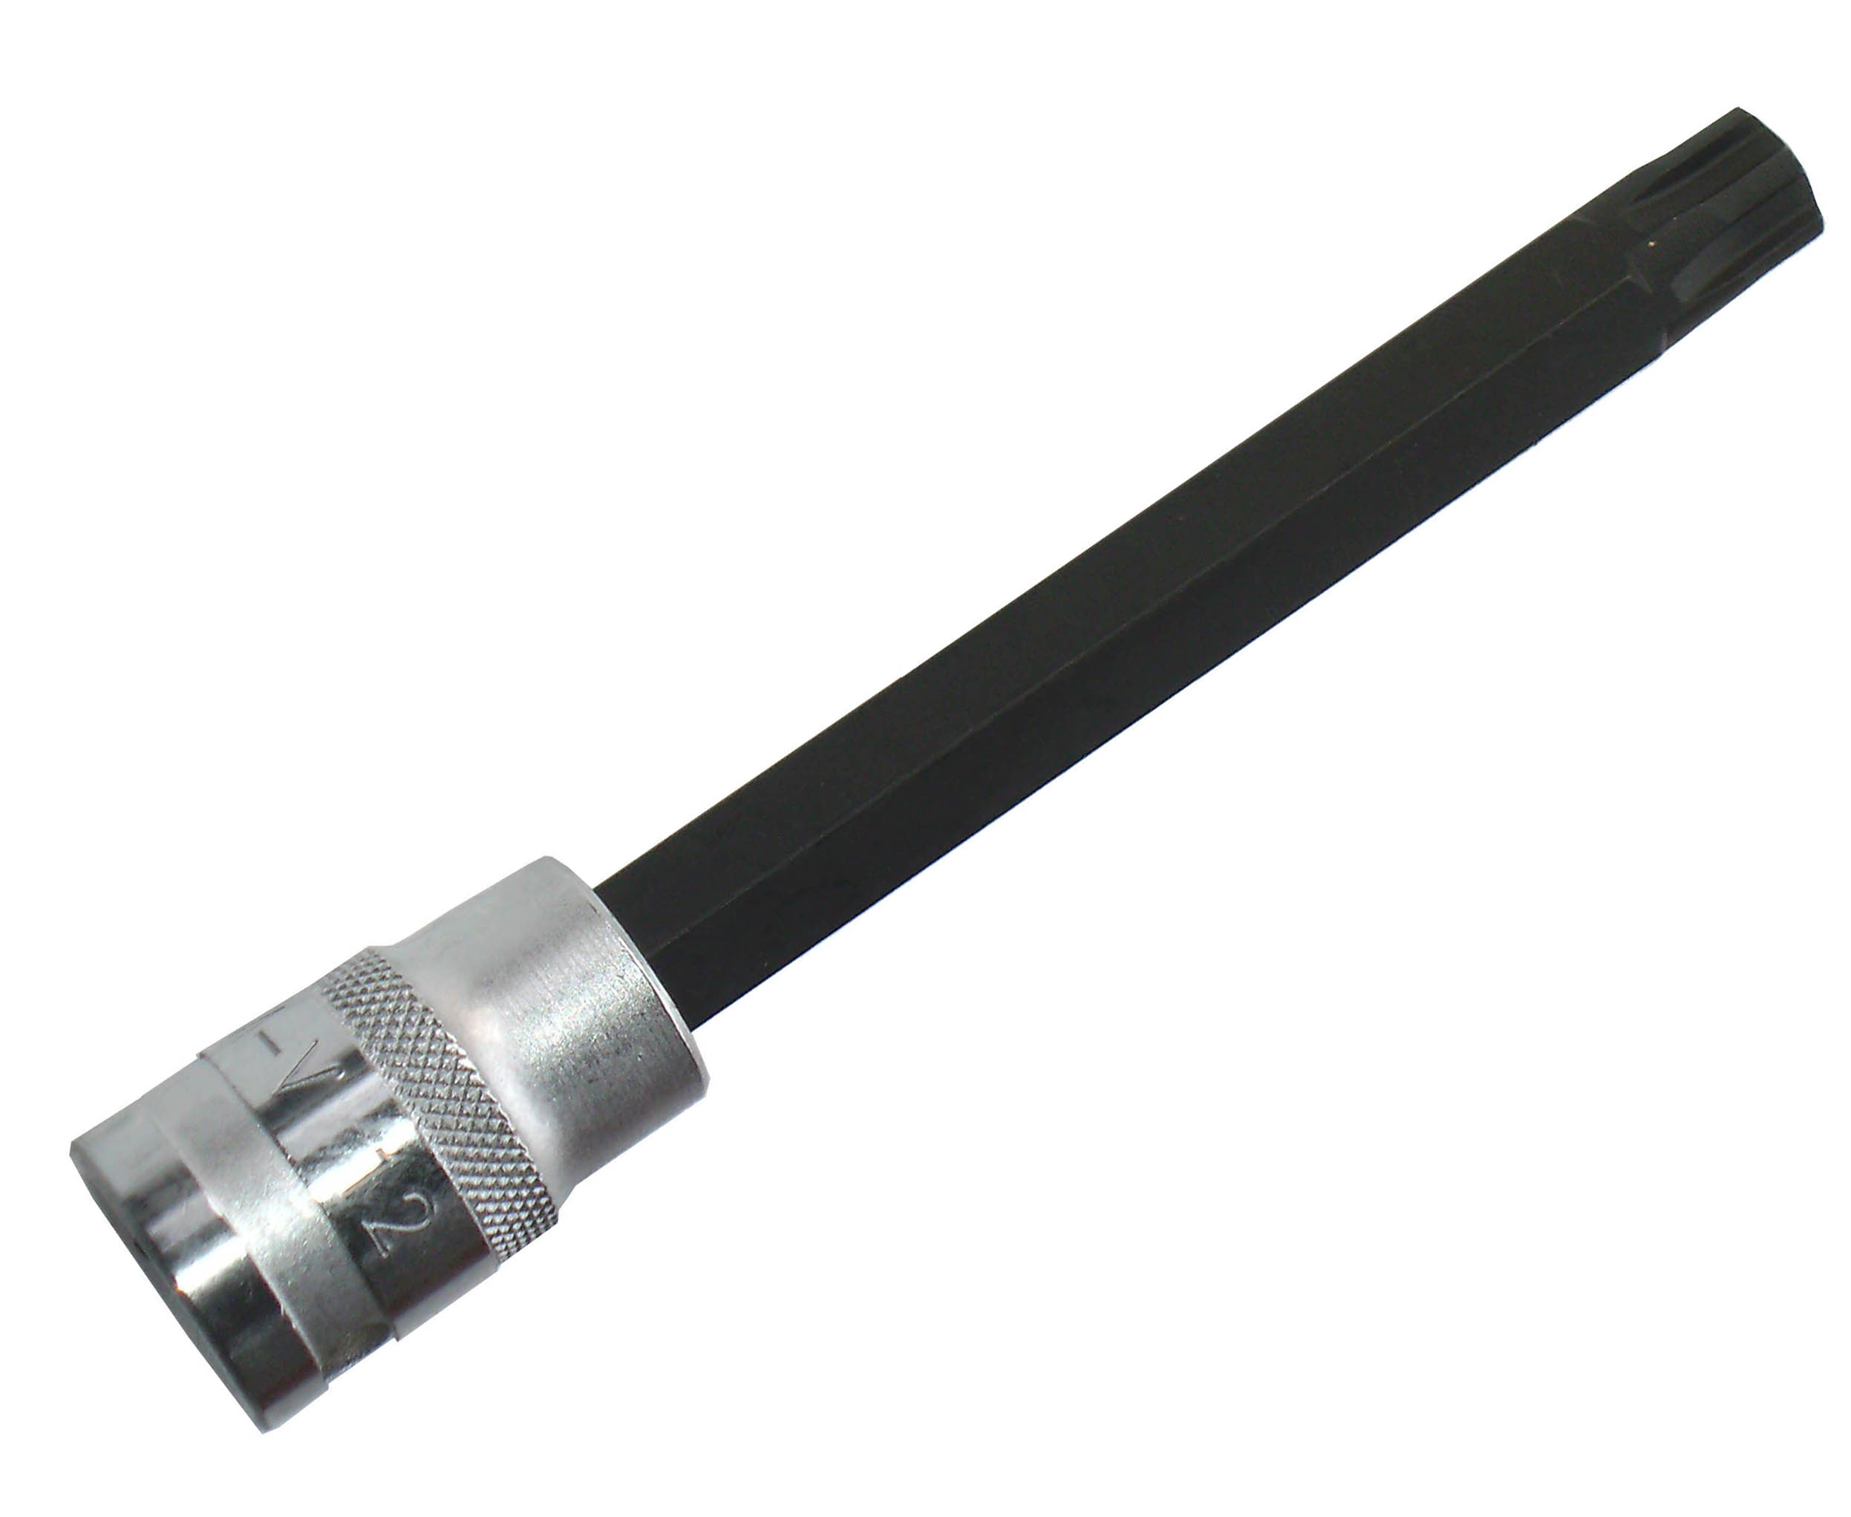
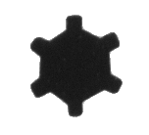
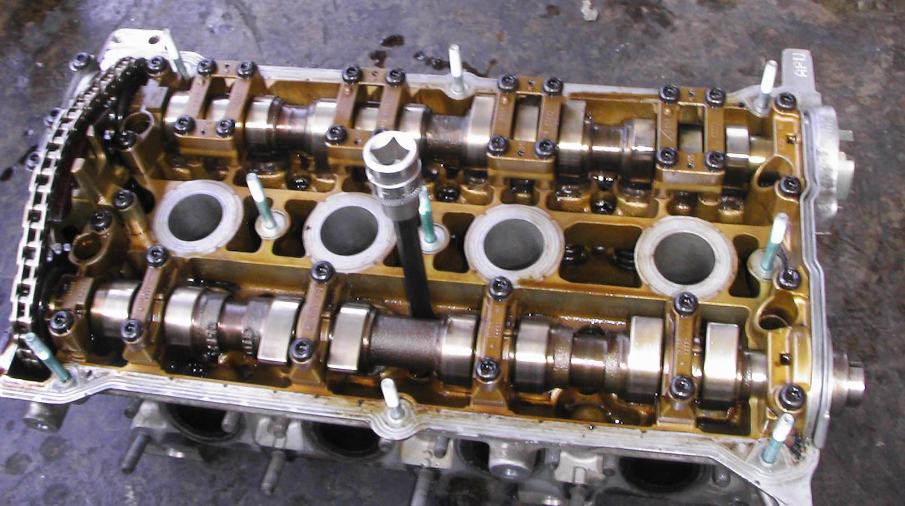

- To recessed head bolts by 100 mm long tool.
- Dr. 1/2” drive for combine with a torque wrench.
- Application: VW, AUDI cylinder head bolts.

H.C.B-B2090
1/2" x M10S CYLINDER HEAD BOLT TOOL (100 mm)

- To recessed head bolts by 100 mm long tool.
- Dr. 1/2” drive for combine with a torque wrench.
- Application: VW, AUDI cylinder head bolts.

