
H.C.B-B1995
DETROIT DIESEL 60 SERIES GUIDE STUD KIT

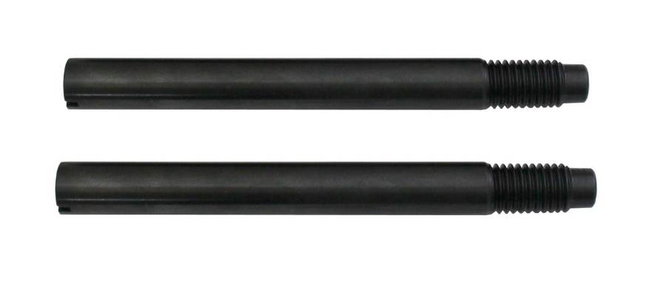

- Applications: DD60
- It alignment studs make quick work of installing the bull gear flywheel housing on the Detroit 60 Series Diesel.

