
H.C.B-B1828-01
VOLVO (FM) TRUCK MAIN SHAFT BEARING REMOVER ADAPTER
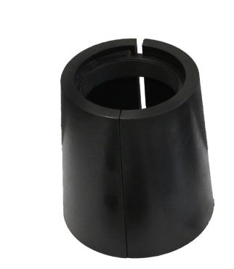

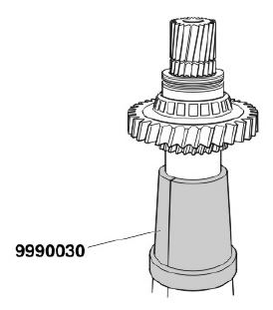

- Use for remove 2end gear and the needle bearing
- This tool must can combine with H.C.B-B1828
- Application: B5LH,B11R,B12B, B13R
- OEM no.ref.: 9990030

